London Borough of Camden
Simon Miller Architects Ltd

12 Forres Gardens
London NW11 7EX

Tel: 020 8201 9875
Fax: 020 8201 9877
Email: info@simonmillerarchitects.com
Planning Services
Camden Town Hall Extension
Argyle Street
London
WC1H 8ND

28th August 2012
Ref: 320/Noble REV A

Design & Access Statement

Subject: Planning application for lower ground floor side extension and alterations to entrance steps at 11a Priory Road, London, NW6 4NN.

Dear Sir and Madame,

Please find attached a full set of existing and proposed drawings for the lower ground floor side extension and associated works at 11a Priory Road, London, NW6 4NN

Introduction:
The flat is located in West Hampstead and it is a lower ground and ground floor flat in a semi-detached house.
The proposal is for a new single storey side extension, internal alterations and a rear external staircase from ground floor to garden level.

The Entrance:
The main entrance to the flat is through the side gate via the side passage with new steps down to flat entrance.

Staircase:
The existing staircase will be replaced.

Windows, roof lights and doors:
Where there will be new windows on upper floors these will match the existing and will be double-glazed.

Garden/Landscape and Access
A garden exists at the rear of the building. This garden is currently accessed externally, via a side passage.
As part of the proposal, a new traditional metal staircase will provide access from the ground floor to the rear garden.

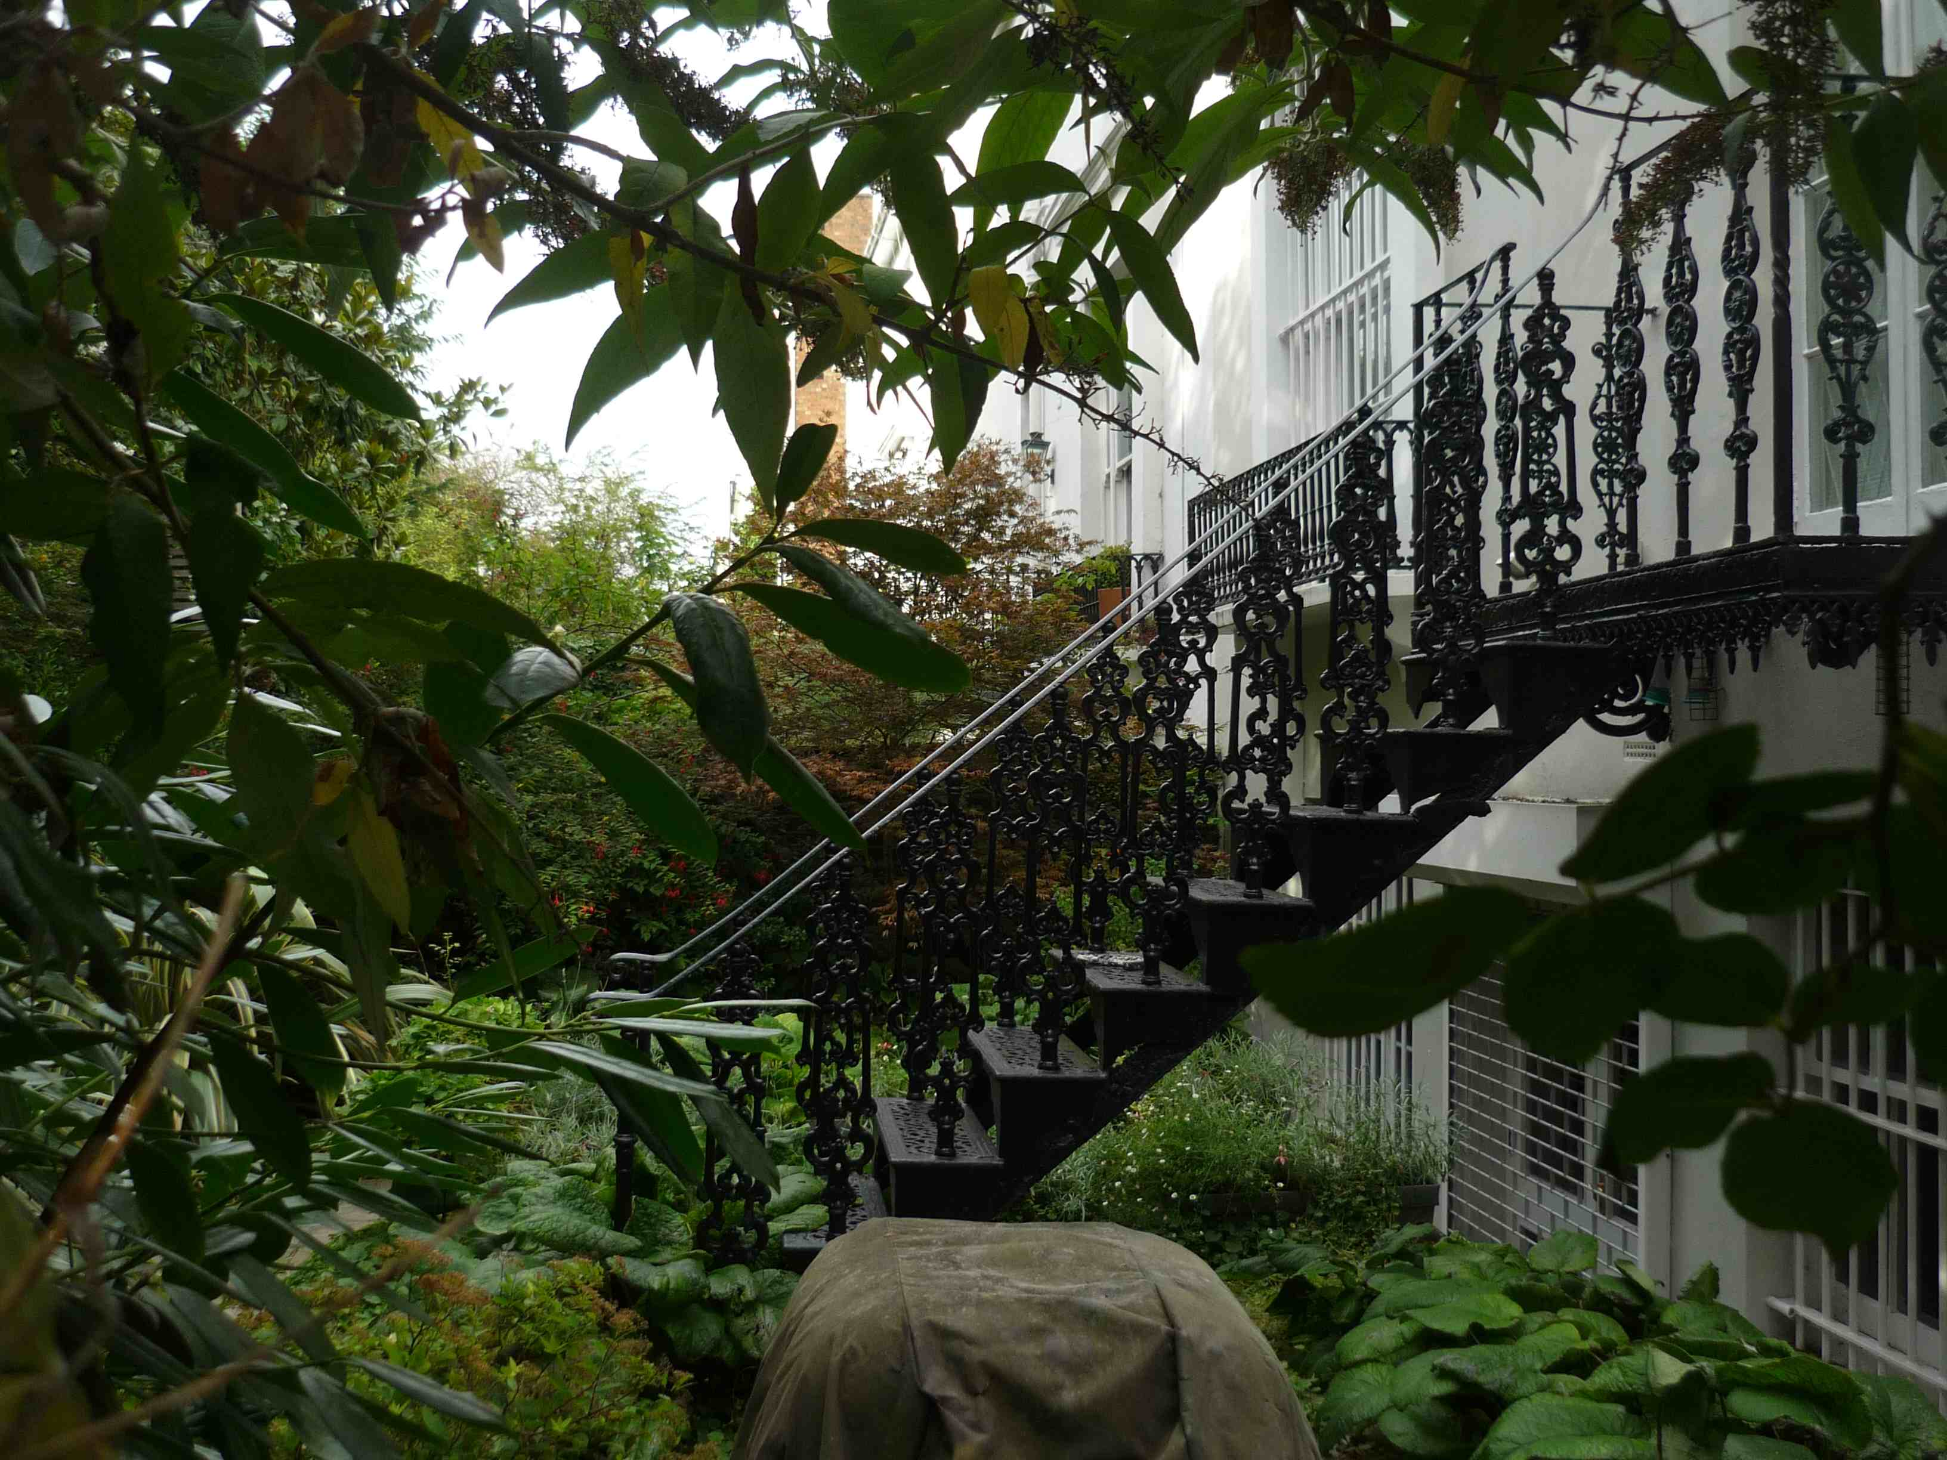
Traditional metal staircase of 13 Priory Road, similar to our proposal.

A new gate to the side passage will replace existing.

Emergency Access:
Access for the emergency services does not change from that of the existing situation. Emergency escape from the building will be via the front garden onto the main street.

Car Parking:
No changes will be made to the existing street parking.

Should you wish to scale off our drawings for planning purposes please do not hesitate to do so.

We believe the above description of the proposed design has addressed the key issues of Design & Access. Should there be additional information or clarification required in order to progress this planning application please do not hesitate to contact myself, and we look forward to hearing from you in due course.

Regards

Ben Clarke
for and on behalf of Simon Miller Architects Ltd

cc: (Client)

