 | SITE  INSPECTION  REPORT

MLM BUILDING CONTROL LTD
Zetland House, 5-25 Scrutton Street, London EC2A 4HJ
Tel: 020 7613 7500 Fax: 020 7613 5747

Project New 2 bedroom dwelling adjacent |  |  |  |  |  | Job No: 8411321
Address: Hodes Row
Surveyor: Stephen Percival |  |  | Time 4pm |  | Date 9.05.12
Project Manager: Michael Wadood |  |  | Inspection Type: Foundation
Inspections carried out: 1 |  |  | Next Inspection: Foundation
Site Contact: Ray Bradley
Site Comments
Met Ray on site and noted the following issues :

- New strip foundation dug 600mm wide x 1000mm deep, this is in line with engineers drawing HR/01, reinforcement will be added to foundation at a later date. Engineers drawings are approved.
- Exposed gas pipe at end of foundation, to be boxed.
- Clay at base of excavation some stones and rubble fallen into it will be cleared out.

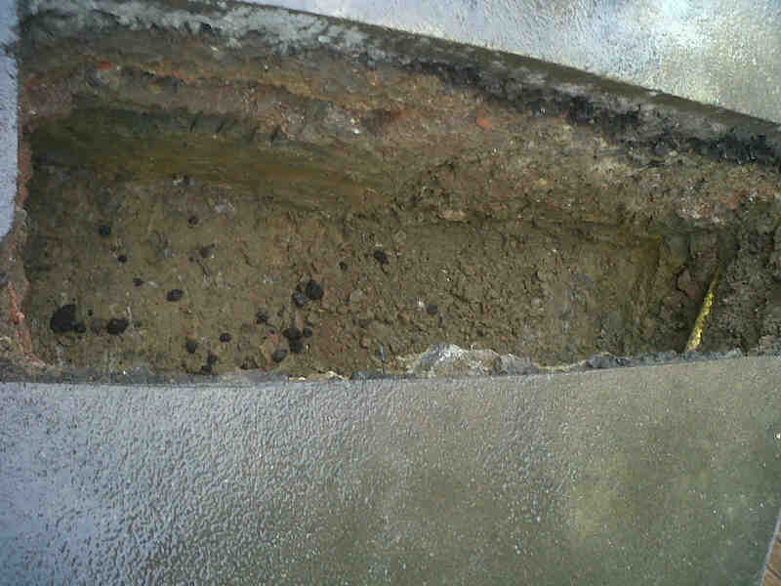

Time Taken: 2 hours |  | Action required by project manager: No
Signed Site Representative: Date 9.05.12
Signed Project Manager 

