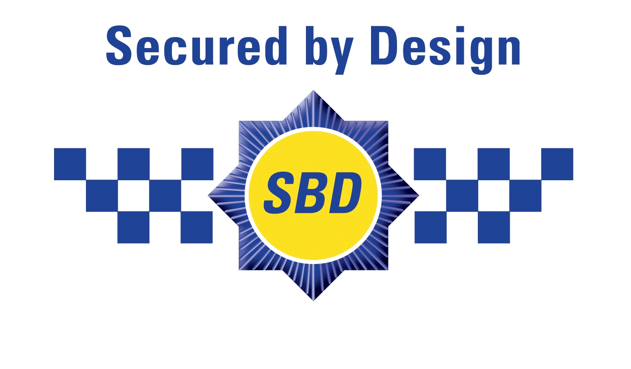
SECURED BY DESIGN
Residential
Part 2 (Physical Security)

Address 17 Murray Street, Camden.

Developer Damsonetti Construction Ltd, 1 Heliport House, 38 Lombard Road, Battersea London SW11 3 RP.

Architect DVM Architects, 4A Murray Street, Camden.

Dear Mr P. Woodford.

I am pleased to confirm that the residential development at;

17 Murray Street Camden

has successfully achieved compliance with “Secured by Design” Part 2 – Physical Security.

Yours truly,

Adam Lindsay
Crime Prevention Designer
Camden Police



The ‘Secured by Design’ scheme and award have been developed by the Association of Chief Police Officers to establish a minimum standard
of physical security, together with an approved development layout, designed to reduce the opportunity for crime and anti-social behaviour.

