22 February 2013

Development Management
Camden Town Hall Extension
Argyle Street
London WC1H 8EQ

Dear Sirs

DESIGN & ACCESS STATEMENT

256 Kilburn High Road, London NW6 2BY: Planning Application / FULL

DESIGN

Please find attached the information and enclosures in order to establish a retrospective and valid planning application for the above existing first floor storage facility in Camden. The application relates to a new single storey extension which will provide storage for the existing ground floor and basement retail units on Kilburn High Road.

The drawings as submitted and relating to this application are as follows:

21112/GA-00, 01, 02, 03 & 04

The drawings show the existing extension and our proposed alterations which we hope Camden may find acceptable in order for my client to retain the bulk of the existing structure.

Previous and most relevant correspondence relating to the above extension can be summarized as follows;

- My client made an appeal against an enforcement notice received from Camden towards the end of 2011.

- The Planning Inspectorate issued an appeal decision dated 12 March 2012 advising that the appeal not be rewarded and that the enforcement notice should thereby stand.

- A further enforcement notice was issued by Camden dated 29 May 2012 stating the terms and steps that will be taken by Camden following the above advice.

Following my meeting on site with Gary Bakall of Camden on 28 January 2013, we spoke about possible modifications that might be employed to address the issues raised by the Planning Inspectorate. These can be seen on the enclosed drawing proposals and are summarized as follows:

- We now propose to chamfer the flat roof as shown adjacent to the existing rear building line in order to maintain adequate daylight and sunlight into the existing rear windows.

- We propose to reduce the height of the existing brick wall enclosing the staircase closest to the building side in order to facilitate additional daylight and morning sunlight to the existing rear bedroom windows.

- The rear extension is currently rendered and unfinished. My client is willing to consider re-cladding it in brick slips to match the existing surrounding context or vertical man made tiling such as Eternit or similar, which is in fact also a fairly common precedent in the area. My own proposal would be to clean up the render and make good with sharp horizontal and vertical lines, and then finish the render with a long lasting external paint to an appropriate colour. At the moment I favor a light Terracotta. My client, however, is willing to be advised by Camden and negotiate further on this issue as required.

- We propose to install new double glazed and opening timber casement windows into the exiting openings which will add more scale and clarity to the current “box-like” look of the current structure. These will also provide natural ventilation to the retail stock without the need to mechanically vent the space.

ACCESS

This work is very common in the area and very straightforward for any competent small to medium sized contractor. It will be stressed that care and attention must be exercised when working near the adjacent first floor property, including the need to respect neighbouring buildings and all local authority time scales for heavy or noisy work.

The chosen contractor will also be instructed to observe all local authority regulations if any works are required next to or on the public footpath or right of way. They will also be informed of the need to inform Camden if any public access needs to be modified in any way during the works, for how long and if the use for a skip is required for any period and where it is to be located.

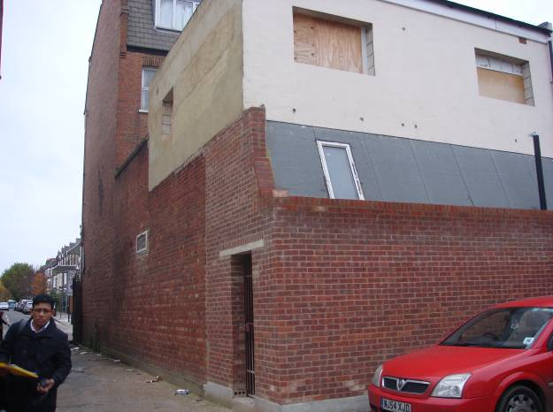

View from the rear Mews looking at the existing extension

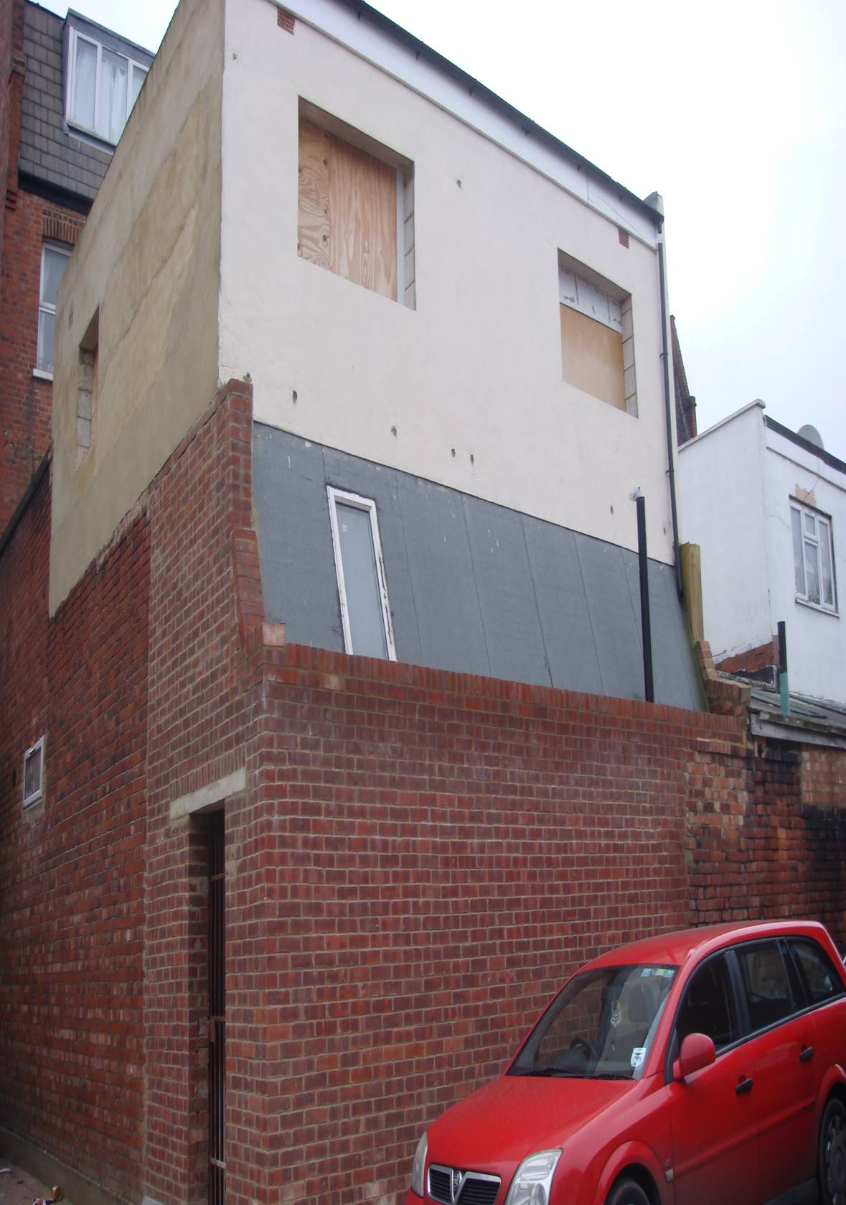

View from the rear Mews looking at the existing extension

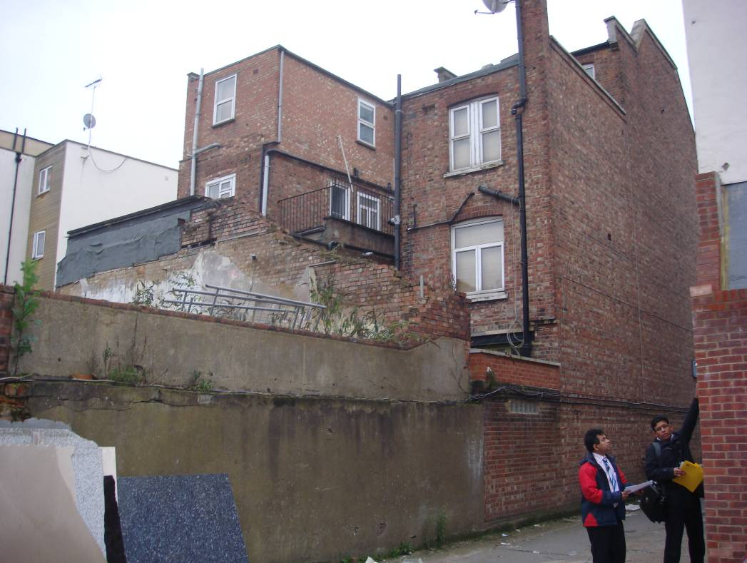

View from the rear Mews looking at No 244 (see also site plan)

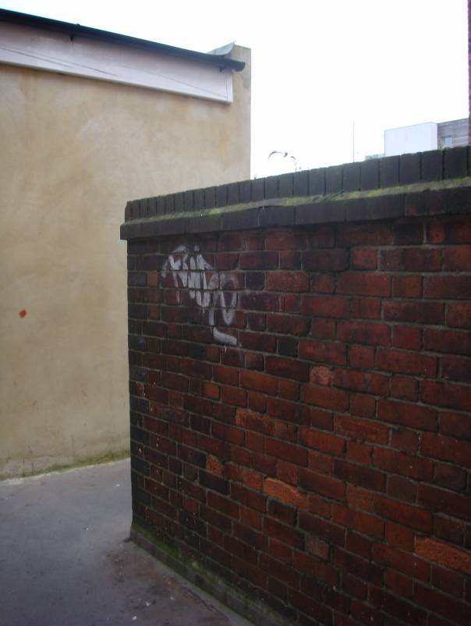

View looking at the existing wall to be reduced in height as shown

This statement is purposefully brief due to the minor nature of the proposed building intervention. We will of course be willing to supply the planning department with any further information, should they wish. We feel the main intentions of the project are self explanatory on the enclosed application form and drawing information.

Yours faithfully
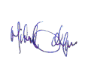
Michael Gallagher AA Dipl RIBA

