RMC design studio

21 The Avenue, Muswell Hill, London N10 2QE
+44(0)7850 920720

www.rmcdesignstudio.co.uk info@rmcdesignstudio.co.uk
Planning Application 1 Smyrna Road, NW6 4LY, Site Photos:
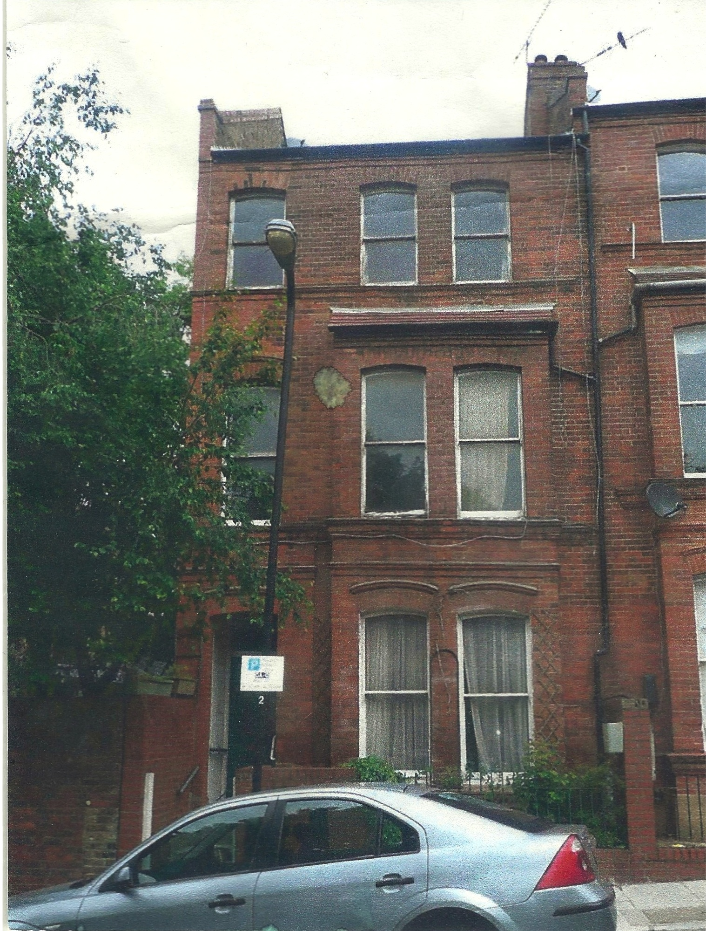 Front Elevation

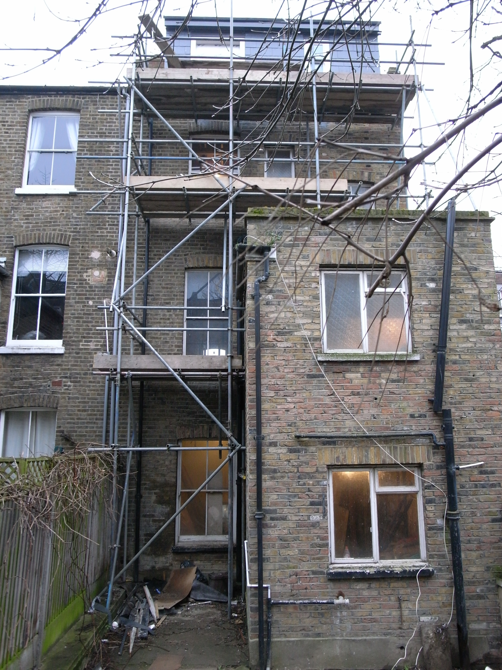Rear Elevation

