

**Alexander Herzen’s Free Russian Press, 61 Judd Street (formerly 82 Judd Street) - Background information relating to the Marchmont Association’s commemorative plaque at this address:**

**Alexander Herzen (1812-1870)**

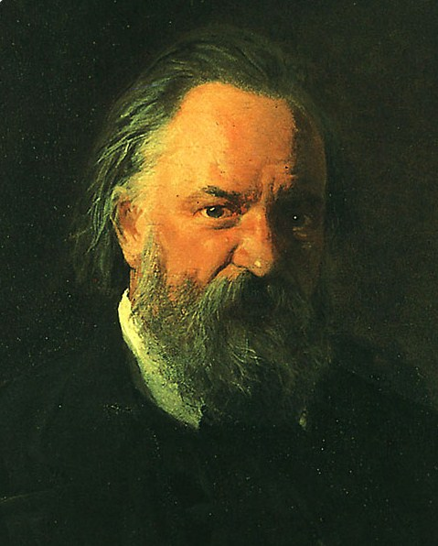

Some twenty years after the official abolition of slavery in the British Empire and while abolitionists such as Harriet Beecher Stowe were touring Britain in 1853, arguing the cause of the Negro slave in the United States, the Russian political theorist and writer Alexander Herzen noted the similarities of slavery with Russian serfdom and set about the task of liberating the serfs through his Free Russian Press in London. As Kunka (2011: 116) notes: *‘London provided the Free Russian Press with the platform and freedom necessary for its success, which would have been impossible elsewhere.’*

In the spring of 1853, the Free Russian press was installed on the premises of the already established Polish Democratic Press at 38 Regent Square (since demolished). **In December 1854, Herzen established the first independent Free Russian Press at 82 (now 61) Judd Street.** In December 1856 the press moved to 2 Judd Street, directly opposite number 61 (since demolished and now the site of a dog-walking area). It was at 5 Thornhill Place [which became 136-138 Caledonian Road] from February 1860-July 1863.

Herzen is widely acknowledged as *‘a towering figure on a world scale’.* Unlike his former colleagues, such as Karl Marx, he was opposed to *‘the delusions of dogmatic systems’.* He opposed the dominant utopian strand of Russian thought. As Kunka (2011: 10) puts it: *‘It was this Russian counter tradition which Herzen influenced and addressed so successfully for a decade through his Free Russian Press’*, most notably through the publication of the almanac ‘*The Polar Star’* and his most famous periodical ‘*The Bell’*.

Later Herzen became the hero of thinkers and activists as diverse as Lenin and the philosopher Isaiah Berlin. Lenin celebrated Herzen’s Free Russian Press as marking the beginnings of the overthrow of the Tsar. Berlin celebrated Herzen’s publications for their liberal democratic, anti-totalitarian tendencies.

Herzen came to England in 1852. From 1852 to 1865 he and his children moved house fifteen times, occasionally staying only a few months. The longest time they spent at the same address was at Orsett House, 1, Orsett Terrace, Paddington, where there is a Greater London Council Blue Plaque (below).

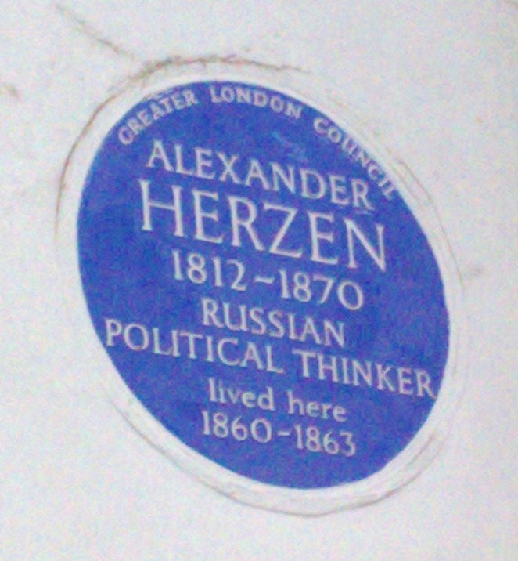

Herzen worked at the Free Russian Press on a daily basis. It was the Free Russian Press addresses in Judd Street which provided him with ‘continuity’ in England, prior to his move to Orsett House in 1860.

Herzen’s stature is illustrated by Tolstoy’s declaration that he had never met another man *‘with so rare a combination of scintillating brilliance and depth’*.

2012 is the 200th anniversary of Herzen’s birthday (6th April 1812)

References:

<http://sarahjyoung.com/site/2010/11/28/russians-in-london-alexander-herzen-with-a-note-on-nikolai-ogarev/>

Francoise Kunka, *Alexander Herzen and the Free Russian Press in London, 1852-1866*, Lambert, 2011.

Adapted from a paper prepared by Richard Ekins – 31st March 2012