The Golden Lion PH, 88 Royal College Street, London NW1
Pool and Darts Leagues
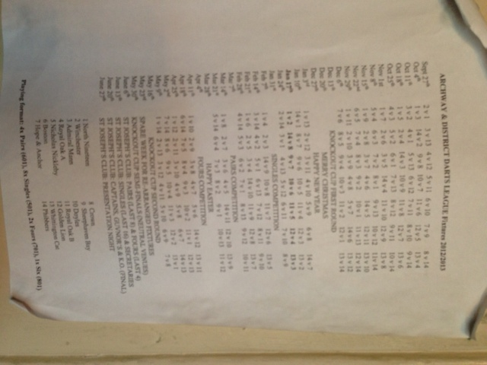

DARTS LEAGUE TEAMS AND FIXTURES

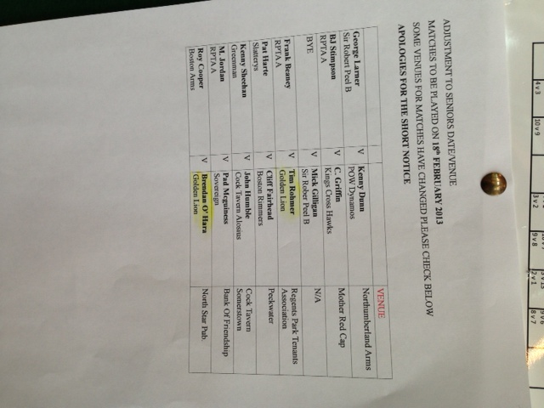
POOL LEAGUE TEAMS
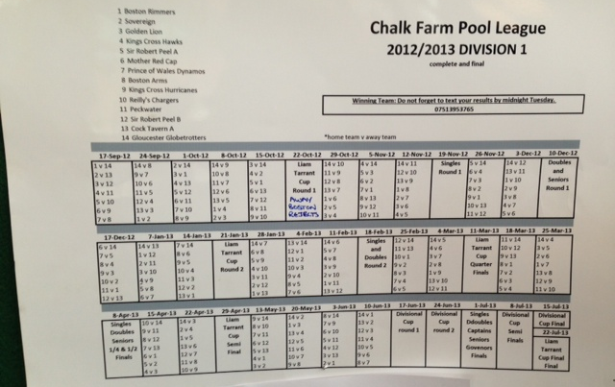
POOL LEAGUE TEAMS AND FIXTURES

