**Design and Access Statement for:**

**John Reynolds Jewellery Ltd – Proposed plan to change shop frontage**

**Exisiting Site**

The submitted application is to replace the existing retail jewellery shop frontage, which was inherited by us from the landlord when we became the new leaseholders in 2005.

The shop front was fitted without any particular consideration to its proposed usage or location. The unit was a new ‘space’ created by the landlord within the main entrance to the Diamond Borse, so therefore the landlord fitted a generic use frontage.

**Current Frontage**

As the new tenants to the newly created retail unit, we had virtually no input into this original design for the shop frontage and it has now become very apparent that this existing shop front is neither fit for purpose or indeed in keeping with the other retail outlets in Hatton Garden.

A retail jewellery shop demands a certain layout to be workable and would also vastly improve the visual aspect from the curbside.

The current frontage has two large plain glass panes and a pedestrian door to the right hand side of the shop front, thus giving a ‘flat front’ appearance. The frame is of a brushed aluminium finish.

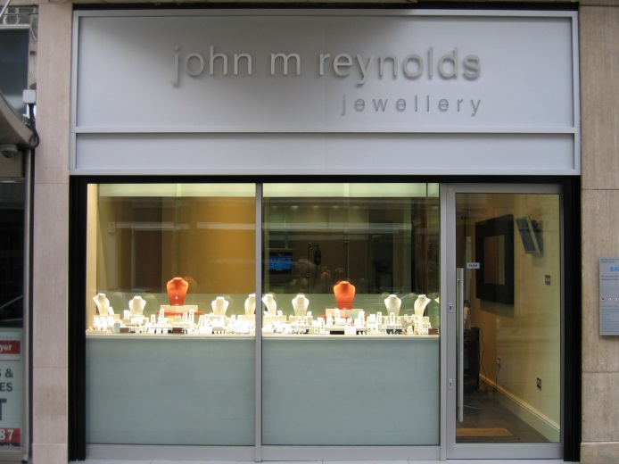

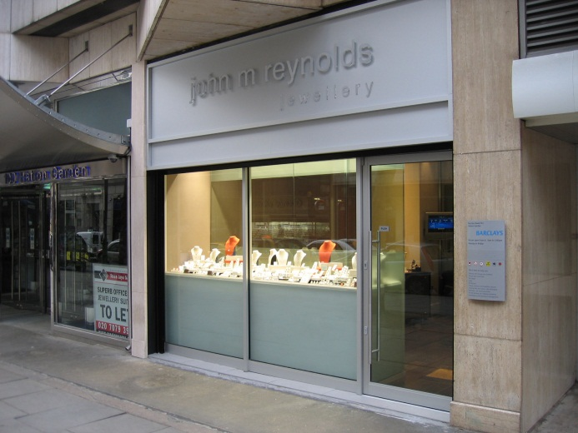

**Proposed Frontage**

As you can see from the submitted plans, we are proposing to remove the existing frontage and replace it with a design of our own that will work with our business needs, whilst also improving the visual appearance from the pavement, thus bringing it more into line with the other retail outlets either side of our shop.

We propose to move the door to the centre of the shop front and set it back from the building line. The window glass will then be replaced left and right of the centrally positioned door, but angled slightly inwards with a small return of glass to the door (please see floor plan), this will the create an ‘arcade’ style frontage.

The design will use a ‘frameless’ technology with the glass panes being fitted together with stainless steel brackets, the perimeter of the frame will be secured to the main building with a stainless steel channel. Throughout the window all stainless steel fittings will be used, with a combination of brushed and polished finishes.

The signage above the proposed replacement frontage will be renewed. The only change proposed for this signage is that of the colours to be used and will be under the 75cm size requirement, will not be illuminated and should therefore not require any additional applications.

To summarise, the proposed new design to our shop front will greatly improve its workability for our business, whilst also bringing it more into line with the visual image that Hatton Garden should represent.

**Works Impact**

The porposed works will be carried out with the full appreciation of all tenants and residents of the nearby premises. We are fully aware of the strict noise disturbance issues of any works that are undertaken and therefore have secured a promise from the contractors that all the work proposed will be completed in no more than two days. This should therefore avoid a prolonged period of disturbance.

All works will be shielded from the pavement with the appropriate safety considerations.