Thomas and Thomas Partners

38A Monmouth Street

London

WC2H 9EP
38A Monmouth Street  London  WC2H 9EP |  | Application Ref: 2013/0739/P
 |  | Please ask for: Jason Traves
 |  | Telephone: 020 7974 2123
 |  | 25 March 2013

Dear Sir/Madam

DECISION

Town and Country Planning Act 1990 (as amended)
Town and Country Planning (Development Management Procedure) Order 2010
Town and Country Planning (Applications) Regulations 1988

Variation or Removal of Condition(s) Refused

Address:
3 - 7 Delancey Street
London
NW1 7NL

Proposal:
Variation of conditions 2 (opening hours of café/restaurant) and condition 6 (opening hours of music recital hall) of planning permission dated 19/03/07 (Ref:2006/2680/P) for the demolition of existing buildings and redevelopment of the site to provide a cafe/restaurant (Class A3) with an internal courtyard to link with a music/recital/practise hall (Sui Generis), and residential use (Class C3) to provide three 1-bed self-contained units, namely to allow the cafe/restaurant and music receital hall to open from 09.00 to Midnight Monday to Thursday, and 09.00 to 03.00 (the following day) on Fridays and Saturdays.
Drawing Nos: Correspondence from Thomas and Thomas Partners LLP dated 01/02/2013.

The Council has considered your application and decided to refuse planning permission for the following reason(s):

Reason(s) for Refusal

1 | The proposed hours of operation would create additional late night activity resulting in noise and disturbance to the detriment of the amenity of the occupiers of nearby residential properties. The proposal is therefore contrary to policies CS5 managing the impact of growth and development of the London Borough of Camden Local Development Framework Core Strategy and DP12 Supporting strong centres and managing the impact of food, drink, entertainment and other town centre uses, DP26 managing the impact of development on occupiers and neighbours, DP28 Noise and vibration of the London Borough of Camden Local Development Framework Development Policies.

In dealing with the application, the Council has sought to work with the applicant in a positive and proactive way in accordance with paragraphs 186 and 187 of the National Planning Policy Framework.

Your attention is drawn to the notes attached to this notice which tell you about your Rights of Appeal and other information.

Yours faithfully
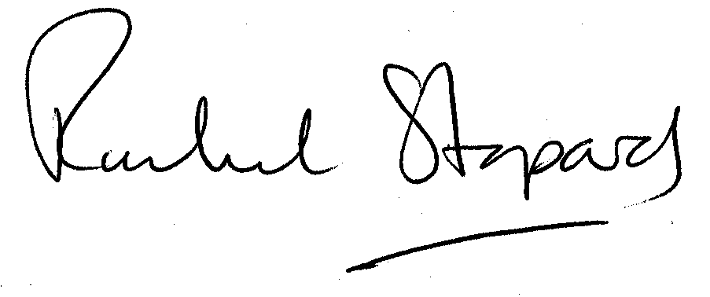
Rachel Stopard
Director of Culture & Environment

It’s easy to make, pay for, track and comment on planning applications on line. Just go to www.camden.gov.uk/planning.
It is important to us to find out what our customers think about the service we provide. To help us in this respect, we would be very grateful if you could take a few moments to complete our online survey at the following website address: www.camden.gov.uk/dmfeedback. We will use the information you give us to help improve our services.

