
Regeneration and Planning
Development Management
London Borough of Camden
Town Hall
Judd Street
London
WC1H 8ND

Tel 020 7974 4444
Fax 020 7974 1930
Textlink 020 7974 6866

planning@camden.gov.uk
www.camden.gov.uk/planning
Meridian Architectural LLP
29 Samwell Way
Northampton
Northamptonshire
NN4 9QJ
29 Samwell Way  Northampton  Northamptonshire  NN4 9QJ |  | Application Ref: 2013/0482/C
 |  | Please ask for: Rachel Miller
 |  | Telephone: 020 7974 1343
 |  | 25 March 2013

Dear Sir/Madam

DECISION

Planning (Listed Building and Conservation Areas) Act 1990
Planning (Listed Buildings and Conservation Areas) Regulations 1990

Councils Own Conservation Area Consent Granted

Address:
Fleet Primary School
Fleet Road
London
NW3 2QT

Proposal:
Demolition of existing building.

Drawing Nos: M-1302/P/04 and M-1302/P/05

The Council has considered your application and decided to grant conservation area consent subject to the following condition(s):

Conditions and Reasons:

1 | The works hereby permitted shall be begun not later than the end of three years from the date of this consent.  Reason: In order to comply with the provisions of Section 18 of the Planning (Listed Buildings and Conservation Areas) Act 1990.
2 | The demolition hereby permitted shall not be undertaken before a contract for the carrying out of the works of redevelopment of the site has been made and full planning permission has been granted for the redevelopment for which the contract provides.  Reason: To protect the visual amenity of the area in accordance with the requirements of policy CS14 of the London Borough of Camden Local Development Framework Core Strategy and policy DP25 of the London Borough of Camden Local Development Framework Development Policies.

Informative(s):

Reasons for granting conservation area consent.

The proposed development is in general accordance with the London Borough of Camden Local Development Framework Core Strategy, with particular regard to policy CS14 (Promoting high quality places and conserving our heritage) and the London Borough of Camden Local Development Framework Development Policies, with particular regard to policy DP25 (Conserving Camden's heritage). Furthermore the proposal accords with the specific policy requirements in respect of the following principle considerations:- The demolition of the existing school building is considered to have no consequence on the character and appearance of the conservation area and accords with policies CS14 and DP25.

Your attention is drawn to the notes attached to this notice which tell you about your Rights of Appeal and other information.

Yours faithfully
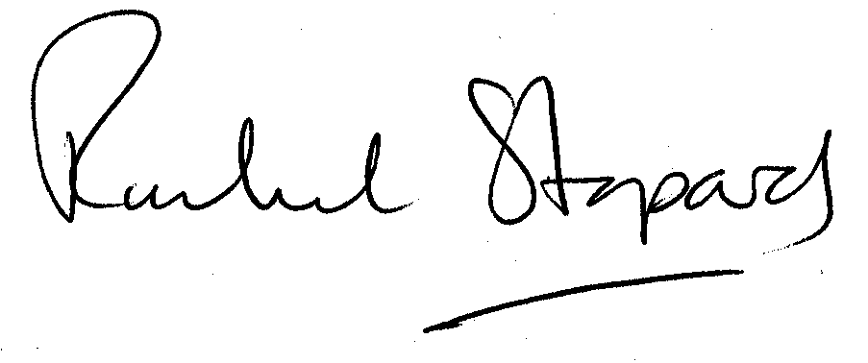
Rachel Stopard
Director of Culture & Environment

It’s easy to make, pay for, track and comment on planning applications on line. Just go to www.camden.gov.uk/planning.
It is important to us to find out what our customers think about the service we provide. To help us in this respect, we would be very grateful if you could take a few moments to complete our online survey at the following website address: www.camden.gov.uk/dmfeedback. We will use the information you give us to help improve our services.

