Our Ref.: JV / 27-TS/ 13KP.
Date: 13th June 2012

DESIGN AND ACCESS STATEMENT
DEVELOPMENT AT: 27 Tottenham Street, London, W1T 4RW.

Re.: Redeveloping the building at 27 Tottenham Street, London, W1T 4RW,
To combine: 1) – Basement Minicab Office and Ground Floor A3 Restaurant.
To create: 2) - Basement and Ground Floor 1- Retail Unit A3 Use.

The project under design is at 27 Tottenham Street, London, W1T 4RW
Developer: Fastlane Productions Ltd.

Location: 27 Tottenham Street, London, W1T 4RW is a four storey building of mixed use – commercial and residential. It is located in the conservation area of Charlotte Street, in the area Camden Council in London.

Brief: The client’s design brief is to redevelop the building to upgrade the quality of construction and accommodation. The existing building incorporates a) Basement – Minicab office; b) ground floor - A3 license restaurant; c) first floor - flat; and d) second and third floor - maisonette.
Access to the existing flat roof is from existing hatch on the landing of the stairwell.
There are no car parking spaces or garage facilities as existing.

Proposal: The proposal is to create a retail Unit at Basement and Ground Floor, providing increased and improved commercial facilities.

The project would be designed and built, after obtaining Planning and Building Control Approval.

The building would be incorporating the following spaces:

Existing Use
Commercial Basement Floor – Minicab office – B1 Use and
Ground Floor – Commercial A3 Restaurant & Amenities.

Proposed Use
Commercial To change of Use to combine: 1) – Basement Minicab Office – B1 Use and Ground Floor A3 Restaurant.
To create: 2) - Basement and Ground Floor - Retail Unit A3 Use.

Parking: There were no car parking spaces or garage provided as existing therefore it would not possible to provide any parking facilities. There are off-street parking spaces available with resident permits facility.

Design Theory:

External Features The main theme of the design is to create a building that would improve the streetscape and reflect the established character of the street.

The façade would be maintained as existing, as it is in the conservation area, and would be upgraded. Where necessary the intension is to make use of similar materials as existing and/or similar to the neighbouring buildings to maintain the streetscape. Changes made at ground floor would be in accordance with the existing environment and/or as required by the local authority. The design of the elevation of the top floors would maintain the existing aesthetic appearance and would be upgraded by the refurbishment.

Refined detailing for the entrance doors to the retail and residential areas would be in the style of the street. The vertical rectangular windows would be kept as existing and where required any changes would be to match existing.

The finishes would be compatible to existing and the colour scheme would complement the surrounding buildings and thus maintaining a pleasant environment.

Design Features

Ground floor frontage has been modified to the minimum maintaining all openings to provide access and light to the commercial unit. The entrance door to the retail unit has been relocated to a more practical position to enable easy access to the commercial unit and the residential accommodation.

The basement area is redesigned to create more open area for easier modification to the user/tenant-leaseholder. The staircase to basement has been relocated and designed internally within the commercial unit. That would be more secure, clean and private for the users. Access to both levels would be from the entrance lobby with glazing to the front door thus providing natural daylight to commercial area.

Glass block / light-providing flooring have been designed on the pavement to provide light to filter natural light in the basement.

Access to building

External Travel: The building can be reached by foot, by car; Public transport is nearby and within a few minutes walking distance.

Approach: The approach to the building is suitable for pedestrians only. There is no ramp or wide access as existing. The existing pavement is wide enough to be used by a wheelchair and would propose disabled access to the commercial retail unit at Ground Floor.

Access: The building as existing has no big steps from the road and /or the pavement. No handrails required. The entrance door to the upper floors would be kept as existing; it would not be possible to provide disable access to the residential accommodation above.

External Entrances: The existing external entrance to the upper storeys is accessible on foot and would continue to be accessed on foot. Provision for wheelchair access is not possible due to lack of space. The existing building does not allow wheelchair access at all levels. It has not been possible to incorporate wheelchair access into this scheme.

Circulation (Internal)

Corridors: All corridors would be level and minimum widths in accordance with building regulations.

Lobbies: The building is fully designed with all required entrance lobbies to meet the standards set by the building regulations 2000 and further amendments incorporating fire requirements.

Internal Doors: Internal doors in the protected escape stairwell have been designed to have half an hour’s fire resistance.
All doors would be fitted in accordance to the Building Regulations Approved Document M and BS 8300.

Sustainability: The design would be based totally on sustainability solutions throughout, from the spaces created to the construction type, detailing, and materials used as required under the current Building Regulations requirements.
The proposed building will incorporate many innovative features designed to achieve an environmentally sustainable building – minimising the impact on the local environment with low energy and running costs.

J.V. Architects.

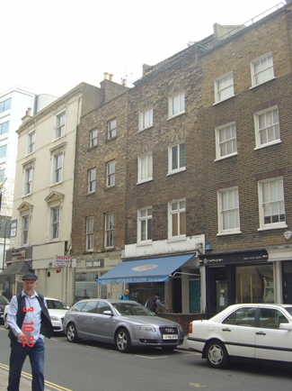

Photo of building showing ground floor retail shop.

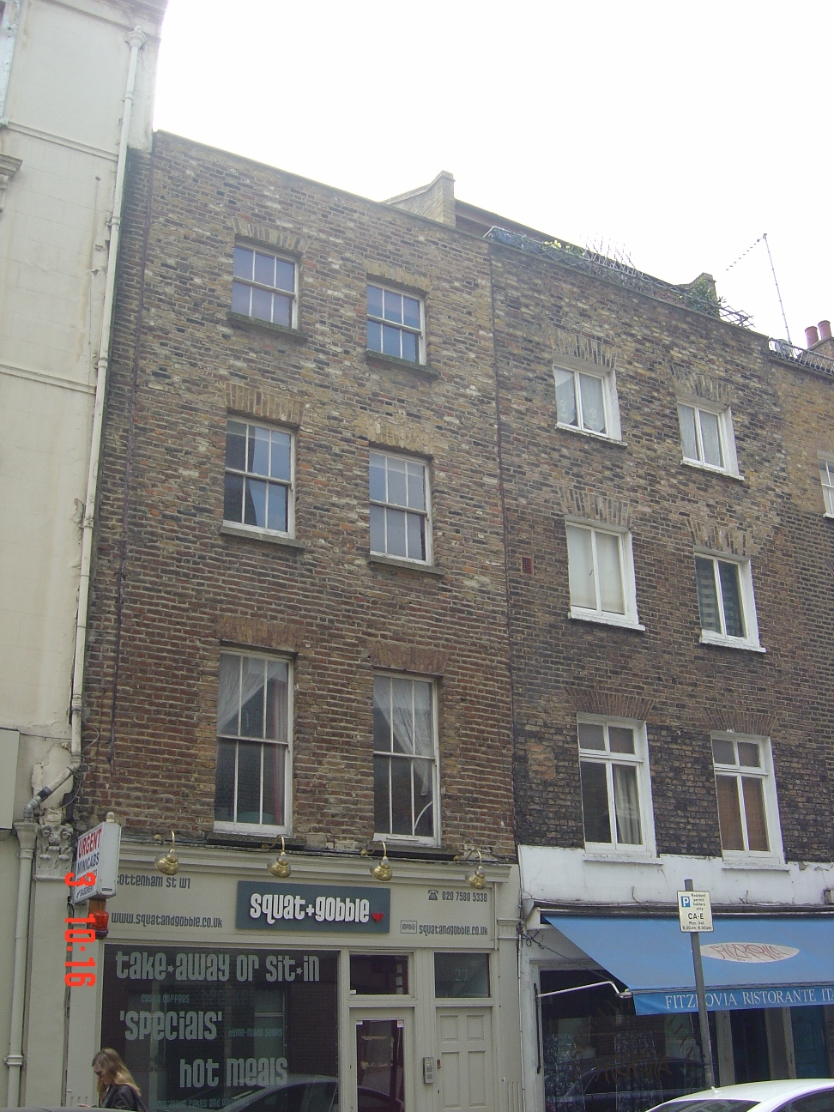

Photo of building facade as existing.

