Reda Iskandar
Scott Brownrigg Architects
77 Endell Street
London
WC2H 9DZ
77 Endell Street  London  WC2H 9DZ |  | Application Ref: 2013/0979/L
 |  | Please ask for: Charles Rose
 |  | Telephone: 020 7974 1971
 |  | 17 April 2013

Dear Sir/Madam

DECISION

Planning (Listed Building and Conservation Areas) Act 1990
Planning (Listed Buildings and Conservation Areas) Regulations 1990

Approval of Details (Listed Building) Granted

Address:
53 Bedford Square
London
WC1B 3DP

Proposal:
Details pursuant to condition 3 (window-finish details) of listed building consent dated 15/10/12 (Ref: 2012/0961/L)for the installation of secondary glazing to existing dwelling house (Class C3)

Drawing Nos: SW/004/06A

The Council has considered your application and decided to grant Approval of Details (Listed Building) subject to the following condition(s):

Informative(s):

You are advised that all conditions in relation to appeal decision ref: APP/X5210/E/12/2175987 (associated listed building consent ref: 2012/0961/L) which require the submission of details, have been discharged.

Your attention is drawn to the notes attached to this notice which tell you about your Rights of Appeal and other information.

Yours faithfully
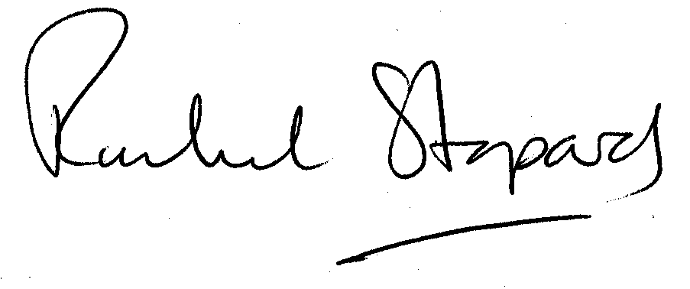
Rachel Stopard
Director of Culture & Environment

It’s easy to make, pay for, track and comment on planning applications on line. Just go to www.camden.gov.uk/planning.
It is important to us to find out what our customers think about the service we provide. To help us in this respect, we would be very grateful if you could take a few moments to complete our online survey at the following website address: www.camden.gov.uk/dmfeedback. We will use the information you give us to help improve our services.

