
Date: 30/05/2013
Your Refs: APP/X5210/A/13/2194368
Our Refs: 2012/6510/P
Contact: Neil Quinn
Direct Line: 020 7974 1908
neil.quinn@camden.gov.uk

Lionel Hutt
The Planning Inspectorate
3/10a Wing
Temple Quay House
2 The Square
Temple Quay
Bristol BS1 6PN

Dear Mr Hutt,

Town and Country Planning Act 1990
Appeal by Mr Libor Krejci
Site at Belvard Point, 17 Murray Street , London NW1 9RE

Summary
The appeal relates to a building on a prominent triangular plot within the Camden Square conservation area. It comprises three stories with basement. It is used as offices with 6 flats on the upper floors. It is known as ‘Belvard Point’.,and can be viewed from many aspects.

Planning permission was refused on 04/02/2013 for an extension consisting of mansard roof to form an additional 1x 3-bedroom flat. It was refused on grounds that the proposed extension, by virtue of its bulk, scale, form and massing would be harmful to the appearance of the building, to the streetscape in this part of Murray Mews and Murray Street and would fail to preserve and enhance the character and appearance of the Camden Square Conservation Area.

The Council’s case is largely set out in the officer’s report, a copy of which was sent with the questionnaire. In addition to this information, I would ask the Inspector to into account the following comments.

Status of Policies and Guidance
The London Borough of Camden Local Development Framework was formally adopted on the 8th November 2010. The policies of relevance to the appeal scheme are set out in the delegated report and decision notice. The full text of the relevant policies was sent with the questionnaire documents.

The Council also refers to supporting guidance documents GPG1: Design. The Camden Planning Guidance has been subject to public consultation and was approved by the Council in December 2011.

With reference to the National Planning Policy Framework 2012, policies and guidance contained within Camden’s LDF 2010 are up to date and fully accord with paragraphs 214 – 216 (Annex 1) of the NPPF and should therefore be given full weight in the decision of this appeal. The National Planning Policy Framework was adopted in April 2012 and states that development should be refused if the proposed development conflicts with the local plan unless other material considerations indicate otherwise. There are no material differences between the council’s policies and the NPPF in relation to this appeal

Comments on appellants’ grounds of appeal
The Appellant’s grounds for appeal focus on how the proposed roof extension would enhance the character and appearance of this part of the Camden Square Conservation Area, and that the proposal has received the support of the local conservation area group and residents in the local area.

It is considered that the Council’s delegated report, submitted with the questionnaire, provides sufficient detail on how the extension would harm the host building and wider conservation area. In particular the report draws on the comments of the previous Inspector’s appeal decision in February 2010, when a similar roof extension to the property was dismissed at appeal (ref. APP/X5210/A/09/2111273). .

In addition the Inspector’s attention is drawn briefly to the aerial and ‘street-view’ images below, which are considered to highlight the prominence of the existing building within this part of the conservation area, particularly from the adjoining railway line and the junction of Murray Street, Agar Grove and St Augustine’s Road to the south.
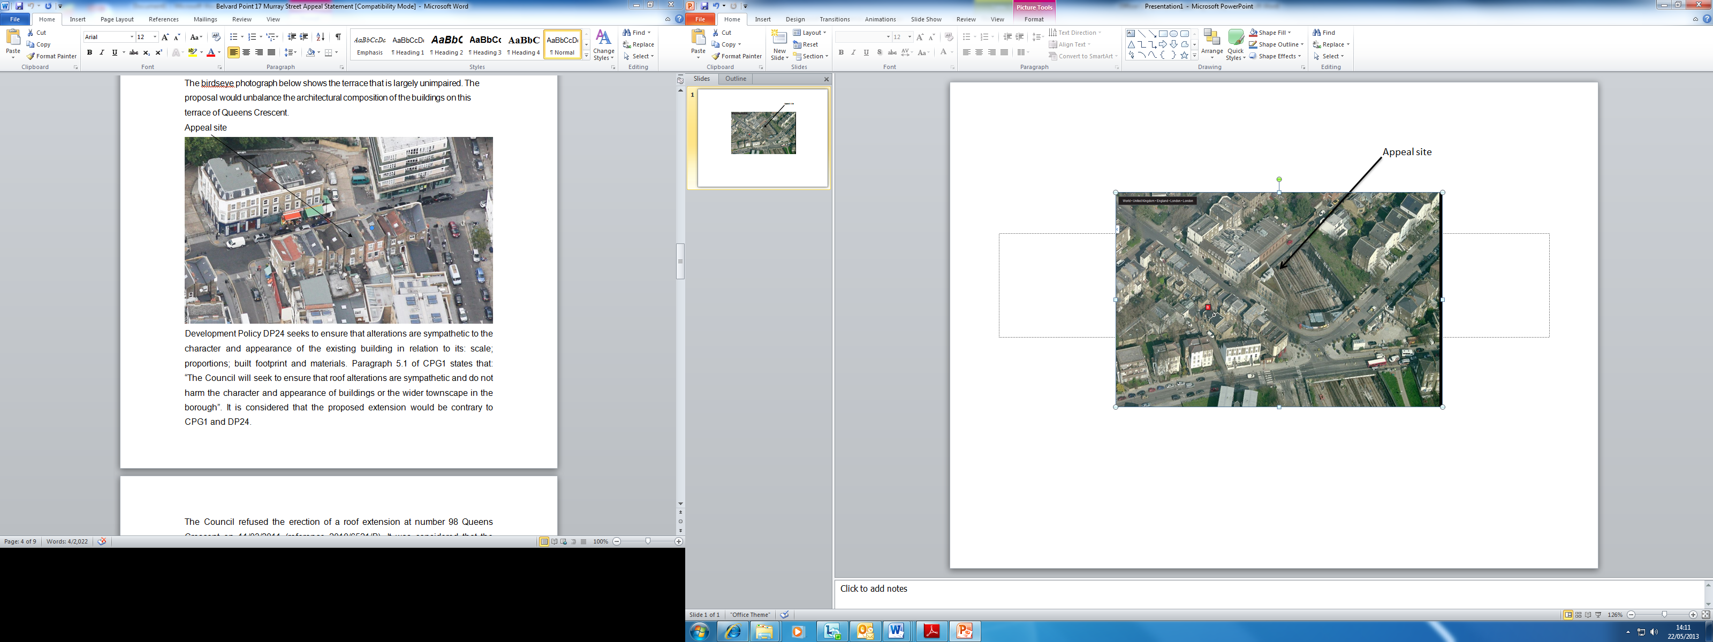
Fig. 1: ‘Birds-eye’ view of appeal site in context with surrounding area
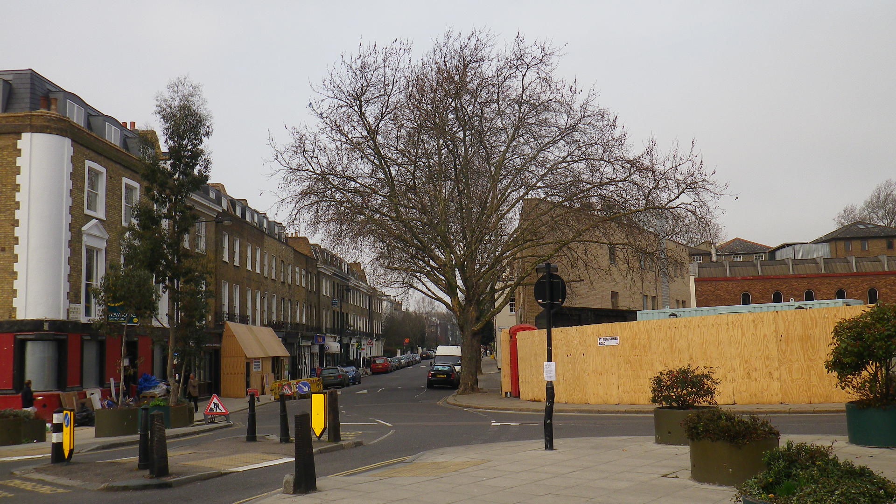
Fig. 2: View from junction of Murray Street and Agar Grove

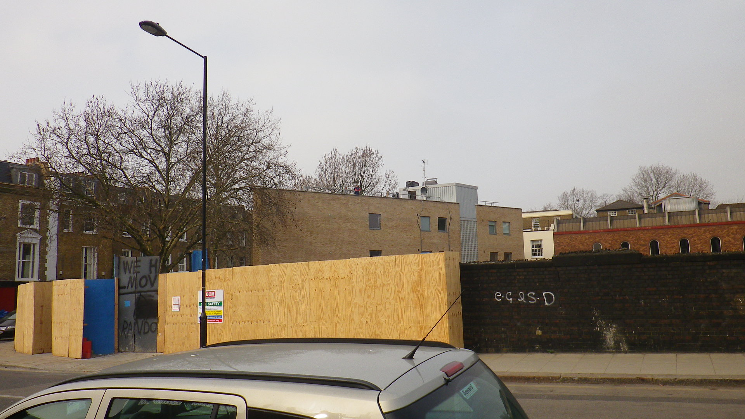
Fig. 3: View from railway bridge on Agar Grove (looking north-west)
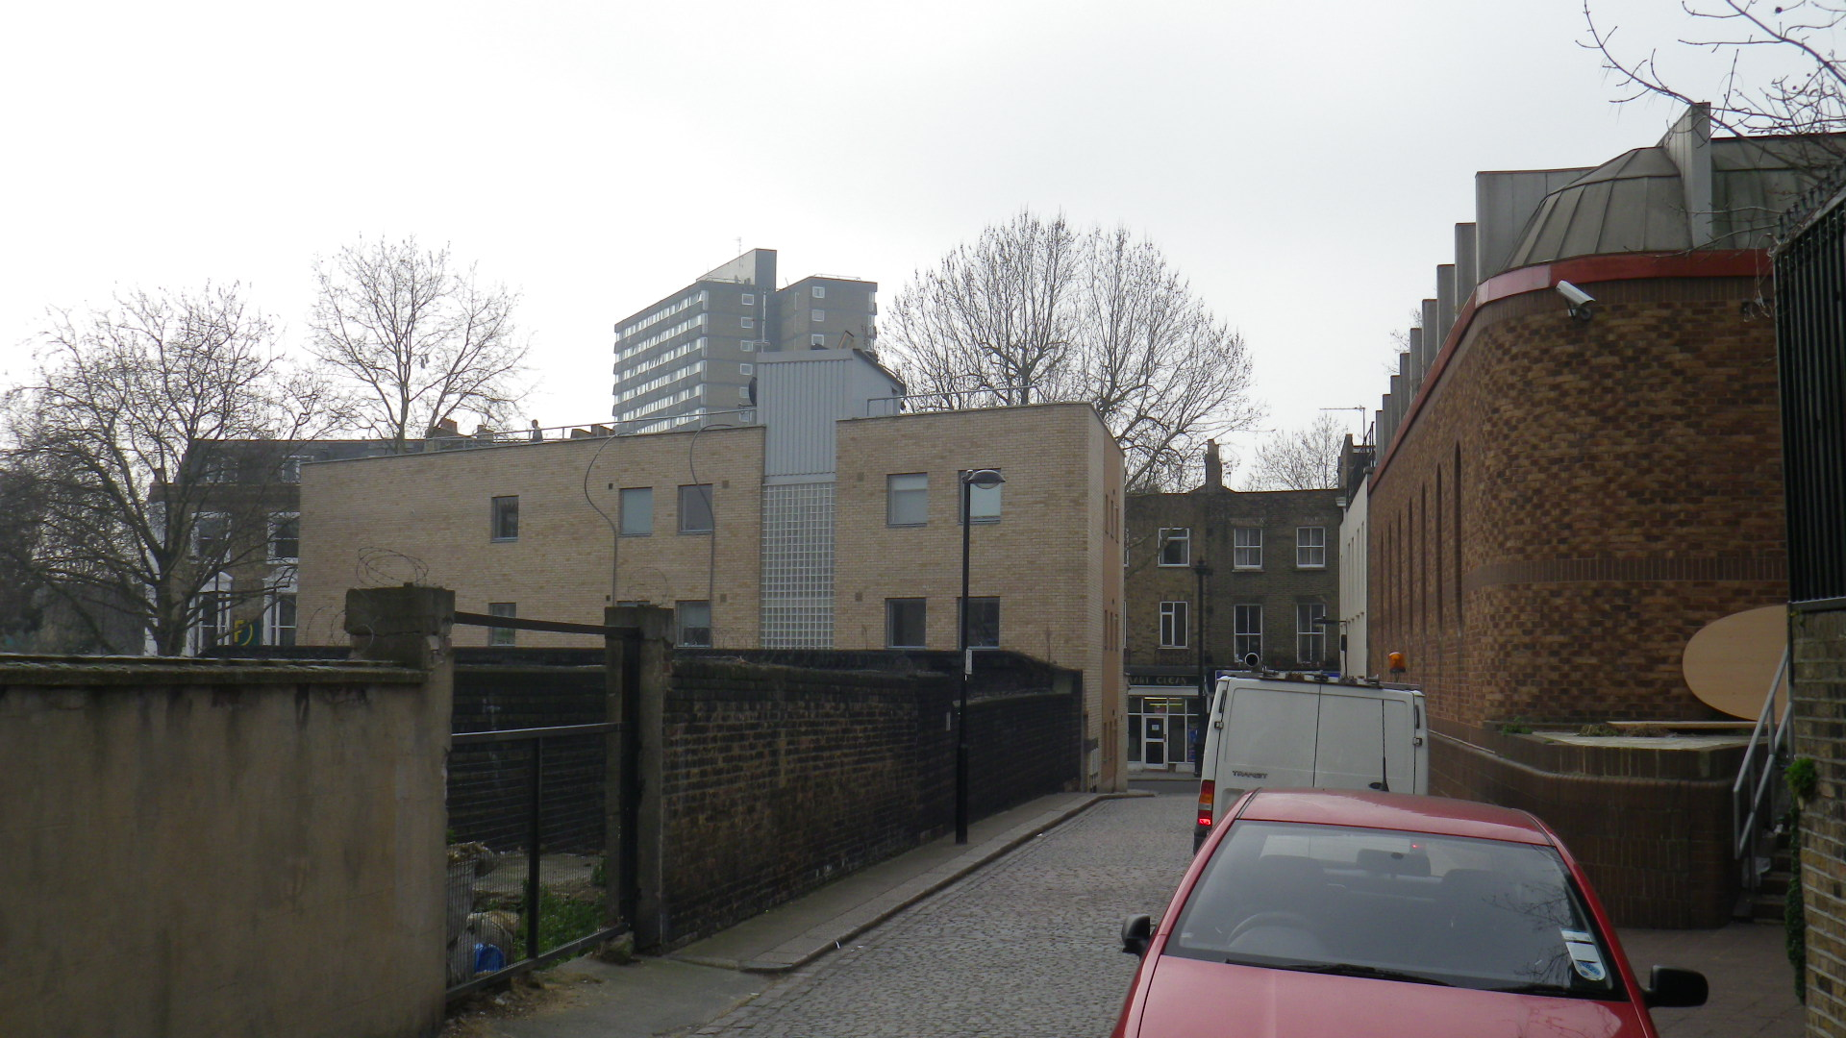
Fig. 4: View from Murray Mews (looking south-west)

Development Policy DP24 seeks to ensure that alterations are sympathetic to the character and appearance of the existing building in relation to its: scale; proportions; built footprint and materials. Paragraph 5.1 of CPG1 states that: “The Council will seek to ensure that roof alterations are sympathetic and do not harm the character and appearance of buildings or the wider townscape in the borough”. It is considered that the proposed extension would be contrary to CPG1 and DP24.

The Appellant states that the roof extension would enhance the appearance of the building, as well as this part of the Camden Square Conservation Area. The council disagrees. The Camden Square Conservation Area Appraisal and Management Strategy (adopted March 2011) recognises that the corner of St Augustine’s Road and Agar Grove is in need of enhancement, but as outlined in the previous appeal decision and the delegated report previously submitted, this proposal is considered to cause further harm.

The appellant also states that the proposal has the support of the local conservation area group, the Camden Square Conservation Area Advisory Committee (CAAC). The officer report confirms that the CAAC raised no objections to the proposal, as well as giving the reasons behind this. It is recognised that the views of local resident groups and stakeholders are important in ensuring communities are fully involved in how their local area is shaped, and the Council does take their views fully into consideration.

However, the Council disagrees with the views of the CAAC in this case, and it is important to note that they were consulted as part of the process of adopting the relevant LDF policies under which this application has been refused. They were also fully consulted on the contents of the Camden Square Conservation Area Appraisal and Management Strategy, which also sets out how inappropriate roof extensions such as this can harm the integrity of the conservation area.

In conclusion, the Council maintains that the proposed mansard roof would harm the appearance of the three-storey building, and this part of the Camden Square Conservation Area. It does not meet the highest standards of design required by policies CS14, DP24 and DP25, and fails to meet the adopted guidance set out in CPG1 in relation to roof level alterations.

I ask the Inspector to uphold the Council’s policies, guidance, London Plan policies and the advice contained in NPPF and dismiss this appeal. However, in the event of the appeals being allowed, the Inspector is requested to impose conditions set out in appendix 1 below.

If you would like to discuss this matter further please contact Neil Quinn on DD 020 7974 1908.

Yours sincerely
Neil Quinn
Planning Officer
(East Team)
Appendix 1

1. The development hereby permitted must be begun not later than the end of three years from the date of this permission.

Reason: In order to comply with the provisions of Section 91 of the Town and Country Planning Act 1990 (as amended).

- The development shall be carried out in accordance with the following approved plans: Site Location Plan (1111-000), 1111-001, 1111-002, 1111-003, 1111-004, 1111-005, 1111-100, 1111-101, 1111-102, 1111-103, 1111-104, 1111-105, 1111-106, 1111-107, 1111-108, 1111-900, 1111-901, 1111-902, 1111-903, 1111-904, 1111-905, 1111-906, Design and Access Statement dated Dec 2012.

Reason: For the avoidance of doubt and in the interest of proper planning.

3. All new external work shall be carried out in materials that resemble, as closely as possible, in colour and texture those of the existing building, unless otherwise specified in the approved application.

Reason: To safeguard the appearance of the premises and the character of the immediate area in accordance with the requirements of policy CS14 of the London Borough of Camden Local Development Framework Core Strategy and policy DP24 of the London Borough of Camden Local Development Framework Development Policies.

4. The applicant shall endeavour to provide all reasonable lifetime homes features prior to the first occupation of the new self-contained residential unit and shall maintain and retained such features permanently thereafter.

Reason: To ensure that the internal layout of the building is acceptable with regards to accessibility by future occupiers and their changing needs over time, in accordance with the requirements of policy CS6 of the London Borough of Camden Local Development Framework Core Strategy and policy DP6 of the London Borough of Camden Local Development Framework Development Policies.

- Notwithstanding the submitted details, detailed drawings, and/or samples of roof tiles, brickwork and windows to be used on the external surfaces of the proposed mansard roof extension, shall be submitted to and approved in writing by the Council before the relevant part of the work is begun.

Reason: To safeguard the appearance of the premises and the character of the immediate area in accordance with the requirements of policy CS14 of the London Borough of Camden Local Development Framework Core Strategy and policy DP24 of the London Borough of Camden Local Development Framework Development Policies.

