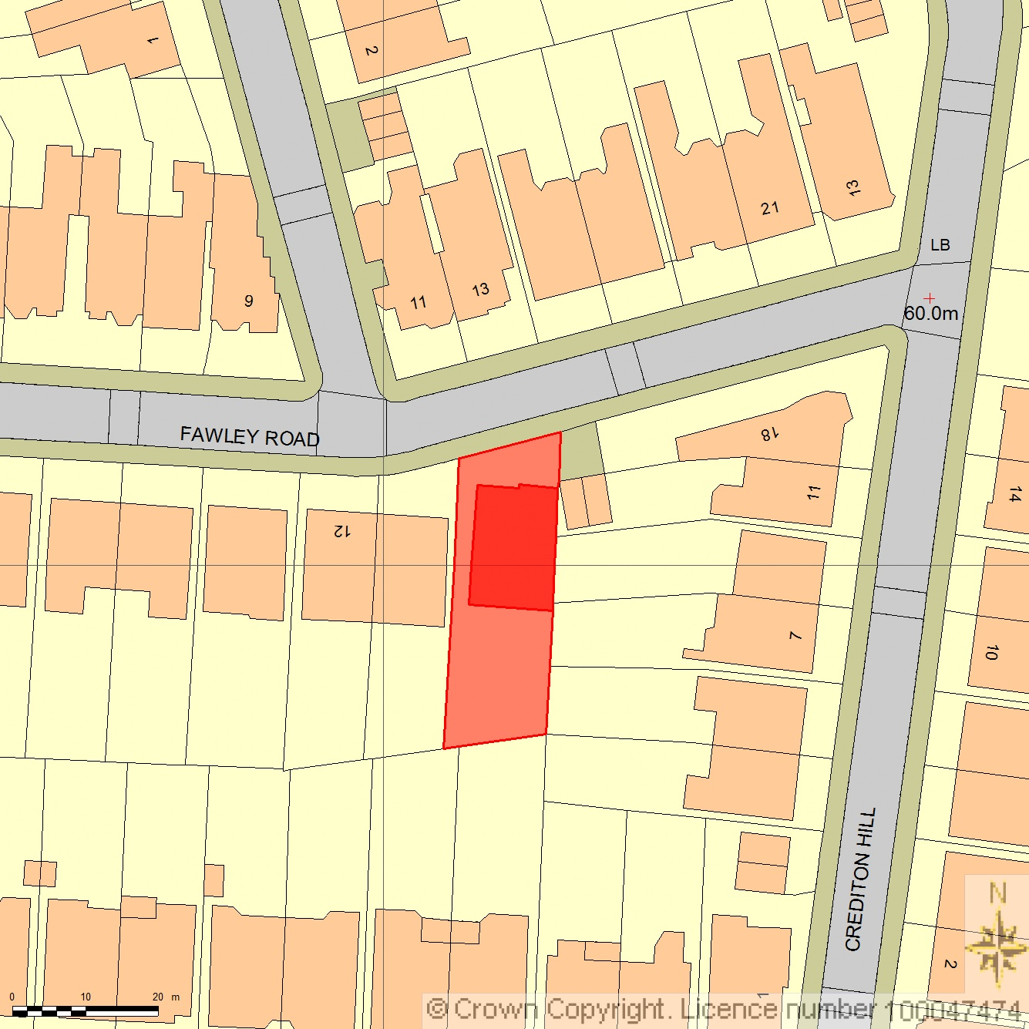
SITE LOCATION PLAN – 09 – 16 Fawley Rd
AREA 2 HA
SCALE 1:1250

CENTRE COORDINATES: 525618, 185007



Supplied by Streetwise Maps Ltd
www.streetwise.net
Licence No: 100047474
30/07/2026 22:05

