DESIGN & ACCESS STATEMENT

SITE ADDRESS: 86 Heath Street, London, NW3 1DP

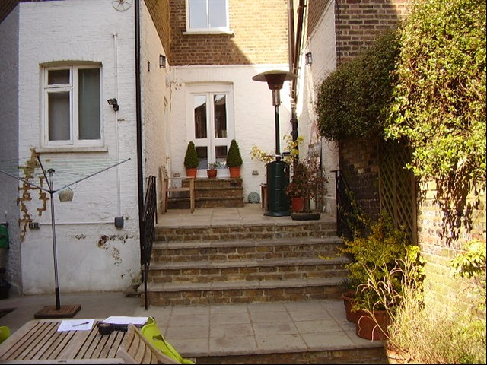Proposal Outline:: Anglian Home Improvements have been contracted to erect a Timber Conservatory to the rear of the property. Our client has chosen a conservatory to meet their personal requirements whilst being considerate to neighbouring properties and council guidelines.

Design Principles: Our client has chosen a sage green timber framed Conservatory. The design of this is predominantly a Timber framed unit and double glazed sealed units

Due consideration has been given to the overall look and size of the unit to give the most
aesthetically pleasing look and giving consideration to privacy without being overbearing.

Size of proposal: The proposed unit size will only project 4.4m and have a width projection of 2.7m

Access: Access to the conservatory can be accessed through internal doors

Landscaping: Our proposal will not require the alteration of the rear garden in any form, we will not be required to remove or cut back any hedges or trees on the site. Our proposal will not affect the amenities of the site or the surrounding area and will go hardly noticed

