Mr Almas Bavcic
Ad Design Concepts
25 Grampian Gardens
London
NW2 1JH
25 Grampian Gardens  London  NW2 1JH |  | Application Ref: 2013/2999/P
 |  | Please ask for: Angela Ryan
 |  | Telephone: 020 7974 3236
 |  | 5 July 2013

Dear Sir/Madam

DECISION

Town and Country Planning Act 1990 (as amended)
Town and Country Planning (Development Management Procedure) Order 2010
Town and Country Planning (Applications) Regulations 1988

Approval of Details Granted

Address:
Merton House
Merton Lane
London
N6 6NA

Proposal:
Details pursuant to condition 3 (hard and soft landscaping and means of enclosure of all un-built, open areas) of planning permission dated 07/09/2010 (Ref: 2010/2460/P) for excavation to create basement floor level, including provision of garage and associated ramped drive; remodelling of rear (north) elevation at ground floor level to provide additional residential accommodation, including erection of new single storey extension on side (east) elevation with glazed link to main house.
Drawing Nos: 93-014, Construction sequence and method statement by Rodrigues Associates dated 06/05/2013

The Council has considered your application and decided to grant permission subject to the following condition(s):

Informative(s):

You are reminded that conditions 5- (Tree protection details); 7- (Details of green roof) and 9- (Final design and construction of basement) of planning permission granted on 7th September 2010 (Ref: 2010/2460/P) are outstanding and require details to be submitted and approved.

In dealing with the application, the Council has sought to work with the applicant in a positive and proactive way in accordance with paragraphs 186 and 187 of the National Planning Policy Framework.

Your attention is drawn to the notes attached to this notice which tell you about your Rights of Appeal and other information.

Yours faithfully
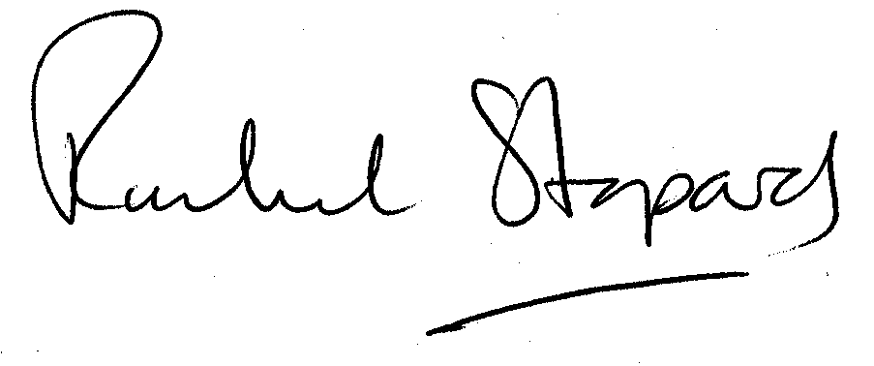
Rachel Stopard
Director of Culture & Environment

It’s easy to make, pay for, track and comment on planning applications on line. Just go to www.camden.gov.uk/planning.
It is important to us to find out what our customers think about the service we provide. To help us in this respect, we would be very grateful if you could take a few moments to complete our online survey at the following website address: www.camden.gov.uk/dmfeedback. We will use the information you give us to help improve our services.

