Mr Mark Pender
PPM Planning Limited
185 Casewick Road
West Norwwod
London
SE27 0TA
185 Casewick Road  West Norwwod  London  SE27 0TA |  | Application Ref: 2013/2537/P
 |  | Please ask for: Seonaid Carr
 |  | Telephone: 020 7974 2766
 |  | 9 July 2013

Dear Sir/Madam

DECISION

Town and Country Planning Act 1990 (as amended)
Town and Country Planning (Development Management Procedure) Order 2010
Town and Country Planning (Applications) Regulations 1988

Householder Application Granted

Address:
1B Gondar Gardens
London
NW6 1EW

Proposal:
Enlargement of basement and lightwell to provide additional residential floor space for single dwelling house and alteration to the rear doors at ground floor level (Class C3)(Retrospective).

Drawing Nos: 08_03_(U2)Sk004, 08_03_(U2)Sk005, pp 01 Rev D, Le_002 Rev B, sp 01 Rev C, Unit 2 - Basement Impact Assessment by Crete Consulting Engineers Ltd dated April 2013

Informative(s):

Your proposals may be subject to control under the Building Regulations and/or the London Buildings Acts which cover aspects including fire and emergency escape, access and facilities for people with disabilities and sound insulation between dwellings. You are advised to consult the Council's Building Control Service, Camden Town Hall, Argyle Street WC1H 8EQ, (tel: 020-7974 6941).

In dealing with the application, the Council has sought to work with the applicant in a positive and proactive way in accordance with paragraphs 186 and 187 of the National Planning Policy Framework.

Your attention is drawn to the notes attached to this notice which tell you about your Rights of Appeal and other information.

Yours faithfully
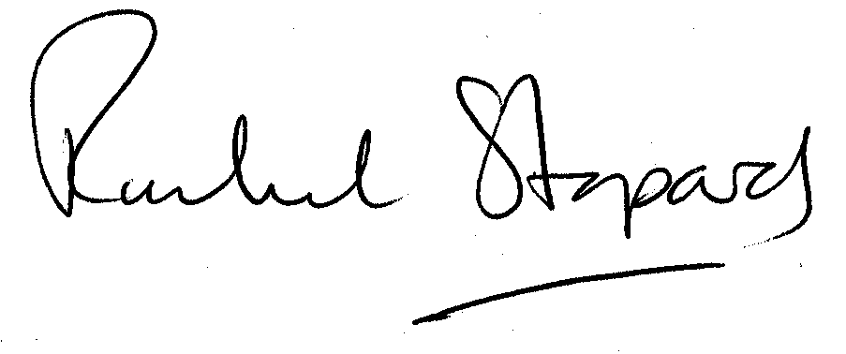
Rachel Stopard
Director of Culture & Environment

It’s easy to make, pay for, track and comment on planning applications on line. Just go to www.camden.gov.uk/planning.
It is important to us to find out what our customers think about the service we provide. To help us in this respect, we would be very grateful if you could take a few moments to complete our online survey at the following website address: www.camden.gov.uk/dmfeedback. We will use the information you give us to help improve our services.

