Mr Matthew Roe
CGMS Limited
7th Floor
140 London Wall
London
EC2Y 5DN
7th Floor  140 London Wall  London  EC2Y 5DN |  | Application Ref: 2012/6400/P
 |  | Please ask for: Amanda Peck
 |  | Telephone: 020 7974 5885
 |  | 20 December 2012

Dear Sir/Madam

DECISION

Town and Country Planning Act 1990 (as amended)

Grant of Non Material Amendments to planning permission

Address:
11-13 St Pancras Way
London
NW1 0PT

Proposal: Non-material amendment to planning permission dated 22/09/11 (Ref: 2011/1586/P for the erection of part 6, 7, 8 and 10 storey building comprising 3,877sqm builders merchant (Class Sui Generis) at ground and part mezzanine level and 563 student bedspaces (Class Sui Generis) with ancillary student facilities to the upper floors), namely with a reduction in size of the building footprint, alterations to internal layout including location of cycle stores, increase in height of the 3 storey element of block A, infilling of surplus space at the podium level and the inclusion of lift overruns.

Drawing Nos: Superseded Drawings:0500_102D; -103E; -104D; -105D; -106D; -107D; -108D; - 109D; -110C; -111C; -112D; -220C; -221C; -222C; -223D; -300A.

Approved Drawings: DM/WR/A0/PL-SKT82; DM/WR/A1/PL101B; -PL102; -PL103; -PL104; -PL105; -PL106; -PL107; -PL107; -PL108; -PL109; -PL110; -PL111; -PL112; -PL300; -PL301; -PL302; -PL303; -PL204.

The Council has considered your application and confirms that the proposals are acceptable as non-material amendments to the planning permission set out above.

Informative(s):

You are advised that this permission relates only to the changes highlighted on the plans and set out in the description and shall only be read in the context of the substantive permission granted on 22/09/2011 under reference number 2011/1586/P] and is bound by all the conditions and obligations attached to that permission.

You are advised that condition 17 refers to drawings showing the location of the previously approved cycle storage areas and requires their provision prior to occupation. As the location of the cycle storage areas is being changed an application to amend condition 17 will need to be submitted.

In dealing with the application, the Council has sought to work with the applicant in a positive and proactive way in accordance with paragraphs 186 and 187 of the National Planning Policy Framework.

Yours faithfully
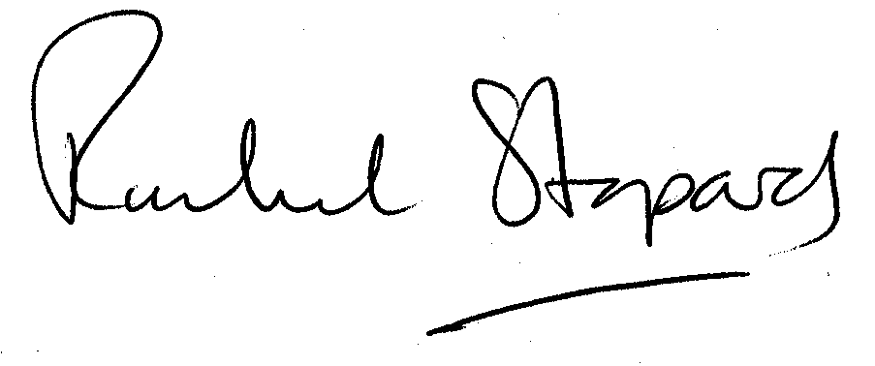
Rachel Stopard
Director of Culture & Environment

It’s easy to make, pay for, track and comment on planning applications on line. Just go to www.camden.gov.uk/planning.

