Ground and Basement flat 50 Maple Street

London W1T 6HJ

Lifetime Homes Statement

July 2013

1. Introduction

The purpose of this document is to comply with the requirements upon submitting a planning application for a new dwelling in London’s Camden council.

This document will outline the Lifetime Homes standards that should be met in proposing a new dwelling in the London borough of Camden.

The proposal illustrated at the end of this document should fully comply with the 16 specified criteria required to qualify for Lifetime Homes.

**Criterion 1 – Car Parking Width**

There is no off street car parking space provided with this property, all parking is on the road perpendicular to Maple Street and requires a Camden parking permit.

**Criterion 2 – Approach to dwelling from parking**

This condition will also mirror the previous criterion as there is no off street parking allocated to this property.

**Criterion 3 – Approach to all entrances**

The approach to the flats is a shared access route with one step being mounted before the main communal door is reached. This is on street level and is part of the street façade which cannot be altered.

**Criterion 4 – Entrances**

The communal entrance door to both flats is 828mm wide and the upstand at the change of threshold for this door will be to a limit of 15mm. This will allow easy manoeuvrability over the threshold into the property. A clear space nib of greater than 300mm on the pull side of the main communal door is available.

**Criterion 5 – communal stairs and lifts**

There are no lifts planned in this design and the stairs are used only for the basement flat occupiers which will meet the required lifetime homes regulations. The rise of each step is set at 170mm and the goings are set at 269mm. All handrails are extended 300mm beyond the top and bottom step of each flight at a height of 900mm from the step noses. A sectional image of the flight is displayed below:

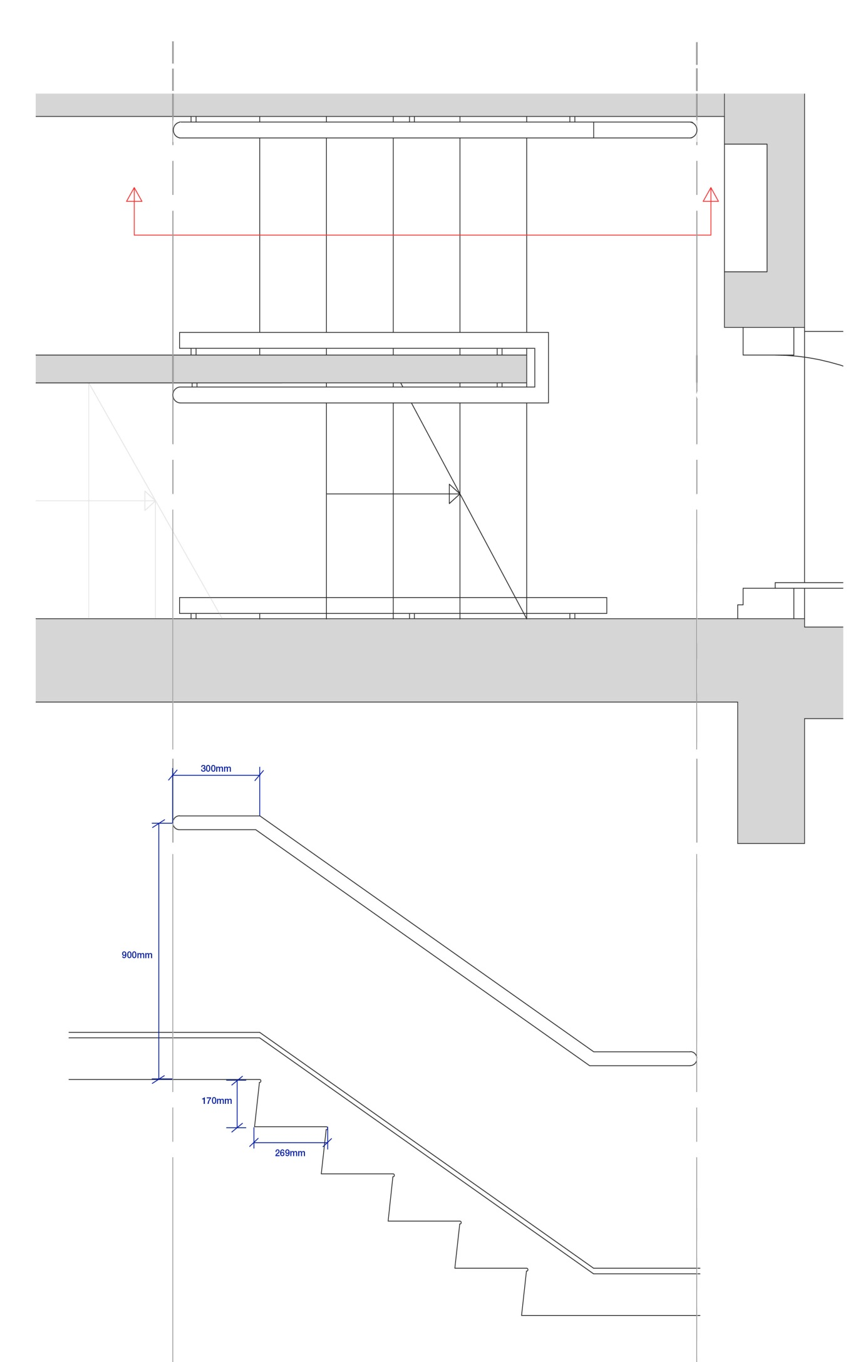

**Criterion 6 – Internal doorways and hallways**

All internal doorways and doors are to a minimum of 775mm wide, all communal doors and doorways are at a measurement of 900mm. The one communal hallway in the property measures at 1200mm wide. All internal hallways are at a minimum of 900mm wide.

The nibs of all entrance doors are 300mm to the handle side, this includes the communal entrance door which has a much longer nib.

**Criterion 7 – Circulation space**

The turning circle for a wheelchair user of diameter 1500mm is very possible in both the dining/kitchen area and in both bedrooms as indicated in the revised proposal plan drawings.

**Criterion 8 – entrance and level living space**

There is provided in both dwellings entry level living/dining space for seating and socialising.

**Criterion 9 – entrance level bed space**

As each dwelling is arranged over a single storey only there is sufficient entrance level bed space provided by the bedrooms and also in the living space also on the same level.

**Criterion 10 – entrance level WC and shower drainage**

Both dwellings will be equipped with entrance level shower rooms which includes a WC.

**Criterion 11 - WC and bathroom walls**

The bathrooms in each dwelling are readily available with space on every wall for accommodating grab rails to support independent use of the facilities.

**Criterion 12 - Stairs and potential through-floor lift in dwellings**

The requirement for a through-floor lift or a stair lift will apply to either dwellings as they are set over single stories only.

**Criterion 13 - Potential for fitting of hoists and bedroom / bathroom relationship**

The strength of all ceilings throughout the dwellings will withstand any additional means for support if hoists are needed to transport to someone from their bed to the bathroom. Both bathrooms in the two dwellings are accessible through the internal hallway and also share neighbouring walls with the bedrooms.

**Criterion 14 – Bathrooms**

Both bathrooms conform with the bathroom standard space needed around the toilet bowl and for the circulation turning circle around the shower drainage point.

**Criterion 15 – Glazing and window handle heights**

All external windows begin at a height of 700mm from the ground and are largely spanning to the ceiling at a minimum height of 1500mm. This is a height that will allow easy viewing out when seated in either the lounge or dining area.

**Criterion 16 – Location of service controls**

Throughout the interior of both dwellings the location of any service points will be within the required specification of 450mm from the floor up until 1200mm and 300mm from any internal corridor. This will include all electrical switches and sockets, central heating thermostat programming points, radiator temperature valves, and mains water stop taps.