Mr Ian Hu
SSR
The Rotunda
42 - 43 Gloucester Crescent
London
NW1 7DL
Application Ref: 2013/3337/P
Please ask for: Christopher Heather
Telephone: 020 7974 1344
15 August 2013

Dear Sir/Madam

DECISION

Town and Country Planning Act 1990 (as amended)
Town and Country Planning (Development Management Procedure) Order 2010
Town and Country Planning (Applications) Regulations 1988

Full Planning Permission Granted

Address:
The Rotunda
42-43 Gloucester Crescent
London
NW1 7DL

Proposal:
Change of use from offices (Class B1a) to a flexible use of B1a and D1 (non-residential institution) at lower ground floor level (retrospective)
Drawing Nos: Site location plan; Lower ground floor; Proposed floor plan; 'As proposed' floor plan.

The Council has considered your application and decided to grant permission subject to the following condition(s):

Condition(s) and Reason(s):

1 | The development hereby permitted must be begun not later than the end of three years from the date of this permission.  Reason: In order to comply with the provisions of Section 91 of the Town and Country Planning Act 1990 (as amended).
2 | The development hereby permitted shall be carried out in accordance with the following approved plans:  Site location plan; Lower ground floor; Proposed floor plan; 'As proposed' floor plan.  Reason: For the avoidance of doubt and in the interest of proper planning.
3 | Notwithstanding the provisions of Class D1 of the Schedule of the Town and Country Planning (Use Classes) Order, 1987, or any provision equivalent to that Class in any statutory instrument revoking and re-enacting that Order, when not in use as B1 the premises shall only be used as a private training company and commercial recording studio.  Reason: To ensure that the future occupation of the building does not adversely affect the adjoining premises in terms of noise and transportation in accordance with policies CS5 and DP16 of the London Borough of Camden Local Development Framework Core Strategy and policies DP26 and DP28 of the London Borough of Camden Local Development Framework Development Policies.

Informative(s):

Your proposals may be subject to control under the Building Regulations and/or the London Buildings Acts which cover aspects including fire and emergency escape, access and facilities for people with disabilities and sound insulation between dwellings. You are advised to consult the Council's Building Control Service, Camden Town Hall, Argyle Street WC1H 8EQ, (tel: 020-7974 6941).

Noise from demolition and construction works is subject to control under the Control of Pollution Act 1974. You must carry out any building works that can be heard at the boundary of the site only between 08.00 and 18.00 hours Monday to Friday and 08.00 to 13.00 on Saturday and not at all on Sundays and Public Holidays. You are advised to consult the Council's Compliance and Enforcement team [Regulatory Services], Camden Town Hall, Argyle Street, WC1H 8EQ (Tel. No. 020 7974 4444 or on the website http://www.camden.gov.uk/ccm/content/contacts/council-contacts/environment/contact-the-environmental-health-team.en or seek prior approval under Section 61 of the Act if you anticipate any difficulty in carrying out construction other than within the hours stated above.

In dealing with the application, the Council has sought to work with the applicant in a positive and proactive way in accordance with paragraphs 186 and 187 of the National Planning Policy Framework.

Your attention is drawn to the notes attached to this notice which tell you about your Rights of Appeal and other information.

Yours faithfully
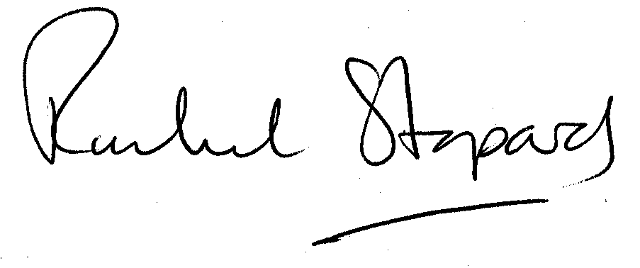
Rachel Stopard
Director of Culture & Environment

It’s easy to make, pay for, track and comment on planning applications on line. Just go to www.camden.gov.uk/planning.
It is important to us to find out what our customers think about the service we provide. To help us in this respect, we would be very grateful if you could take a few moments to complete our online planning applicants’ survey. We will use the information you give us to monitor and improve our services.

