List Entry Summary
This building is listed under the Planning (Listed Buildings and Conservation Areas) Act 1990 as amended for its special architectural or historic interest.

Name: No name for this Entry

List Entry Number: 1329905

Location
1-15, PRINCE ALBERT ROAD
The building may lie within the boundary of more than one authority.
County: Greater London Authority
District: Camden
District Type: London Borough
Parish:

National Park: Not applicable to this List entry.

Grade: II

Date first listed: 14-May-1974

Date of most recent amendment: 11-Jan-1999

Legacy System Information
The contents of this record have been generated from a legacy data system.

Legacy System: LBS

UID: 477800

Asset Groupings
This List entry does not comprise part of an Asset Grouping. Asset Groupings are not part of the official record but are added later for information.

List Entry Description

Summary of Building
Legacy Record - This information may be included in the List Entry Details.

Reasons for Designation
Legacy Record - This information may be included in the List Entry Details.

History
Legacy Record - This information may be included in the List Entry Details.

Details
CAMDEN
TQ2883NW PRINCE ALBERT ROAD
798-1/75/1339 (North side)
14/05/74 Nos.1-15 (Consecutive)
(Formerly Listed as:
PRINCE ALBERT ROAD
Nos.1-8 AND 10-15 (Consecutive))
GV II
Street of 15 related detached and semi-detached villas. Mid
C19. Probably built by J Guerrier and P Pearse. Stucco.
EXTERIOR: No.1: double fronted with 3 windows; 3 storeys and
basement. Currently being converted to 2 dwellings. Tall slab
chimney-stacks on return walls.
No.2: double fronted with 3 windows; 3 storeys and basement.
Portico with console bracketed cornice continuing around the
house at 1st floor level. Doorway with fanlight and panelled
door with narrow side lights. Tripartite sashes to ground
floor with margin glazing. 1st floor, round-arched architraved
sashes with margin glazing and keystones. 2nd floor,
architraved sashes with continuous sill band. Projecting
bracketed eaves. Tall slab chimney-stacks on return walls.
Left hand return with canted bay windows to ground and 1st
floor.
No.3: similar to No.2 but porch with plain band continuing
around the house. 1st floor, architraved sashes with margin
glazing and cornices. Canted bay windows on right hand return.
No.4: 5 windows, 3 storeys and basement; originally double
fronted with 3 windows but 2-window extension on east side, of
studio with bedrooms over, designed by Sir Edward Maufe in
1913 for the artist AE Maude. Asymmetrically placed Doric
portico; entablature continuing around the house at 1st floor
level supported by Doric pilasters. Doorway with fanlight and
panelled door. Tripartite sashes with margin glazing flanking
the porch; to right, paired transom and mullion windows with
margin lights. 1st floor, round-arched architraved sashes with
bands and keystones and margin glazing. 3rd floor, recessed
sashes with guttae sill string. Slated hipped roof with
projecting bracketed eaves and tall slab chimney-stacks on
return walls. Canted bay windows on left hand return.
No.5: double fronted with 3 windows; 3 storeys, attic and
basement. Ionic portico in antis, the entablature continuing
around the house at 1st floor level. Ground floor sashes
architraved and tripartite with margin glazing. 1st floor
architraved sashes with cornices (that above the porch with
floating cornice) and margin glazing. Architraved sashes to
2nd floor. Projecting eaves with dentil cornice; above,
central rectangular dormer with architraved Diocletian window.
Tall slab chimney-stack on right hand return; canted bay
windows on left hand.
Nos 6 & 7: semi-detached pair. Irregular facade of 3 storeys
and attics, 4 windows plus later C19 2-window recessed
entrance extension to west end. No.6 with projecting right
hand entrance bay; round-arched entrance with fanlight and
panelled door. Recessed sashes, 2nd floor in shallow
rectangular recesses. 1st floor casements with cast-iron
balconies. Projecting cornice continuing around the house.
Entrance bay with small pedimented attic having an oculus.
No.7 with projecting right hand bay having canted bay window
with margin glazing to ground floor, upper floors with
tripartite sashes; pediment with Diocletian attic window in
tympanum. Tall slab chimney-stacks.
Nos 8 & 9: semi-detached pair, No.9 rebuilt in facsimile
following war damage and included for group value. 3 storeys
and attics. Symmetrical facade of 4 windows plus 2 storey
single window extension to No.9. Attic dormers in slated
mansard roofs. Outer entrance bays slightly projecting with
segmental-arched porticoes with keystones and parapet.
Square-headed doorways with fanlights and panelled doors.
Corinthian pilasters rising through 1st and 2nd floors
flanking recessed sashes with margin glazing. Houses divided
by paired Corinthian pilasters to either side of which
tripartite sashes; 1st floor with floating cornices; 2nd floor
with sill band continuing across the front of the houses.
Simplified entablature. Extension with 2-light windows having
margin glazing.
Nos 10 & 11: semi-detached pair. Symmetrical facade of 3
storeys and attics, 2 windows each. Attic dormers in slated
mansard roofs. Entrances in central bays, recessed to 2nd
floor level and separated by paired Ionic columns in antis
supporting a simplified entablature with continues around the
building. No.10, round-arched doorway, No.11, square-headed;
both with patterned fanlights and panelled doors. Recessed
sashes with margin glazing above. Slightly projecting outer
bays with pilasters at angles rising to support entablature.
Tripartite sashes; ground floors with pilasters supporting
pediments, upper floors with consoles on mullions. Attic
storey with recessed sashes having margin glazing and
pilasters supporting cornice and parapet. Tall slab
chimney-stacks.
Nos 12 & 13: semi-detached pair. Symmetrical facade of 3
storeys and attics, 2 windows each, plus later single storey
single window extension to No.13. Slightly projecting central
entrance bay with double portico having square-headed doorways
with fanlights and panelled doors. Tripartite sashes with
margin glazing to ground floors. Corinthian pilasters marking
bays rise through 1st and 2nd floors to support simplified
entablature with pediment over central bay and blocking course
over outer bays. Central bay with recessed sashes having
margin glazing to upper floors; outer bays, tripartite sashes,
1st floor with floating cornices. Tall slab chimney-stacks.
Nos 14 & 15: semi-detached pair. Irregular facade of 3 storeys
and attics, 5 windows, plus late C20 single storey single
window extension to No.14. No.14 with Doric portico
(originally with Ionic portico on return) above which recessed
sashes with margin glazing. Projecting pedimented left hand
bay with canted bay window to ground floor having cast-iron
veranda; upper floors with tripartite windows, 1st floor with
cornice and cast-iron balcony extending to entrance bay, 2nd
floor with sill string. Pediment with Diocletian attic window
in tympanum. No.15, projecting left hand entrance bay carried
up an extra storey as a tower. Round-arched entrance with
fanlight and panelled door. Ground and 2nd floor recessed
sashes with margin glazing; 1st floor, casements with
cast-iron balconies. Projecting cornice. Additional tower
storey with paired pilasters at angles and arcaded 2-light
window; simplified entablature and blocking course. Tall slab
chimney-stacks.
INTERIORS: not inspected.
Listing NGR: TQ2845283679

Selected Sources
Legacy Record - This information may be included in the List Entry Details.

Map

National Grid Reference: TQ 28452 83679
The below map is for quick reference purposes only and may not be to scale. For a copy of the full scale map, please see the attached PDF - 1329905.pdf
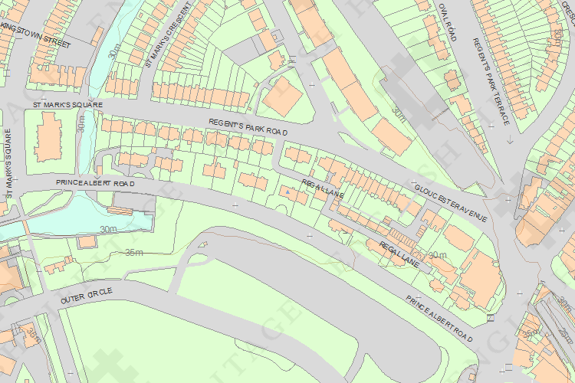
© Crown Copyright and database right 2012. All rights reserved. Ordnance Survey Licence number 100019088.
© British Crown and SeaZone Solutions Limited 2011. All rights reserved. Licence number 102006.006.

This copy shows the entry on 20-Aug-2013 at 10:26:39.

