TECHNICAL REPORT ON A SUBSIDENCE CLAIM

Crawford Reference: SU1302786

Mrs Sima Berger
37 Compayne Gardens
London
NW6 3DD
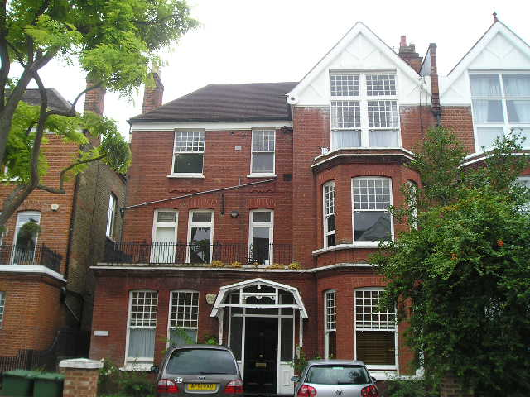

Prepared for

RSA
3rd Floor, Bowling Mill, Dean Clough, Halifax, HX3 5WA

Claim Reference 201308005636

SUBSIDENCE CLAIM

DATE 20 August 2013

Specialist Property Services – Subsidence Division
Cartwright House,
Tottle Road,
Riverside Business Park, Nottingham, NG2 1RT
Tel: 0115 943 8260
Fax: 0121 200 0309
Site Plan |  |  |  | This plan is Not to Scale
This plan is diagrammatic only and has been prepared to illustrate the general position of the property and its relationship to nearby trees etc. The boundaries are not accurate, and do not infer or confer any rights of ownership or right of way. Position of utilities is only indicative and contractors must satisfy themselves regarding actual location before commencing works.
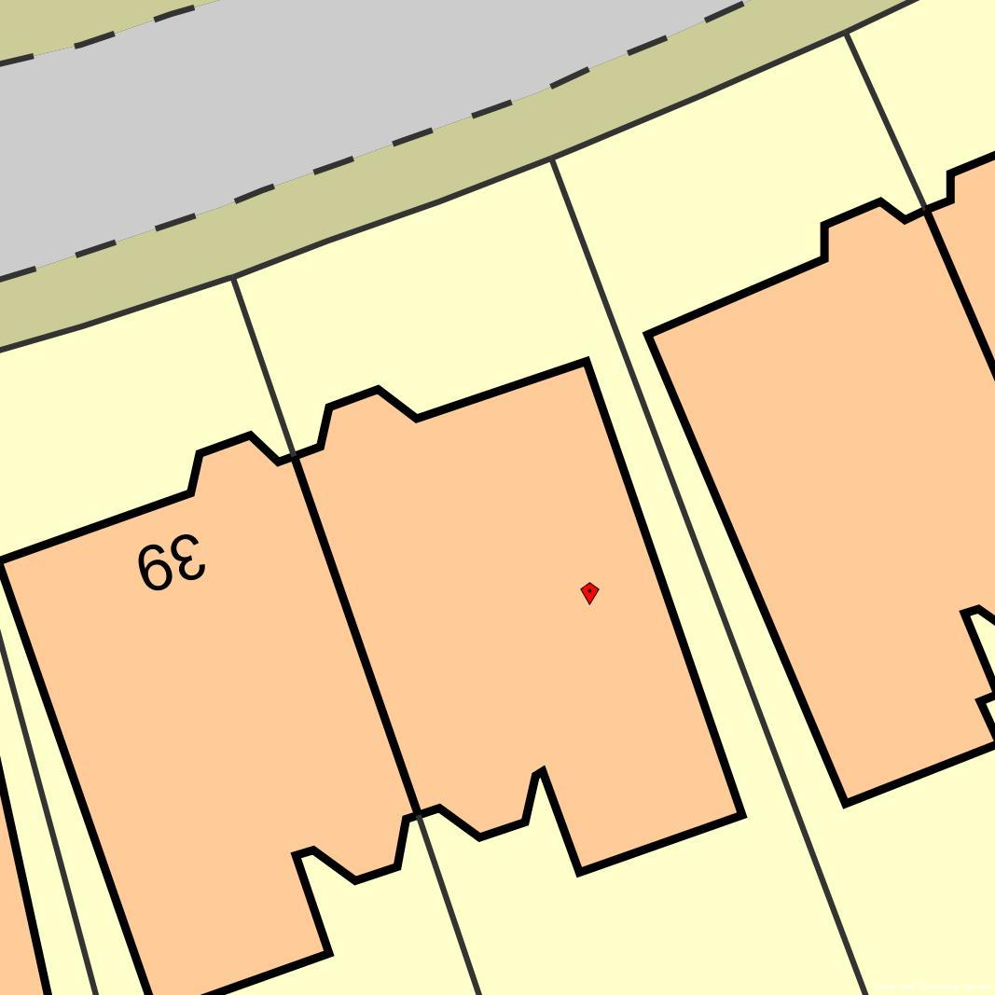
T1
© Bluesky International & © Infoterra 2006.
Map Reproduced with the Permission of Ordnance Survey License Number ########
Key:
 | Tree: Deciduous |  | Tree: Conifer |  |  | Shrub
 | Hedge |  | Area of Damage |  |  | Bore Hole
 | Trial Hole |  | Trial & Bore Hole |  |  | Level Monitoring
 | Rain Water Manhole |  | Rain Water Gulley |  |  | Rain Water Pipe
 | Waste Water Manhole |  | Waste Water Gulley |  |  | Toilet Pipe
 | Rain Water Drain |  | Waste Water Drain |  |  | Electricity Cable
 | Water Supply Pipe |  | Gas Supply Pipe |  |  | Incoming Gas Pipe
 | Incoming Water |  | Incoming Electrics

INTRODUCTION
We have been asked by RSA to comment on movement that has taken place to the above property. We are required to briefly describe the damage, establish a likely cause and list any remedial measures that may be needed.

Our report should not be used in the same way as a pre-purchase survey. It has been prepared specifically in connection with the present insurance claim and should not be relied on as a statement of structural adequacy. It does not deal with the general condition of the building, decorations, timber rot or infestation etc.

The report is made on behalf of Crawford & Company and by receiving the report and acting on it, the client - or any third party relying on it - accepts that no individual is personally liable in contract, tort or breach of Statutory duty. Where works address repairs that are not covered by the insurance policy we recommend that you seek professional advice on the repair methodology and whether the works will involve the Construction (Design & Management) Regulations 2007. Compliance with these Regulations is compulsory; failure to do so may result in prosecution. We have not taken account of the regulations and you must take appropriate advice.

Investigations have been carried out in accordance with the requirements of The Institution of Structural Engineers.

We have not commented on any part of the building that is covered or inaccessible.

TECHNICAL CIRCUMSTANCES
The property has been the subject of two previous subsidence claims. A claim was made in 1997 which centred around movement to the rear of the property. A further claim was made in 2006 which centred around movement to the front left hand corner and left hand flank areas and which was repaired at the end of 2007. Mrs Berger advised that she noted some movement to the front of the property a couple of years ago. Insurers were recently notified as Mrs Berger has received complaints from the left hand neighbour about the tree at the front of the property causing damage to his driveway.

PROPERTY
The risk address is a three storey semi-detached property of traditional construction with brick walls surmounted by a hipped, tiled roof. The property has been converted to provide three, self contained flats.

HISTORY & TIMESCALE
Site investigations are being organised and level monitoring is to be established.

Date of Construction Circa 1850
Purchased 1973
Policy Inception Date 31/05/2001
Damage First Noticed July 2013
Claim Notified to Insurer……………………… 05/08/2013
Date of our Inspection 16/08/2013
Issue of Report 20/08/2013
Anticipated Completion of Claim May 2015

TOPOGRAPHY
The property occupies a reasonably level site with no unusual or adverse topographic features.

GEOLOGY
Reference to the 1:625,000 scale British Geological Survey Map (solid edition) OS Tile number TQNW suggests the underlying geology to be London Clay.

London Clays are marine deposits characterised by their silty, sandy composition. They are typically stiff, dark or bluish grey, weathered dark to mid-brown superficially with fine particle size (less than 0.002mm). Tomlinson describes it as a ‘fat’ clay with high loadbearing characteristics due to pre-consolidation pressures in its geological history.
The upper horizon is often encountered at shallow depth, sometimes just below ground level. They have high shrink/swell potentials, and can be troublesome in the presence of vegetation.
The solid geology appears to outcrop in this location, although we cannot rule out the presence of superficial deposits at shallow depth.

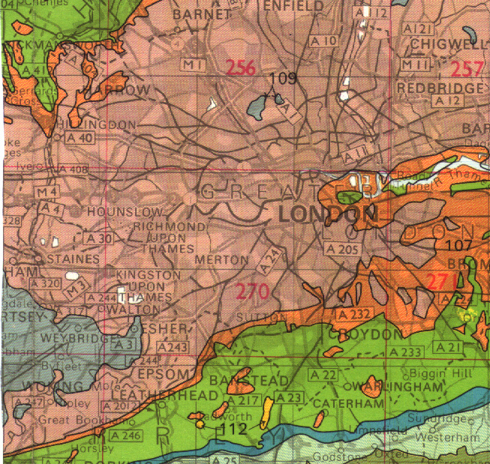
Geology. Reproduced with consent of The British Geological Survey at Keyworth.
Licence IPR/34-7C CSL British Geological Survey. ©NERC. All rights Reserved.

VEGETATION
There are several trees and shrubs nearby, some with roots that may extend beneath the house foundations. The following are of particular interest:-

Type Height Distance Ownership
T1 - Acacia 15 m 6 m Owners

See sketch. Tree roots can be troublesome in cohesive (clay) soils because they can induce volumetric change. They are rarely troublesome in non-cohesive soils (sands and gravels etc.) other than when they enter drains, in which case blockages can ensue.

False Acacia (Robinia) are deciduous and can reach heights between 15-25m depending on health, environment and soil conditions. They have a fast growth rate of around 700mm per year and medium root activity. Maximum tree-to-damage distance recorded in the Kew survey was 12.4mtrs, and 50% of cases occurred within 7mtrs. Life expectancy between 50 - 100 years. Young trees withstand surgery, but older trees only light pruning.

Typical proportions of a Robinia. Note the potential root zone.

OBSERVATIONS
The movement to the front left hand corner is the focal point of the Insured's concerns.

The following is an abbreviated description. Photographs accompanying this report illustrate the nature and extent of the problem.

INTERNAL

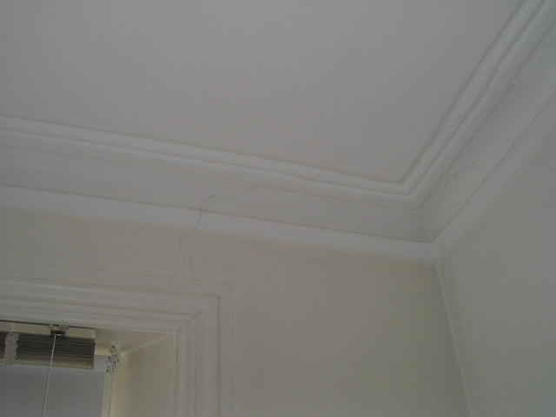 | 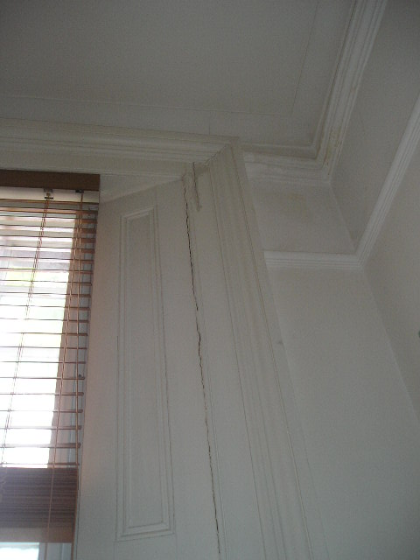
Movement to front wall in first floor front left hand bedroom | Movement to panelling in ground floor front left hand bedrrom

Ground Floor Flat - Front Left Hand Bedroom - Vertical cracking in wood panelling to left hand side of front window, damp staining to ceiling in front corner, localised slope in floor towards left hand flank under bed.

Basement - Dampness noted to left hand flank wall area, localised movement noted to suspended timber floor to front left hand bedroom around old fireplace hearth area due to failure of support.

Lounge - Various cracks noted to ceiling.

First Floor Flat - Rear Right Hand Bedroom - Historic slope to floor towards rear of property noted.

En-suite Shower Room - Shower tray is leaking causing water damage to flat below, old hairline crack in tile noted below right hand side of window.

Bathroom - Hairline vertical and diagonal cracking noted to wall tiles on both partition walls towards rear.

Hall - Historic slope to floor towards rear of property noted.

Rear Left Hand Bedroom - Historic slope to floor towards rear of property noted, 1mm diagonal crack at high level to left hand side of rear window.

Lounge - Evidence of water leak on right hand side of bay ceiling, cracking to coving on front wall, hairline diagonal crack above door to balcony, movement around door frame to balcony.

Front Left Hand Bedroom - Hairline vertical crack above left hand side of window continues into coving.

Communal Hall, Stairs and Landing - Hairline vertical crack below right hand side of 2nd floor landing window.

Second Floor Flat - Hallway - Historic slope to floor towards rear of property noted.

Rear Left Hand Bedroom - Hairline diagonal crack to rear wall.

En - Suite Shower Room - Old hairline vertical crack in tiles on left hand partition.

Lounge - Hairline vertical previously repaired crack to partition at junction of stud partition and solid wall.

Kitchen - Cracking to ceiling and evidence of water leak (possibly from valley gutter above).

Front Left Hand Bedroom - 1mm diagonal cracking to left hand flank at high level above picture rail only.

EXTERNAL

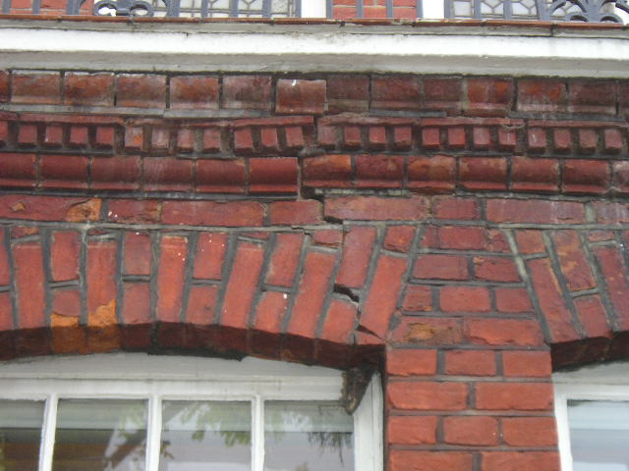 | 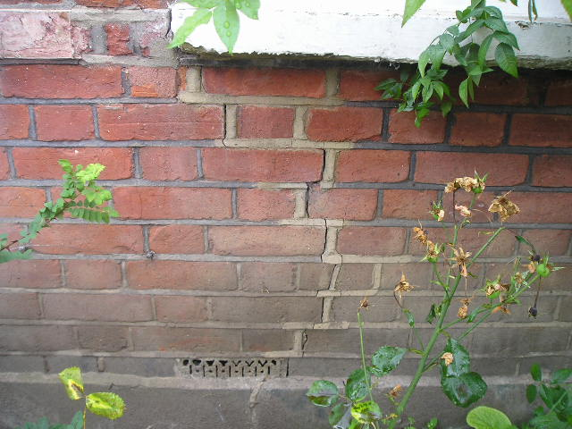
Movement to brick arch on front left hand corner | Cracking below left hand window

Front Elevation - 4mm vertical previously repaired crack below right hand window, brick arch has dropped above left hand window causing disruption to decorative brickwork above, mortar fillet down left hand side of left hand window has de-bonded, 10mm vertical crack in left hand dwarf boundary wall near tree, tree trunk has caused damage to the driveway edging bricks around the base of the trunk, disruption noted to brick paved driveway.

Balcony Area - 1mm stepped crack above door to lounge, 1mm stepped crack above door to kitchen.

CATEGORY

In structural terms the damage falls into Category 2 of Table 1, Building Research Establishment Digest 251, which describes it as “slight”.

Category 0 | "negligible" | < 0.1mm
Category 1 | "very slight" | 0.1 - 1mm
Category 2 | "slight" | >1 but < 5mm
Category 3 | "moderate" | >5 but < 15mm
Category 4 | "severe" | >15 but < 25mm
Category 5 | "very severe" | >25 mm

Extract from Table 1, B.R.E. Digest 251
Classification of damage based on crack widths.

DISCUSSION
The pattern and nature of the cracking to the front left hand corner and left hand flank of the property is indicative of an episode of subsidence. The cause of movement appears to be clay shrinkage.

The presence of shrinkable clay beneath the foundations and the proximity of vegetation where there is damage indicates the shrinkage to be root induced. This is a commonly encountered problem and probably accounts for around 70% of subsidence claims notified to insurers.

Fortunately, the cause of the problem (dehydration) is reversible. Clay soils will re-hydrate in the winter months, causing the clays to swell and the cracks to close. Provided the cause of movement is dealt with (in this case, vegetation) there should not be a recurrence of movement.

The minor cracking noted in other areas of the property is not indicative of that associated with foundation movement and the repair of these cracks therefore falls outside the scope of this claim. We noted that there is some distortion to the floors especially at first and second floor levels in the rear parts where the floor appears to slope down towards the rear of the property. There is no corresponding structural movement to the load bearing walls in the affected area which would suggest that this is an ongoing problem associated with foundation movement. We therefore suspect that this is a historic problem which falls outside the scope of this claim.

From our inspection of the basement void, the problem with the sloping floor in the ground floor flat front bedroom appears to relate to a localised problem with the floor structure around the old fireplace hearth area. It would appear that there has been a failure in the timber support in this area which has resulted in the floor dropping. This is not connected to the movement to the front corner.

RECOMMENDATIONS
Although the cause of the movement needs to be dealt with, we note the vegetation is subject to a Preservation Order. Unfortunately, current legislation requires certain investigations to be carried out to support an application for the tree works.

Typically, these investigations would involve trial pit(s) to determine the depth and type of footings, boreholes to determine the nature of the subsoil/influence of any roots and monitoring to establish the rate and pattern of movement. The monitoring data provided must be sufficient to show a pattern of movement consistent with the influence of the vegetation and therefore it may be necessary to carry out the monitoring for up to a 12 month period.

It will also be necessary to obtain a specialist Arboricultural Report. We will report further once these investigations have been completed.

Yours Faithfully,

Matt Deller
Matt Deller BSc (Hons) MCIOB Dip CII
Specialist Property Services UK
Crawford & Company Adjusters (UK) Ltd
subsidence@crawco.co.uk

Photographs

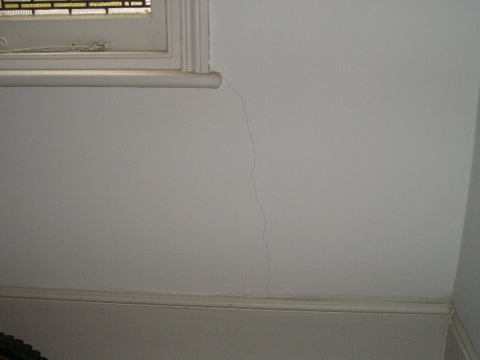 | 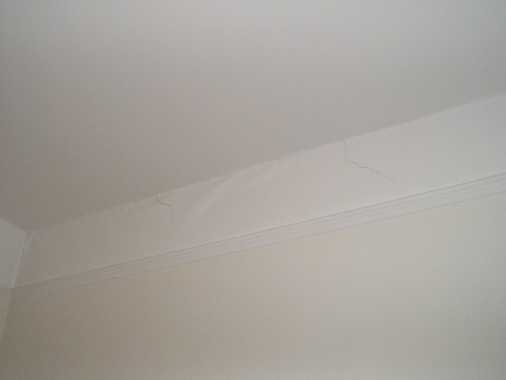
Movement to left hand flank wall on communal 2nd floor landing | Movement to flank wall in 2nd floor front left hand bedroom
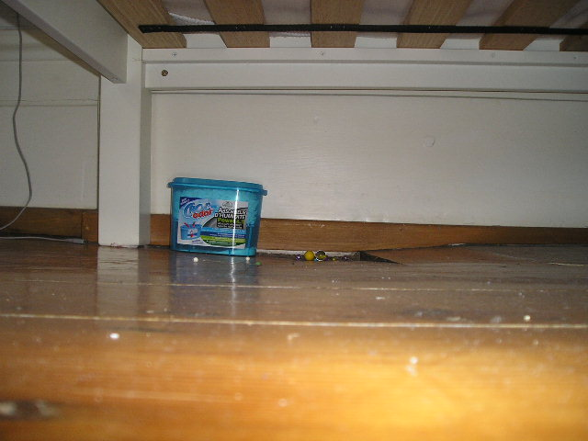 | 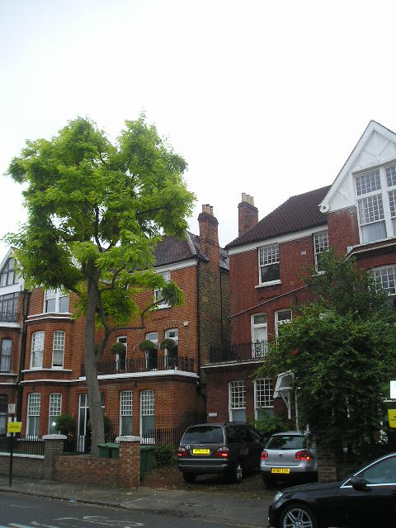
View of localised movement to floor in ground floor front left hand bedroom - Not subsidence movement | View of Acacia tree to front of property
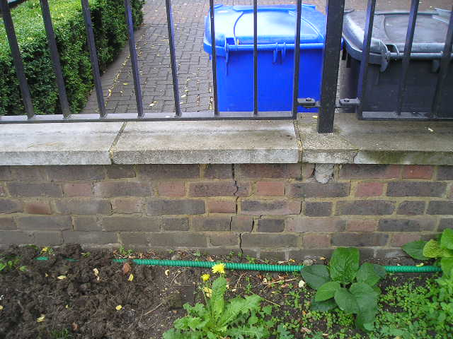 | 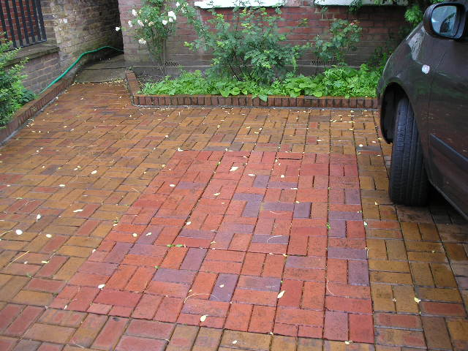
Movement to boundary wall | Disruption to driveway block paving

Institution of Structural Engineers (1994) “Subsidence of Low Rise Buildings”
Tomlinson M.J. (1991) “Foundations Design & Construction” Longman Scientific Publishing. ? B.S. 5930 (1981) “Site Investigations”
DriscollL R. (1983) “Influence of Vegetation on Clays” Geotechnique. Vol 33.
Table 1, Chapter 4.2, Para. 2.3 of N.H.B.C. Standards, 1986.
Richardson & Gale (1994) "Tree Recognition" Richardson's Botanical Identifications
Cutler & Richardson (1991) “Tree Roots & Buildings” Longman Scientific
Building Research Establishment, Garston, Watford. Tel: 01923.674040

