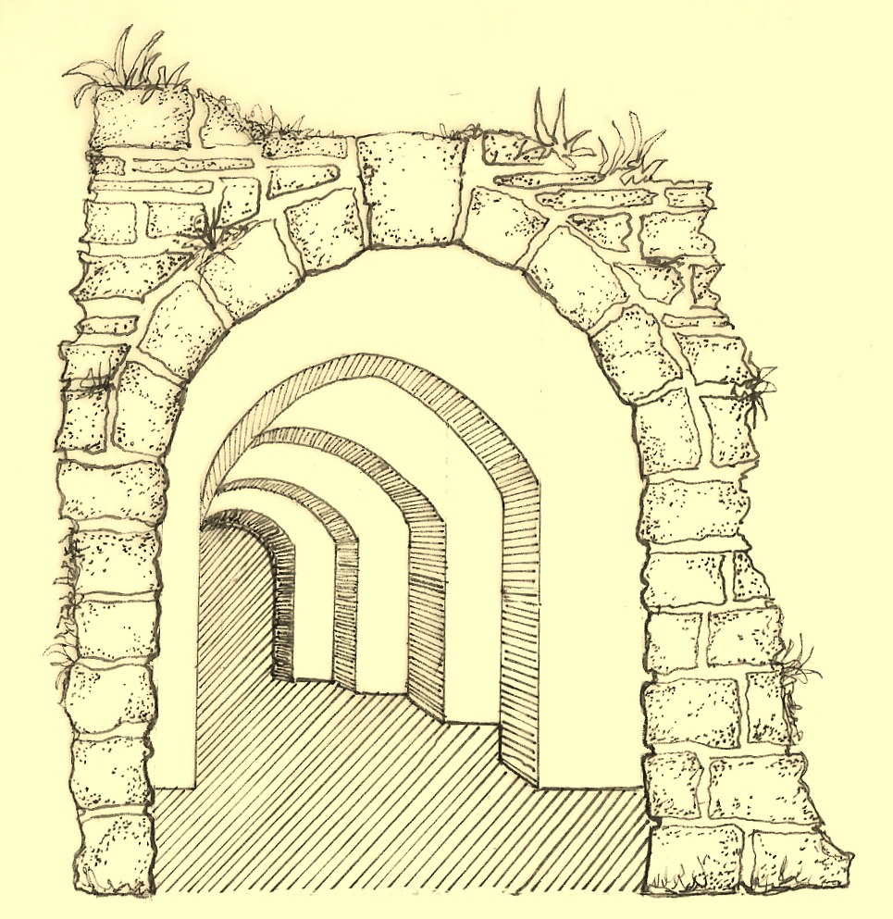
5
Arches
Design & Planning

LIFETIME HOMES STATEMENT – SEPTEMBER 2013

Proposed development at:

13 St. Augustines Road,
Camden
London
NW1 9RL

5 Arches Design & Planning on behalf of Mr. Kolajo Lawal.

LH 1. Re. Car Parking Width

No specific extra car parking provision is being made and therefore this point is non applicable.

LH 2. Re. Access from Car Parking.

No specific extra car parking provision is being made and therefore this point is non applicable.

LH 3. Re. Approach gradients.

As the net level difference between the front garden entrance gate and the access to the lower ground floor is approx. 660mm, this could not be achieved without significant impact on the front garden and amenity space and is therefore considered to be unachievable.

LH 4. Re. Entrances.

The access as it stands is lit and will be better illuminated after project completion. The proposed altered entrance to the lower ground floor dwelling is 840mm. Again, with respect to levelling out thresholds, this will be unachievable in view of the considerable existing difference in levels.

LH 5. Re. Communal stairs and lifts.

As the proposals for the lower ground floor extension do not involve creating an extra dwelling, this provision does not apply. The access to the upper ground floor dwelling is and will remain compliant.

LH 6. Re. Doorways & Hallways.

With regards to both dwellings within the property, all criterion are complied with. Specifically within the lower dwelling, internal separations are all stud and therefore can be adapted either during the construction phase or at a later date, should someone’s specific needs require greater adaptation.

LH 7. Re. Wheelchair accessibility.

With regards to the lower ground floor dwelling, the proposed living room / dining area comfortably allows for the recommended turning circle even when taking into account the example furniture layout shown on the scheme drawings. Clearly, that layout will be subject to the occupier’s own discretion. Ample space has been allowed for wheelchair circulation.

LH 8. Re. Living room.

With regards to the lower ground floor dwelling, the Living Room is indeed at entrance level as required.

LH 9. Re. Entrance level bedspace.

With regards to the lower ground floor dwelling, there is a bedroom proposed at the entrance level. Also, the proposed Living Room could indeed accommodate bedspace if the need arose. Again, this area is at entrance level as specified in this requirement.

LH 10. Re. Entrance level WC & Shower drainage.

With regards to the lower ground floor dwelling there is indeed a wheelchair accessible WC. A provision for drainage could easily be catered for as the WC lies directly next to the main drainage run, which can be tapped into.

LH 11. Re. Bathroom & WC walls.

With regards to the lower ground floor dwelling, the bathroom & WC walls will be reinforced where required to accommodate adaptations such as handrails . This has become standard practice in such projects.

LH 12. Re. Stair Lift / Through floor lift.

With regards to the lower ground floor dwelling, a possible stair lift location has been shown on the scheme drawings. The landings at both top and bottom are indeed unobstructed. Unfortunately, due to restrictions related to the layout and overall space allocation, a through floor lift would be impractical and therefore considered to be unachievable.

LH 13. Re. Tracking Hoist route.

With regards to the lower ground floor dwelling, the scheme drawings show a reasonable route for a potential hoist in bedroom 2. This is highly achievable as this area of the construction will undoubtedly incorporate steel beams within the ceiling void.

LH 14. Re. Bathroom Layout.

With regards to the lower ground floor dwelling, the layouts of both the bathrooms have been designed with such considerations in mind. However, if required, internal separations, which are all stud wall, can be adapted either during the construction phase or at a later date, should someone’s specific needs require greater adaptation.

LH 15. Re. Window Specification.

With regards to the lower ground floor dwelling, the window sill heights in the Living Room are at floor level, which clearly meets this criterion, as they are planned to be sliding sash.

LH 16. Re. Controls, Fixtures & Fittings.

With regards to the lower ground floor dwelling, the switches, sockets, ventilation and service controls will all be located at a height between 450mm and 1200mm from the floor. A specific note to this effect has been made on the scheme drawings.

5 Arches Design & Planning.

