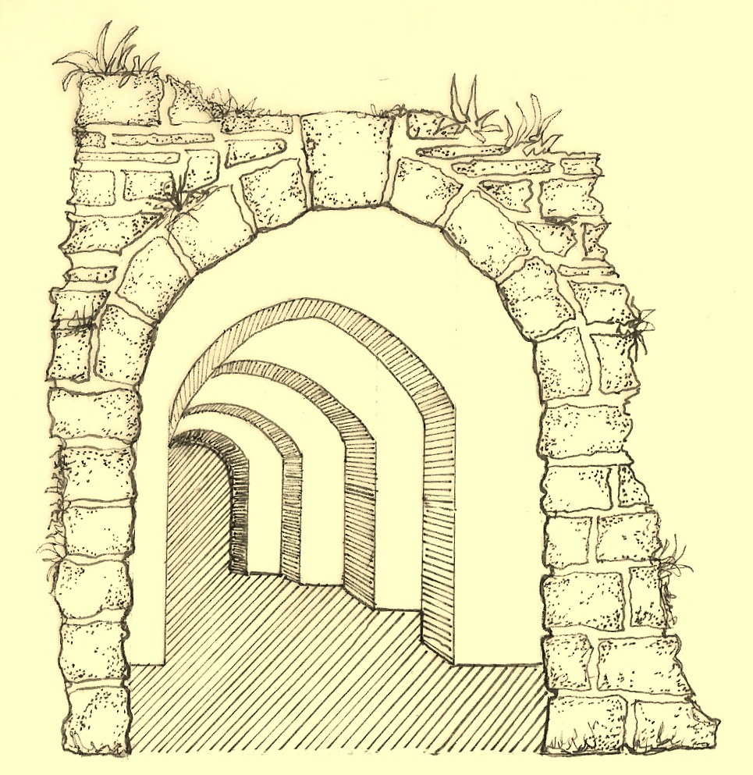
5
Arches
Design & Planning

DESIGN & ACCESS STATEMENT

Proposed EXTENSIONS

13 St. Augustines Road,
Camden
London
NW1 9RL

5 Arches Design & Planning on behalf of Mr. Kolajo Lawal

Amount
The proposal is to extend the lower ground floor dwelling by excavating a basement totalling 89m2, adding a single storey rear extension totalling 13m2 and to extend the elevated side entrance through to the rear of the property totalling 7.2m2. A roof dormer to the existing loft accommodation is also proposed.

Layout
The design rationale behind this scheme is to provide improved living accommodation to the lower ground floor dwelling, comprising of 3 extra bedrooms, a media room and ancillary areas such as storage and bathrooms. The upper dwelling is to be improved internally by creating more generously proportioned living and accommodation space, especially within the loft level.

Scale
The extent of the basement works will be contained wholly within the footprint of the dwelling.

Landscaping
The front garden aspect will be greatly improved in appearance as part of the proposed works. The existing amenity space will also be improved and bin storage concealed from the street scene. The rear garden, which is currently in a seriously overgrown state, will be landscaped and formed into a more versatile and usable family space.

Appearance
Externally, this has been limited to the formation of one front and one rear lightwell, with the construction of a single storey rear extension.

These proposals are consistent with other basement developments within this area which have previously met with the approval of Camden planning Officers.

Use
The proposed improvements are to be used by the current owner and his family.

Access
Both pedestrian and vehicular access to the property will remain unchanged.

Lifetime Homes
Whilst we are aware that our works are generally exempt from Part M, in terms of access for the disabled, we do as a matter of course incorporate into our design as many LTH Standards possible. For example, internal walls are generally non-load bearing and can be removed to accommodate future layouts. Bathrooms can be designed for walk-in showers where appropriate with walls strengthened to incorporate future rails and shower seats. Doorways can be increased to accommodate larger door sizes and window sills are generally lower than the required height from FFL. (For further details, please see attached ‘Lifetime Homes Statement’)

5 Arches Design & Planning.

