DESIGN AND ACCESS STATEMENT FOR CAMDEN WORKS LONDON NW1 7DL FOR NEW TENANT DIRECTORY BOARD

Introduction

The application site comprises of three separate office blocks. One of the buildings is a retired piano factory.

Planning consent was gained on 02/09/2011for non-illuminated signage (2011/4373/l) (2011/4372/A

The proposal is to erect three tenant sign boards at the three entrances into the site. (12 Oval Road, 42-43 Gloucester Crescent, Jamestown Road)

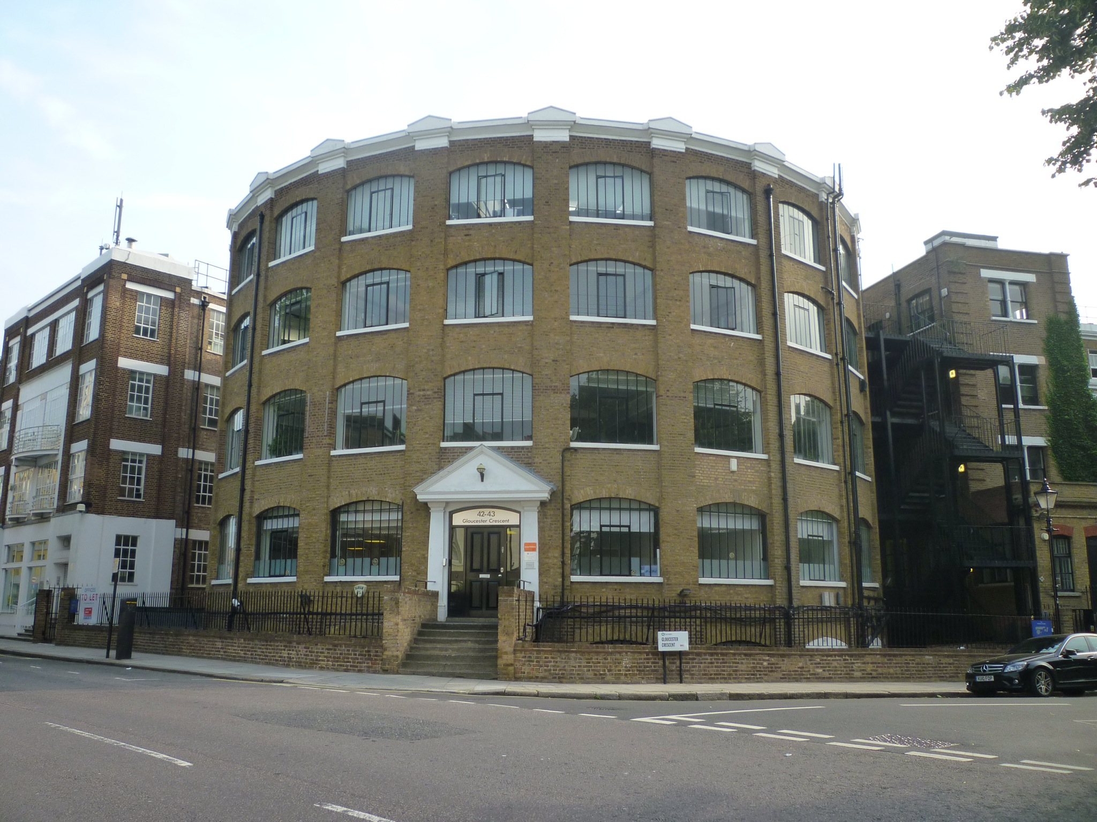

View from Gloucester Road

Use

The use continues unaffected.

Consideration has been given to the buildings listed status with regard to the colours selected.

Size

42-43 Gloucester Road Signage - 80cm (w) x 50cm (H)

12 Oval Road Signage - 80cm (w) x 50 (H)

Jamestown Road Signage - 120cm (w) x 78cm(H)

Installation

The signs are to be fixed to the railings around the perimeter of the building.

Appearance

Metal signage in shades of grey.

Access

Will not be affected

Parking

Will not be affected

Summary

The proposed installation is an integral part of the service and operation of the offices for both tenant visitor.

