Miss Sophie Chapman
Savills
33 Margaret Street
LONDON
W1G 0JD
33 Margaret Street  LONDON  W1G 0JD |  | Application Ref: 2013/5122/P
 |  | Please ask for: Charles Rose
 |  | Telephone: 020 7974 1971
 |  | 8 October 2013

Dear Sir/Madam

DECISION

Town and Country Planning Act 1990 (as amended)
Town and Country Planning (Development Management Procedure) Order 2010
Town and Country Planning (Applications) Regulations 1988

Approval of Details Granted

Address:
St George's Court
2-12 Bloomsbury Way and
2-28 New Oxford Street
London
WC1A 2SH

Proposal:
Details of facing materials, namely glazing units and metalwork, relating to partial discharge of condition 4 of planning permission dated 31/1/13 (ref: 2012/1400/P), for the erection of single storey glazed extension with associated roof terraces and new rooftop plant at 9th floor level, change of use from offices to three flexible retail or restaurant units (Class A1/A3) at part ground floor level, reconfiguration of front entrance, replacement of ground and first floor façade with double storey glazed frontages to all elevations and associated alterations for to existing offices (Class B1).

Drawing Nos: ipasol glazing samples; 770_GE_01 rev C2; 2 rev C2; 3 rev C2

The Council has considered your application and decided to grant permission subject to the following condition(s):

Informative(s):

You are reminded that conditions; 10 (waste) and; 11 (green roof) of planning permission granted on 30/03/2012 (ref: 2012/1400/P) are outstanding and require details to be submitted to and approved by the Council.

In dealing with the application, the Council has sought to work with the applicant in a positive and proactive way in accordance with paragraphs 186 and 187 of the National Planning Policy Framework.

Your attention is drawn to the notes attached to this notice which tell you about your Rights of Appeal and other information.

Yours faithfully
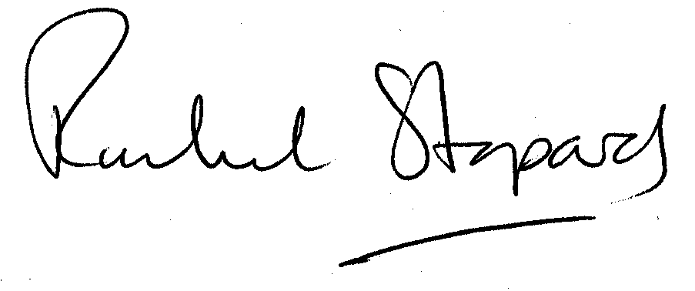
Rachel Stopard
Director of Culture & Environment

It’s easy to make, pay for, track and comment on planning applications on line. Just go to www.camden.gov.uk/planning.
It is important to us to find out what our customers think about the service we provide. To help us in this respect, we would be very grateful if you could take a few moments to complete our online planning applicants’ survey. We will use the information you give us to monitor and improve our services.

