55 & 57 Chester Road, 126 & 128 Croftdown Road Photos
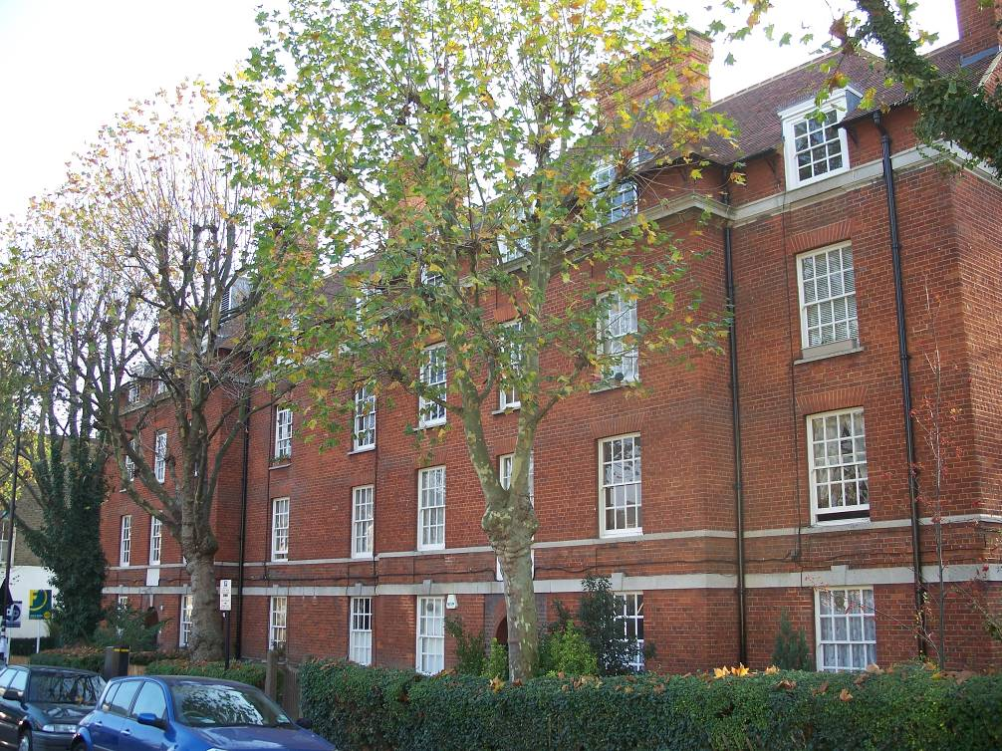
Front Elevation
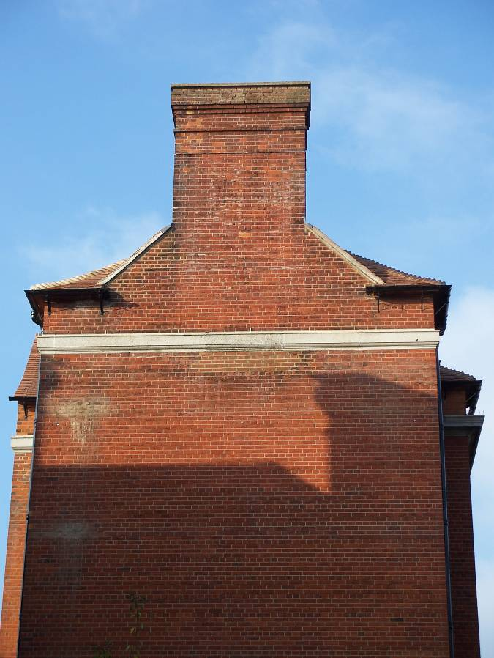
Side Elevation
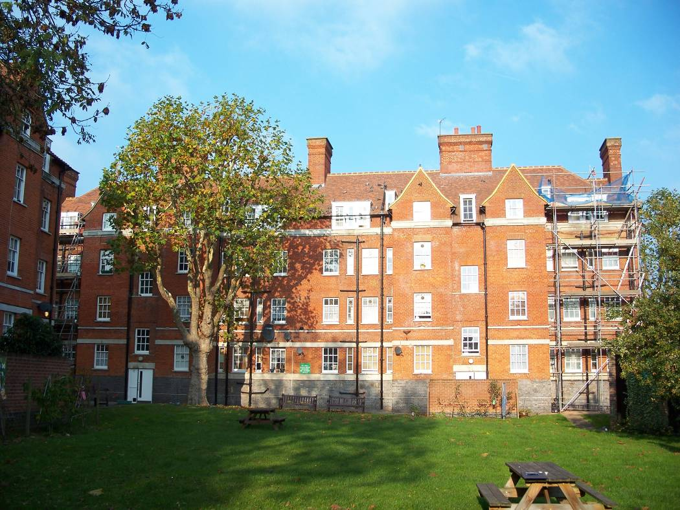
Rear Elevation

