1 – 12 Chest House Photos
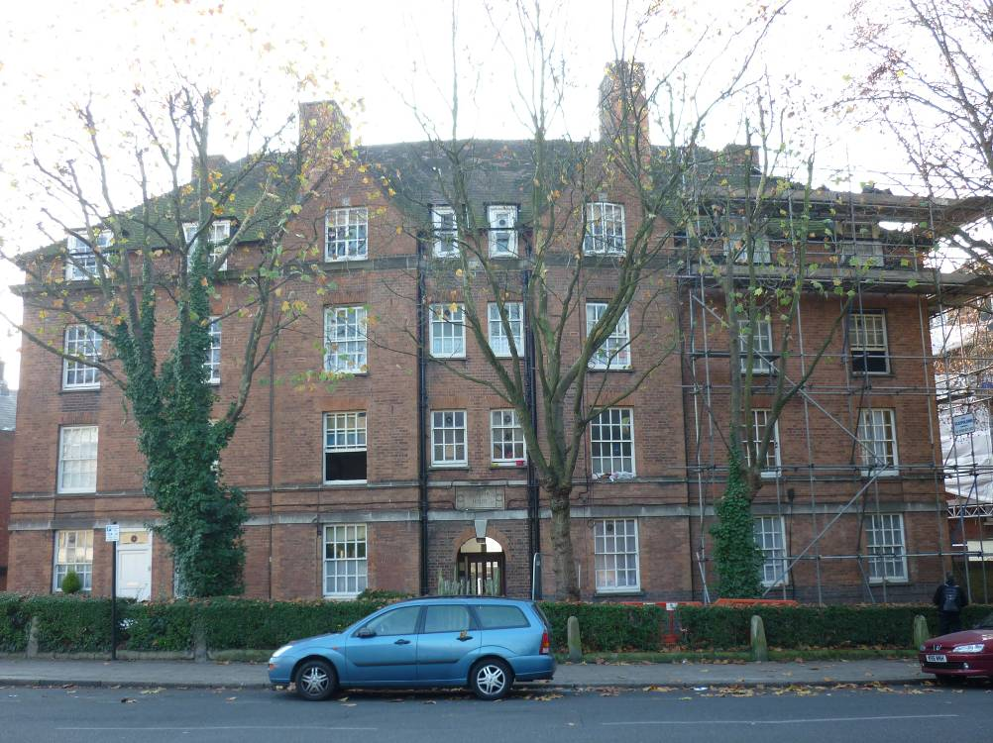
Front Elevation
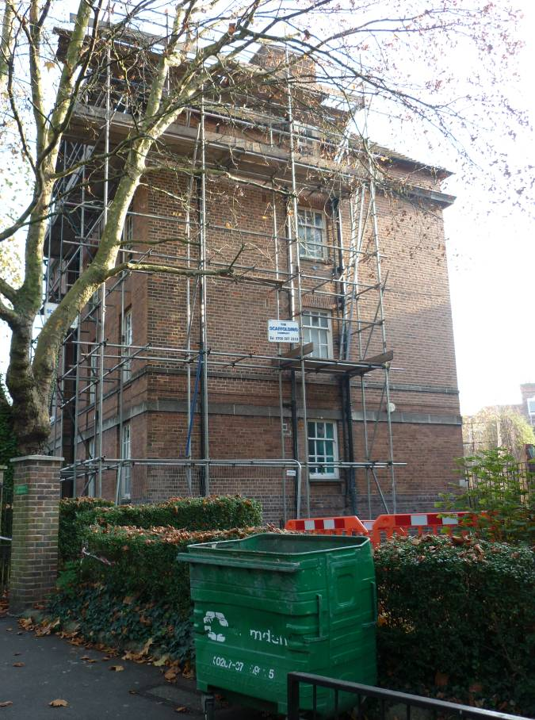
Side Elevation
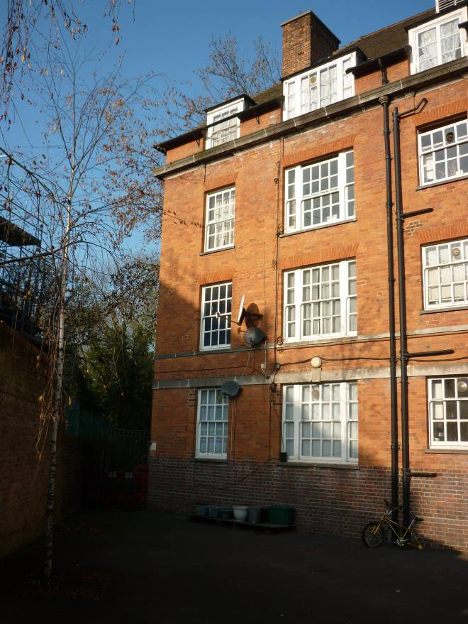
Rear Elevation (Left Hand Side)
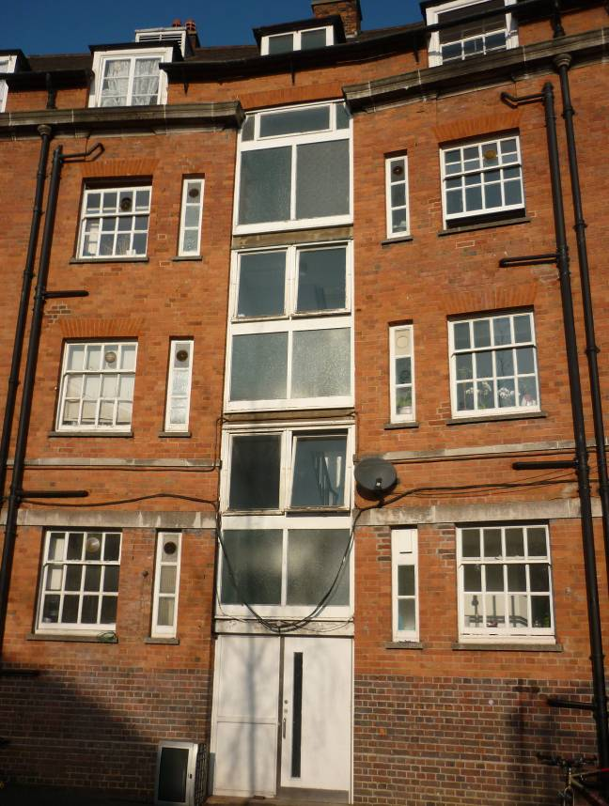
Rear Elevation (Centre)
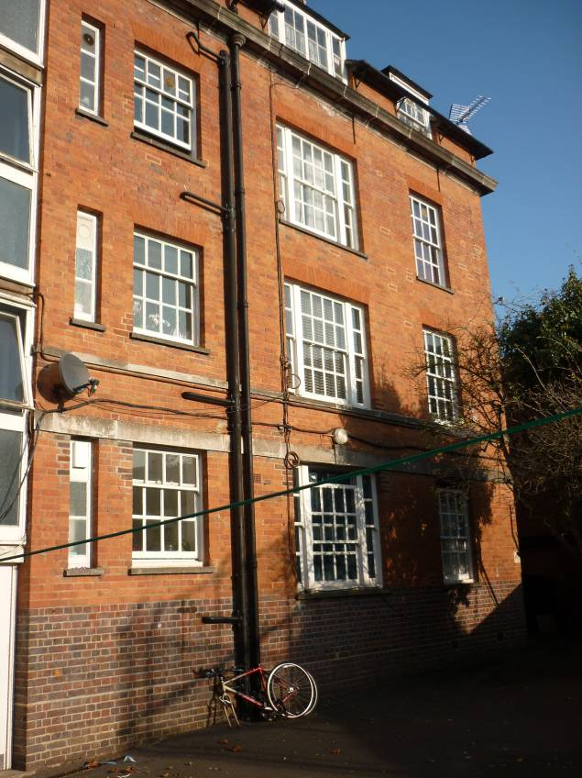
Rear Elevation (Right Hand Side)

