|  |
| --- |
| **FELDMAN**DESIGN  COMPANY LIMITED  DESIGN CONSULTANTS |

2 Belsize Park Mews

London NW3 5BL

**T** 0207 794 4447

**E** admin @ feldmandesign.co.uk

**BARKAT HOUSE**

**116 -118 FINCHLEY ROAD**

**LONDON NW3 5HT**

**BH 02 DESIGN AND ACCESS STATEMENT**

Prepared for Rion Investments Ltd

746 Finchley Road NW11 7TH**BH 02 DESIGN AND ACCESS STATEMENT**

**Barkat House 116 – 118 Finchley Road**

**Building Description**

Barkat House is a 1960’s mixed usage block sitting on the east side of the Finchley Road. The ground floor consists two retail units (currently a bookshop and furniture emporium) and entrance hall to the offices on the 1st to 4th floors and four residential flats on the 5th and 6th floors. The structure steps back on the front elevation to provide open terracing of approx 2.3m depth. Similarly the glazing (but not the structure) is set back at 5th floor level by approximately 1.0m. This may have been an advantage when the building was first designed and built, but with the levels of air and noise pollution nowadays these terraces are an unusable waste of available floor space. There is no division between the terrace areas for each flat. A ramped driveway under the building leads from the Finchley Road to parking at the rear of the site and to the Rotunda Studio which is a separate building backing to Maresfield Gardens

The structure of the building is concrete frame with internal columns. The front and rear elevations consist of horizontal bands of steel framed glazing and infill. The infill is made up of two mosaics. A glass mosaic expresses the slab thickness and riven grey slate is used for the infill from slab band to window cill. There is a large external escape stair to the rear elevation rising the full height of the building. This comprises of cast concrete stair sections within a concrete frame. The stair structure projects from a painted rendered zone which terminates above the normal roof line which is the lift motor and tank room. The stairs and landings are protected by timber plank balustrades on painted steel frames. The side elevations are solid and fully tilled with a third small format ceramic tile. These ceramic and glass materials are showing their age and the glazing is fast reaching the end of its working life. The timber balustrades to the rear are rotting and their design no longer meet safety standards.

During the course of the last 40 years several adjustments and additions to the building have taken place including the provision of air conditioning to the majority of the floor space. The pipework to the external components are contained in some instances in sheet metal ducts and others just exposed insulation lagging.

At ground floor there was originally no provision made for the housing of refuse containers and the signage on the façade is uncontrolled. The entrance to the offices and residential is set back from the front building line creating an unsightly and recess with security risks.

**Proposals**

The re-cladding proposals have been designed to contribute to the energy efficiency of the building and to replace the tired finishes with a timeless modern scheme to bring the appearance up to date and to serve well into the distant future. At the same time it is intended to make the best usage of the available space at ground and residential levels.

**General Glazing**

As noted in the building review the original glazing is inefficient by modern standards and the original fittings need constant repair and attention. It is therefore proposed to completely replace the original windows throughout using purpose made replacements in prefinished thermally broken aluminium double glazed units. The split of the office partitioning is based ion the existing window module and so this will be exactly repeated with the replacement glazing.

**Ground Floor**

The proposal is to bring the entrance doors to the offices and residences forward to the same line as the shop front to the adjacent retail space. This enables the construction of a secure enclosure for the refuse bins. It also dispenses with the unsightly metal barriers and gives an opportunity to form level entrance to the bookshop and office entrance to comply with Part M of the Building regulations. The proposal also rationalises the suspended areas of ceilings and soffits.

**5th Floor**

On the 5th floor residential the glazing is set back from the front face of the building by approximately 1m. Perhaps when the building was originally designed this external space was desirable. In today’s conditions this is not the case.

**6th Floor**

On the 6th floor it is possible to enclose and protect the terrace areas and offer some protection from the elements using sliding opening elements to separate terraces.

**Rain Screen Panels – Front Elevation**

The proposal is to clad the front elevation of the building between the windows with custom manufactured stainless steel insulated panels supported on engineered brackets from the existing structure. The finish of this material will withstand all environmental conditions and will maintain a crisp appearance for the foreseeable future of the building. Its neutral colour and finish will sit comfortably between the existing building at No.114 and the future proposed building at No. 120. The insulated stainless steel panels will allow protection to the structure of the building from rain and radiant heat creating a well ventilated comfortable building. The stainless steel panels will be installed from the ground floor facia level to the fifth floor. The set back 6th floor will be clad using fibre cement panels in a silver grey to tone with the stainless steel. (see below)

**Rain Screen Panels - Rear Elevation**

The new window frames will be the same throughout the refurbishment, however the high cost and limited exposure of the rear of the building makes the use of stainless steel panels un economic option . It is therefore proposed to use a purpose made fibre cement panel system. Equitone fibre cement panels manufactured by Marley are a light weight sustainable product and has a life expectancy exceeding 50 years. The ventilated rain screen system protects the structure in the same way as the stainless steel to the front elevation.

**Safety Balustrades to Fire Escapes**

The balustrades are fabricated from square section mild steel tube with softwood planks which have deteriorated. The spacing of the rails does not comply with standards. It is therefore proposed to replace the timber rails with toughened textured glass panels bracket fixed to the existing uprights.

**Reference Photographs**

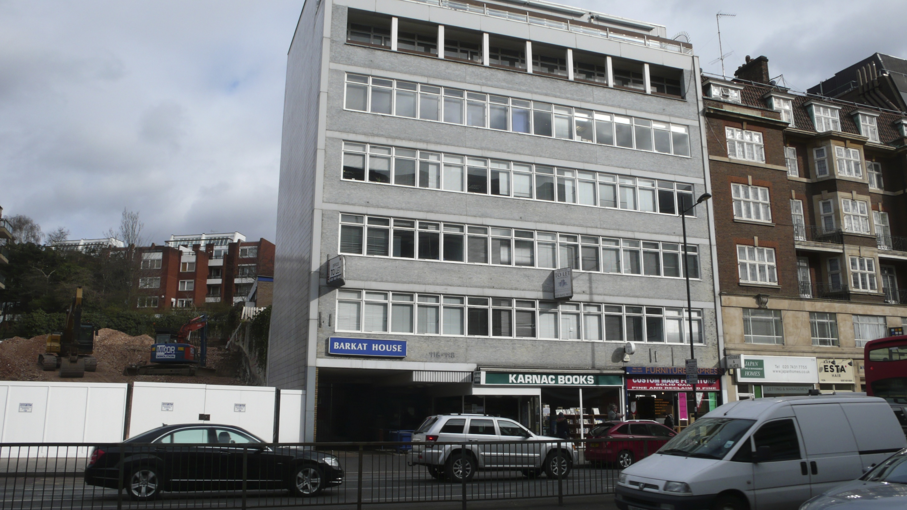

Front elevation



Finchley Road Elevation

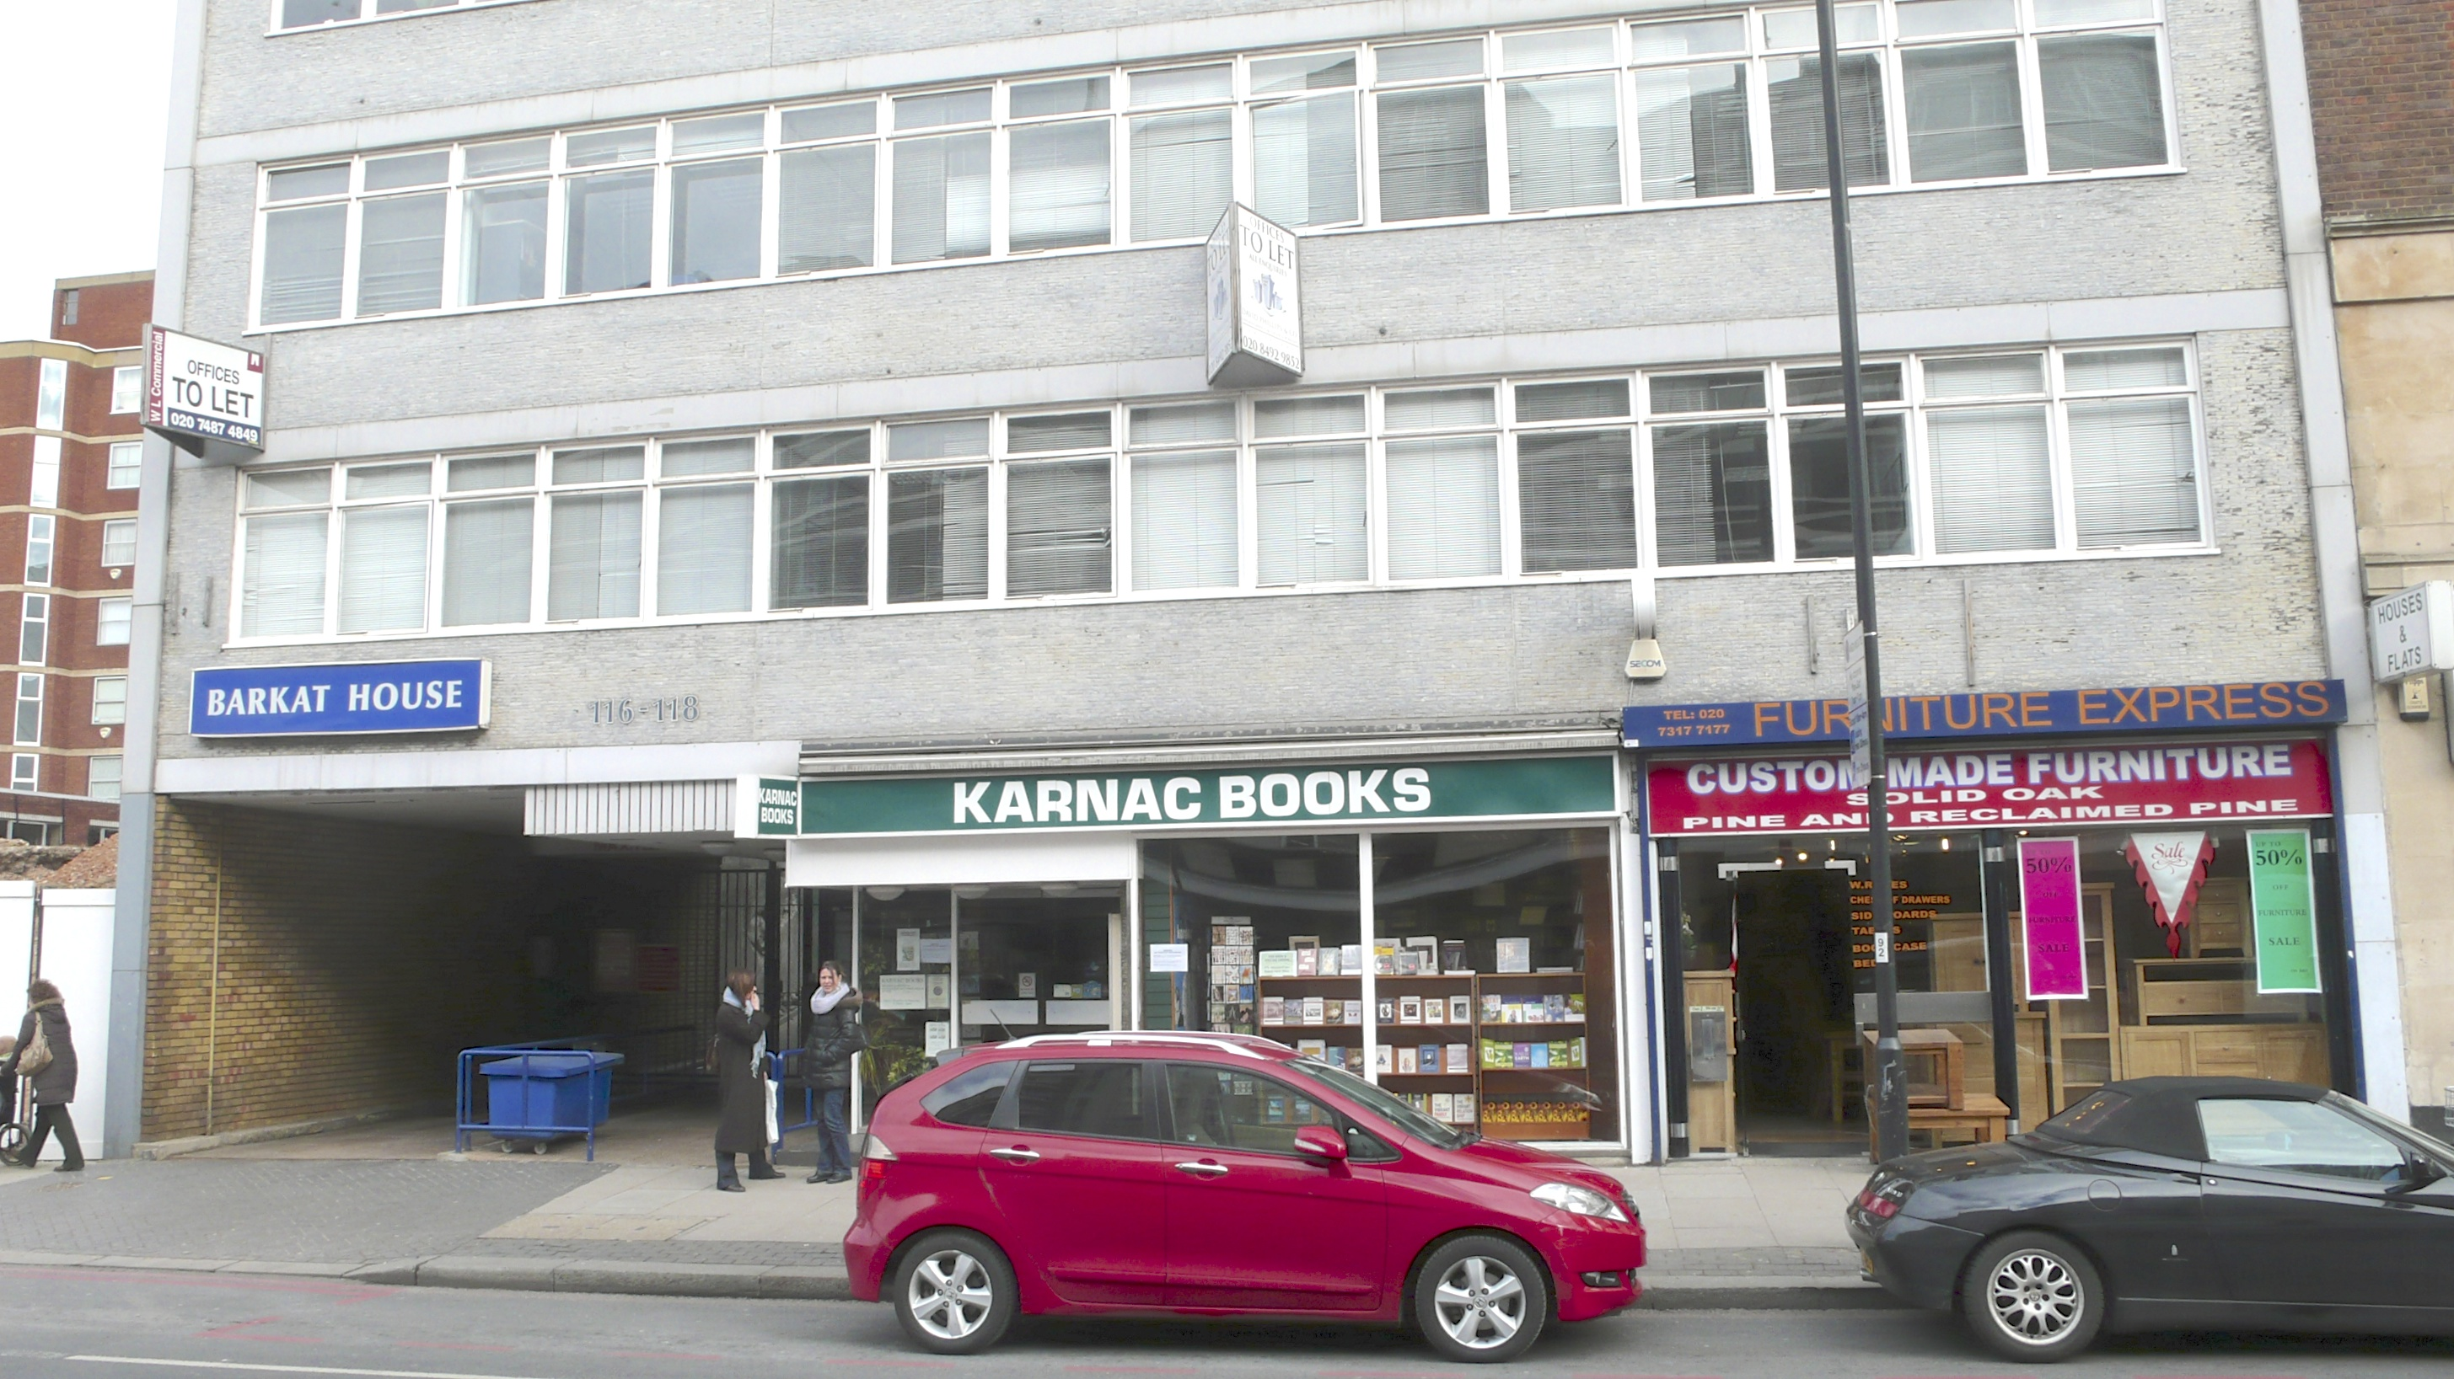

Ground Floor Entrance and Retail Shop Fronts

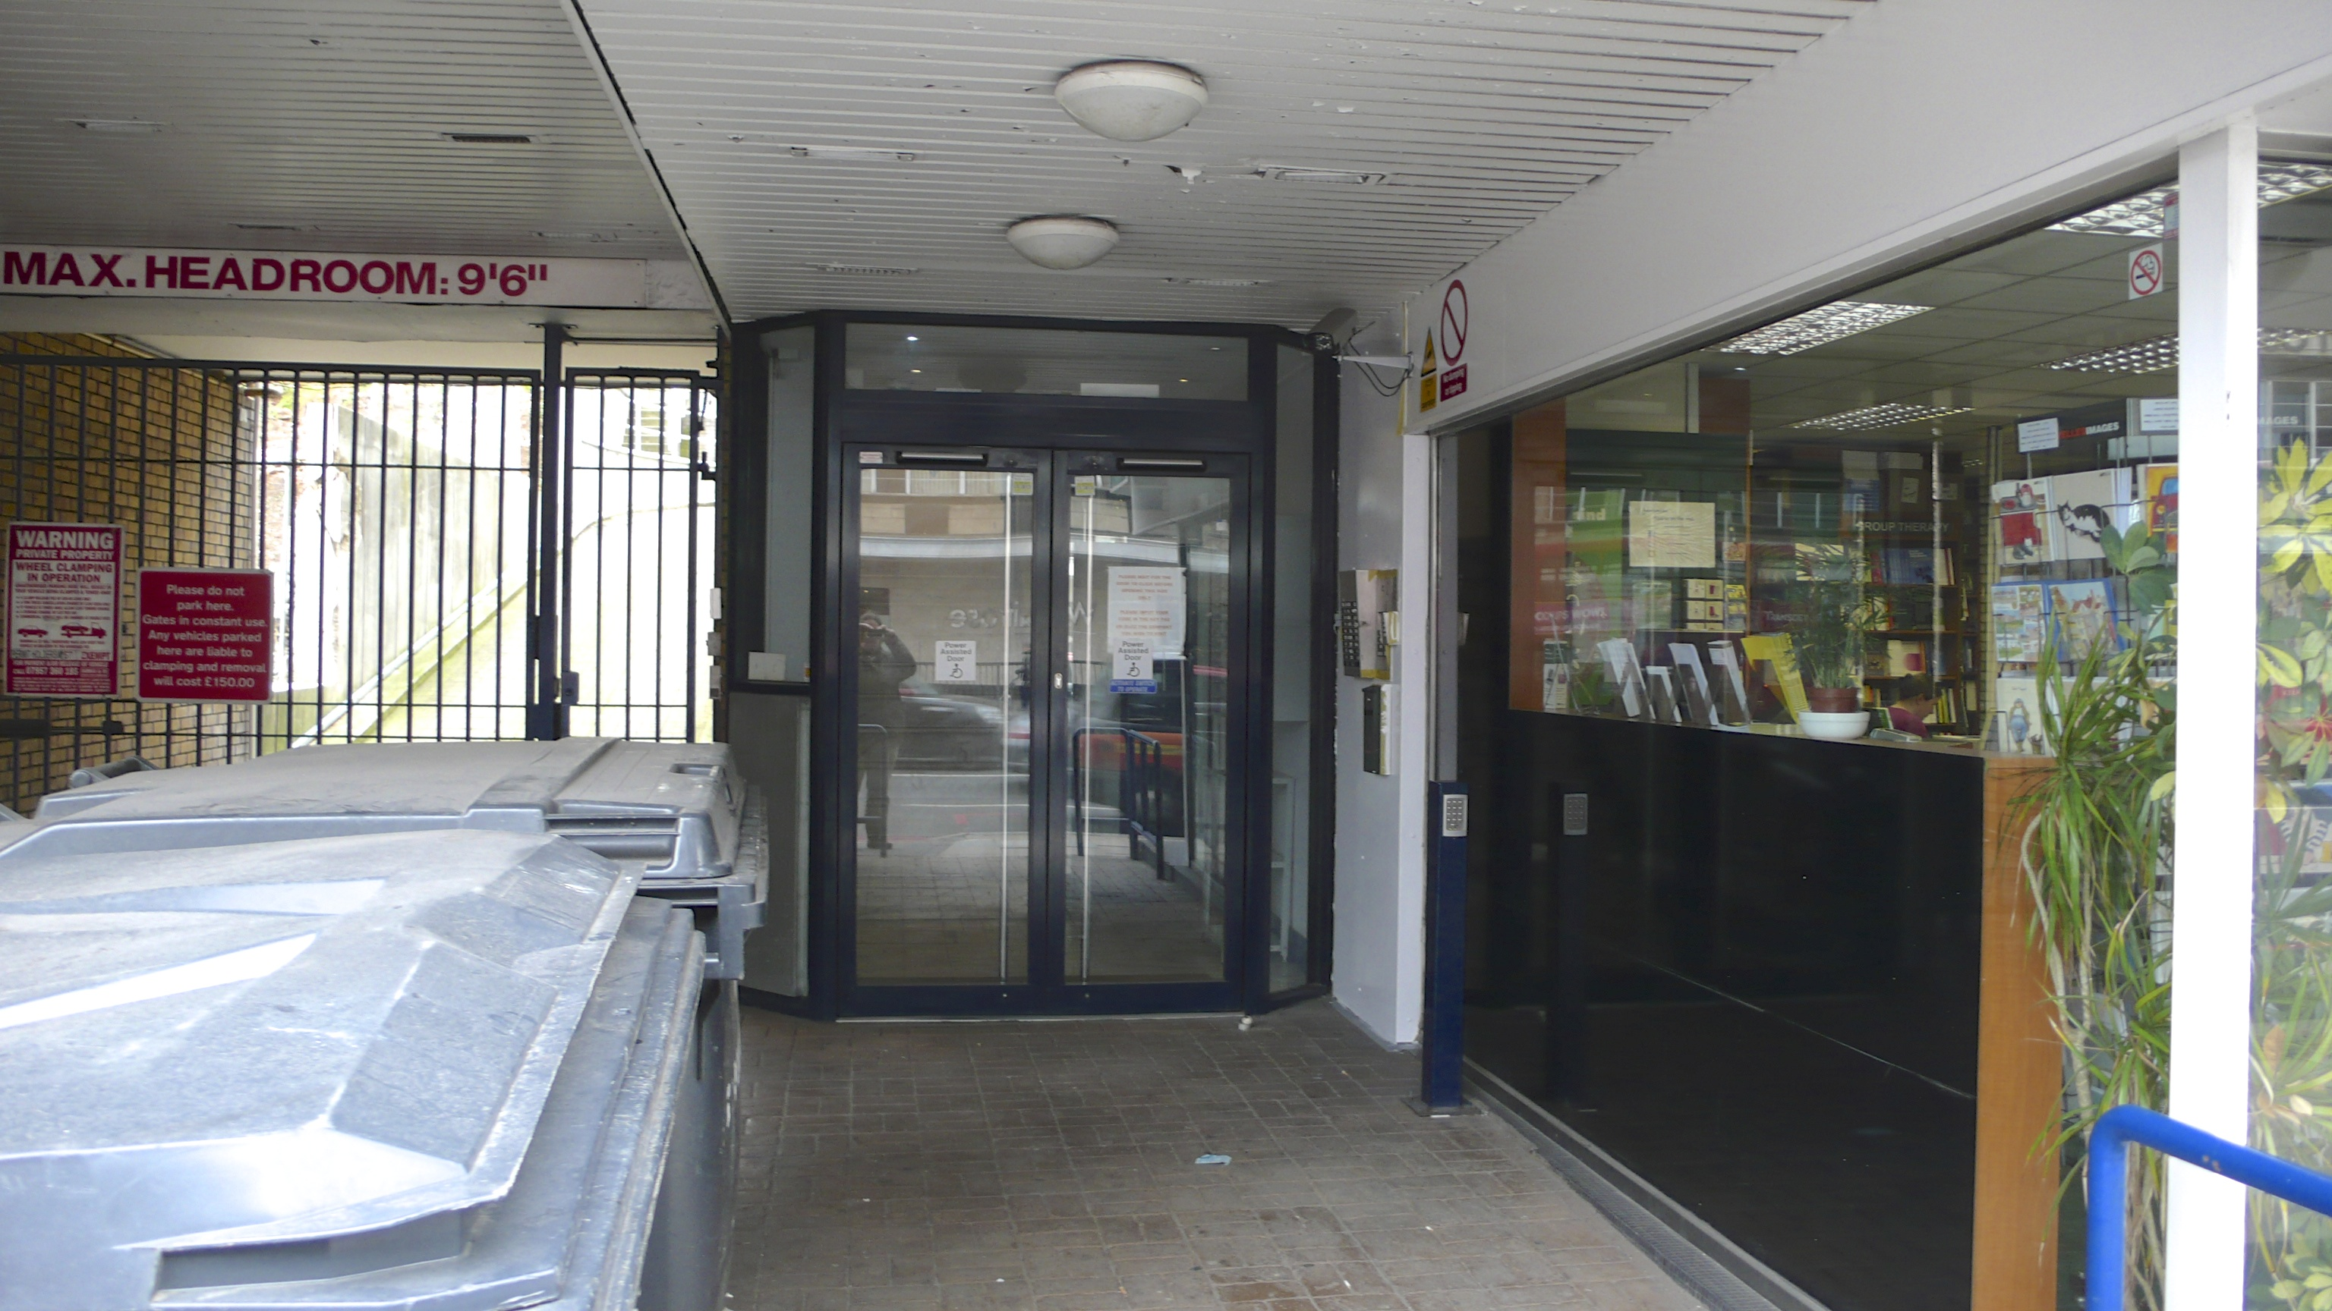

Office and Residential Entrance Area