List Entry Summary
This building is listed under the Planning (Listed Buildings and Conservation Areas) Act 1990 as amended for its special architectural or historic interest.

Name: NUMBER 30 AND ATTACHED RAILINGS AND WALL

List Entry Number: 1322106

Location
NUMBER 30 AND ATTACHED RAILINGS AND WALL, 30, NEW END
The building may lie within the boundary of more than one authority.
County: Greater London Authority
District: Camden
District Type: London Borough
Parish:

National Park: Not applicable to this List entry.

Grade: II

Date first listed: 14-May-1974

Date of most recent amendment: Not applicable to this List entry.

Legacy System Information
The contents of this record have been generated from a legacy data system.

Legacy System: LBS

UID: 477578

Asset Groupings
This List entry does not comprise part of an Asset Grouping. Asset Groupings are not part of the official record but are added later for information.

List Entry Description

Summary of Building
Legacy Record - This information may be included in the List Entry Details.

Reasons for Designation
Legacy Record - This information may be included in the List Entry Details.

History
Legacy Record - This information may be included in the List Entry Details.

Details
CAMDEN
TQ2685NE NEW END
798-1/27/1190 (West side)
14/05/74 No.30
and attached railings and wall
II
Terraced house. Early C18. Brown brick, stuccoed to mid ground
floor window height; parapet rebuilt. Slated roof. 3 storeys 2
windows. Architraved doorway with C20 bracketed hood; C20 part
glazed door. Gauged red brick segmental arches to flush framed
sashes with exposed boxing; 2nd floor yellow brick segmental
arches. Rear elevation with 3 segmental-arched sashes with
exposed boxing, 1 flat arched. INTERIOR: not inspected.
SUBSIDIARY FEATURES: attached cast-iron railings on low brick
wall.
Listing NGR: TQ2650585955

Selected Sources
Legacy Record - This information may be included in the List Entry Details.

Map

National Grid Reference: TQ 26505 85955
The below map is for quick reference purposes only and may not be to scale. For a copy of the full scale map, please see the attached PDF - 1322106.pdf
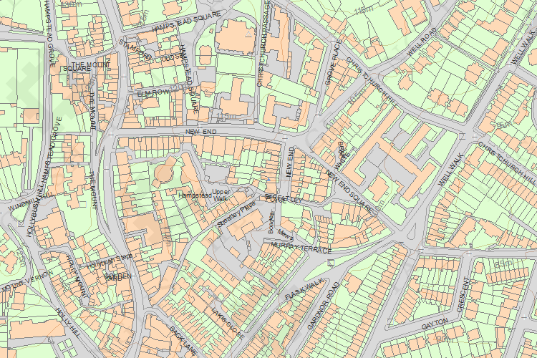
© Crown Copyright and database right 2012. All rights reserved. Ordnance Survey Licence number 100019088.
© British Crown and SeaZone Solutions Limited 2011. All rights reserved. Licence number 102006.006.

This copy shows the entry on 22-Oct-2013 at 04:35:00.

