Mr M Moradov

102 Parkway

London

NW1 TAN
102 Parkway  London  NW1 TAN |  | Application Ref: 2013/4955/P
 |  | Please ask for: Hilary Cuddy
 |  | Telephone: 020 7974 3844
 |  | 30 October 2013

Dear Sir/Madam

DECISION

Town and Country Planning Act 1990 (as amended)
Town and Country Planning (Development Management Procedure) Order 2010
Town and Country Planning (Applications) Regulations 1988

Full Planning Permission Refused and Warning of Enforcement Action to be Taken

Address:
102 Parkway
London
NW1 7AN

Proposal:
Change of use at basement, first and second floor levels from 3 x self contained residential units (Class C3) to short let holiday rental units (Class C1).

Drawing Nos: Site location plan; Change of Use Application Supporting Statement and Documentation; 1206.11.

The Council has considered your application and decided to refuse planning permission for the following reason(s):

Reason(s) for Refusal

1 | The proposed change of use to short stay accommodation (Class C1) would result in the unacceptable loss of permanent residential housing (Class C3) contrary to objectives to maximise the supply of additional homes in the borough. As such, the proposal would be contrary to Core Strategy Policy CS6 'Providing quality homes' and Development Policy DP2 'Making full use of Camden's capacity for housing' of Camden's Local Development Framework.

In dealing with the application, the Council has sought to work with the applicant in a positive and proactive way in accordance with paragraphs 186 and 187 of the National Planning Policy Framework.

ENFORCEMENT ACTION TO BE TAKEN

The Council has authorised the Planning Department to instruct the Borough Solicitor to issue an Enforcement Notice alleging breach of planning control.

Your attention is drawn to the notes attached to this notice which tell you about your Rights of Appeal and other information.

Yours faithfully
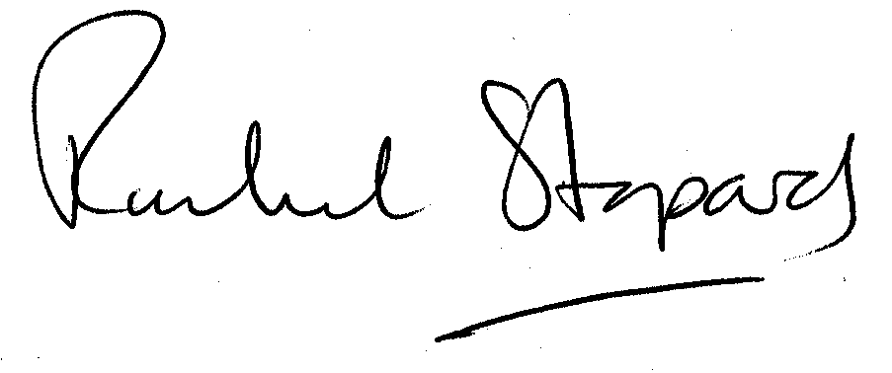
Rachel Stopard
Director of Culture & Environment

It’s easy to make, pay for, track and comment on planning applications on line. Just go to www.camden.gov.uk/planning.
It is important to us to find out what our customers think about the service we provide. To help us in this respect, we would be very grateful if you could take a few moments to complete our online planning applicants’ survey. We will use the information you give us to monitor and improve our services.

