Miss Hannah Biss
Flat 4
19 Fitzjohn's Avenue
Hampstead
NW3 5JY
Flat 4  19 Fitzjohn's Avenue  Hampstead  NW3 5JY |  | Application Ref: 2013/5579/P
 |  | Please ask for: Obote Hope
 |  | Telephone: 020 7974 2555
 |  | 31 October 2013

Dear Sir/Madam

DECISION

Town and Country Planning Act 1990, Section 191 and 192
Town and Country Planning (Development Management Procedure) Order 2010

Certificate of Lawfulness (Existing) Refused

Address:
Flat 4
19 Fitzjohns Avenue
London
NW3 5JY

Proposal:
Amenity use of roof terrace.
Drawing Nos: 393604

The Council has considered your application and decided to refuse a certificate of lawfulness for the following reason:

Reason(s) for Refusal

1 | The applicant has provided insufficient evidence to prove in accordance with Section 191 of the Town and Country Planning Act 1990 that on the balance of probability the development took place prior to 1997.

Your attention is drawn to the notes attached to this notice which tell you about your Rights of Appeal and other information.

Yours faithfully

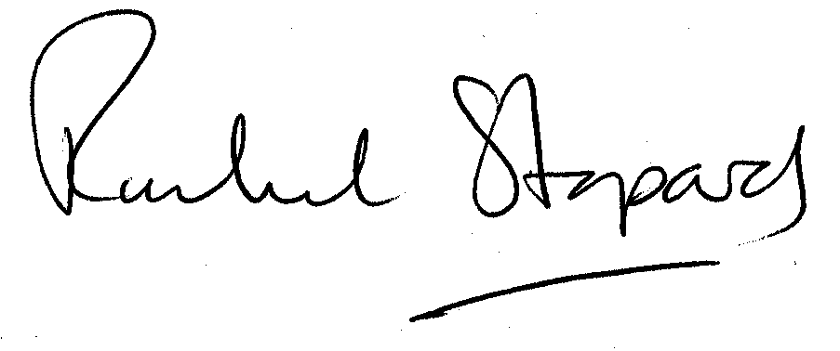
Rachel Stopard
Director of Culture & Environment

It’s easy to make, pay for, track and comment on planning applications on line. Just go to www.camden.gov.uk/planning.
It is important to us to find out what our customers think about the service we provide. To help us in this respect, we would be very grateful if you could take a few moments to complete our online planning applicants’ survey. We will use the information you give us to monitor and improve our services.

