List Entry Summary
This building is listed under the Planning (Listed Buildings and Conservation Areas) Act 1990 as amended for its special architectural or historic interest.

Name: NUMBER 16 AND GARDEN WALLS AND GATE PIERS

List Entry Number: 1379394

Location
NUMBER 16 AND GARDEN WALLS AND GATE PIERS, 16, LYNDHURST GARDENS
The building may lie within the boundary of more than one authority.
County: Greater London Authority
District: Camden
District Type: London Borough
Parish:

National Park: Not applicable to this List entry.

Grade: II

Date first listed: 01-Jul-1998

Date of most recent amendment: Not applicable to this List entry.

Legacy System Information
The contents of this record have been generated from a legacy data system.

Legacy System: LBS

UID: 478773

Asset Groupings
This List entry does not comprise part of an Asset Grouping. Asset Groupings are not part of the official record but are added later for information.

List Entry Description

Summary of Building
Legacy Record - This information may be included in the List Entry Details.

Reasons for Designation
Legacy Record - This information may be included in the List Entry Details.

History
Legacy Record - This information may be included in the List Entry Details.

Details
CAMDEN
TQ2685SE LYNDHURST GARDENS
798-1/38/1829 (South East side)
01/07/98 No.16
and garden walls and gate piers
GV II
Formerly known as: Highcrofts LYNDHURST GARDENS.
Detached house. c1886. By Harry B Measures. For William
Willett and Son, builder-developers. Red and buff bricks,
rubbed brick and terracotta dressings; tiled roofs with tall
stacks. 3 storeys with attic in roof, L-shaped asymmetrical
plan with projecting bay under gable to right. Timber sash
windows, the upper sash to windows above the ground floor with
small panes, under moulded keystones linked by string courses
and divided by pilaster strips. Entrance in narrow centre of
three-bay composition, with panelled door set under pedimented
porch with small-paned top light. Pedimented gable with
terracotta ball finials.
INTERIOR not inspected.
SUBSIDIARY FEATURES: dwarf garden wall in front with plinth,
buttresses and polygonal piers topped by terracotta finials.
The Willett houses in Lyndhurst Gardens form a compact and
powerful group.
Listing NGR: TQ2693585112

Selected Sources
Legacy Record - This information may be included in the List Entry Details.

Map

National Grid Reference: TQ 26935 85112
The below map is for quick reference purposes only and may not be to scale. For a copy of the full scale map, please see the attached PDF - 1379394.pdf
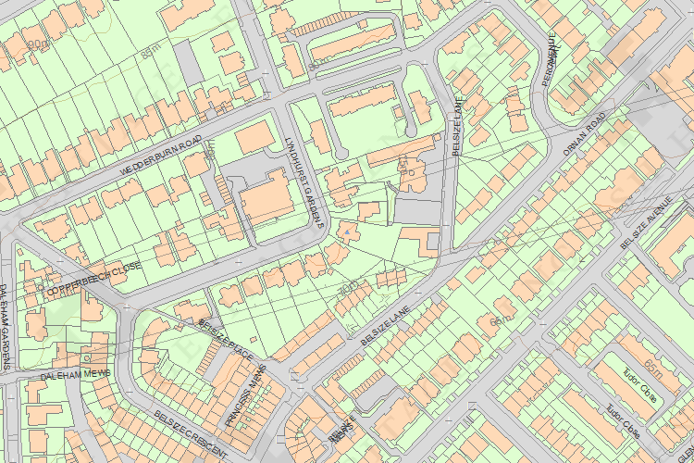
© Crown Copyright and database right 2012. All rights reserved. Ordnance Survey Licence number 100019088.
© British Crown and SeaZone Solutions Limited 2011. All rights reserved. Licence number 102006.006.

This copy shows the entry on 07-Nov-2013 at 12:21:38.

