Bchitecture
11A Beresford Road
London
N2 8AT
11A Beresford Road  London  N2 8AT |  | Application Ref: 2013/4656/P
 |  | Please ask for: Miheer Mehta
 |  | Telephone: 020 7974 2188
 |  | 31 July 2026

Dear Sir/Madam

Town and Country Planning Act 1990 (as amended)

Grant of Non Material Amendments to planning permission subject to Section 106 Legal Agreement

Address:
15 Cleve Road
Hampstead
NW6 3RL

Proposal:
Non material amendment to planning permission ref: 2013/1299/P (dated 15/05/2013) for the erection of rear extension at lower ground to second floor levels following demolition of existing rear conservatory. Creation of 2 x front lightwells and landscaping of the existing front forecourt area. In association with the change of use of the existing premises from elderly persons' residential accommodation at upper floor levels (Class C3) and an elderly persons day centre at ground and lower ground floor levels to form 9 x residential units (Class C3) (2 x 1-bed, 5 x 2-bed and 2 x 3-bed). Namely, reconfiguration of flats 1 & 3, internal alterations to flat 7 & 8.

Superseded plans/documents:
[insert Superseded plans/documents:]

Drawing Nos: 2893 072E, 2893 073E, 2893 074D, 2893 075D, 2893 076C, 2893 077B, 2893 078C, 2893 079B, 2893 080C, 2893 081C.

The Council has considered your application and confirms that the proposals are acceptable as non-material amendments to the planning permission set out above subject to the conclusion of a Section 106 Legal Agreement.

Informative(s):

You are advised that this permission relates to the changes shown on the plans referred to on this decision notice and shall only be read in the context of the substantive permission granted on 15/05/2013 under reference number [2013/1299/P] and is bound by all the conditions and obligations attached to that permission.

Your attention is drawn to the fact that there is a separate legal agreement with the Council which relates to the development for which this permission is granted.

In dealing with the application, the Council has sought to work with the applicant in a positive and proactive way in accordance with paragraphs 186 and 187 of the National Planning Policy Framework.

Your attention is drawn to the notes attached to this notice which tell you about your Rights of Appeal and other information.

Yours faithfully
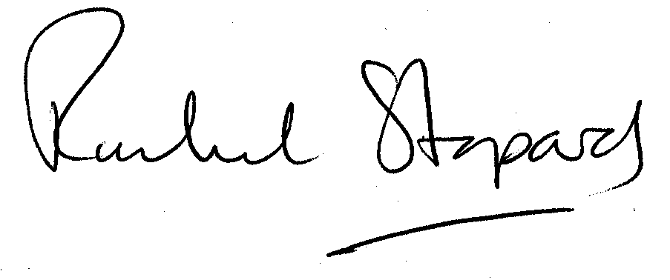
Rachel Stopard
Director of Culture & Environment

It’s easy to make, pay for, track and comment on planning applications on line. Just go to www.camden.gov.uk/planning.
It is important to us to find out what our customers think about the service we provide. To help us in this respect, we would be very grateful if you could take a few moments to complete our online planning applicants’ survey. We will use the information you give us to monitor and improve our services.

