Date first listed: 30-Jun-1969

Date of most recent amendment: Not applicable to this List entry.

Legacy System Information
The contents of this record have been generated from a legacy data system.

Legacy System: LBS

UID: 476727

Asset Groupings
This List entry does not comprise part of an Asset Grouping. Asset Groupings are not part of the official record but are added later for information.

List Entry Description

Summary of Building
Legacy Record - This information may be included in the List Entry Details.

Reasons for Designation
Legacy Record - This information may be included in the List Entry Details.

History
Legacy Record - This information may be included in the List Entry Details.

Details
CAMDEN
TQ3081NW BLOOMSBURY SQUARE
798-1/100/101 (West side)
30/06/69 Nos.9-13 (Consecutive)
White Hall Hotel (Nos.9-11) and
attached railings
GV II
5 terraced houses. c1662-5. Built by T Coxe. Many C18 & C19
alterations. Nos 10, 11 & 13 refronted c1770-2; 3rd floor
added 1841. Fronts stuccoed c1862 in Italianate style.
Nos 9-11 form a symmetrical group with a recessed central,
pedimented bay. Slated mansard roof with dormers. 4 storeys,
No.10 plus an attic storey, attics and basement. 3 windows
each. Rusticated ground floor. Pilasters rise from 1st floor,
articulating each house, carrying entablature, with dentil
cornice on outer bays. Square-headed doorcase with pilasters,
round-headed arch with keystone and voussoirs, paterae, and
cornice; fanlight and 2 leaf panelled doors. Ground floor
windows partly with hexagonal and small square leaded lights.
Architraved 2-pane sash windows, the 1st floor with cornices
and wrought-iron balconies, 2nd floor with cornices broken
upwards over the keystones. Balustraded parapet to outer bays;
central bay with pediment over the attic storey with enriched
tympanum containing a cartouche with the words "White Hall".
INTERIOR: not inspected but noted to have been reconstructed
for use as a hotel 1909-11. Nos 12 and 13 continue the terrace
north in the same style as Nos 9 and 11 but without mansard
roofs and dormers. Square-headed recessed doorways with
fanlights and panelled doors. INTERIORS: not inspected but
No.12 contains a panelled ground floor front room, formerly
the office of the historian Sir Nikolaus Pevsner.
SUBSIDIARY FEATURES: attached late C19 cast-iron railings to
areas.
HISTORICAL NOTE: No.10 was the house of Dr Robert Willan,
dermatologist, GLC plaque.
Listing NGR: TQ3028181647

Selected Sources
Legacy Record - This information may be included in the List Entry Details.

Map

National Grid Reference: TQ 30295 81638
The below map is for quick reference purposes only and may not be to scale. For a copy of the full scale map, please see the attached PDF - 1244507.pdf
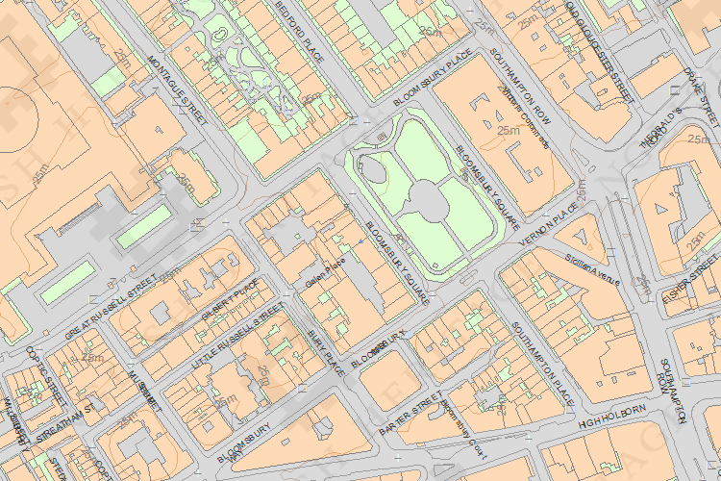
© Crown Copyright and database right 2012. All rights reserved. Ordnance Survey Licence number 100019088.
© British Crown and SeaZone Solutions Limited 2011. All rights reserved. Licence number 102006.006.

This copy shows the entry on 28-Nov-2013 at 10:42:42.

