Planning and Access Statement
The Calthorpe Project: closed loop installation

Modifications to an existing structure and an expansion of existing indoor food growing capacity are proposed for a food growing area on this educational community garden site to demonstrate a waste-energy-food closed loop cycle.
N.B. Please note the sketches in this document are not drawn to scale.

Amount
- One polytunnel replacing a smaller existing polytunnel,
- Modifications to the roof and internal layout of an existing greenhouse,
- Creation of a small external fenced area.
- Installation of four solar PV panels.

Layout
The proposed development is situated in an established, self-contained food growing area on the Calthorpe Project site – see p.2 of the FINAL Calthorpe site drawings.

Development area 1
An existing greenhouse will be partitioned into two areas with the larger space adapted for volunteer use - teas, coffees, training etc. The smaller space will house a micro anaerobic digestion (AD) system designed to process small amounts of food and green waste to generate renewable biogas and fertiliser. An adjacent outdoor area will be fenced off containing storage facilities for the AD generated fertiliser and gas.
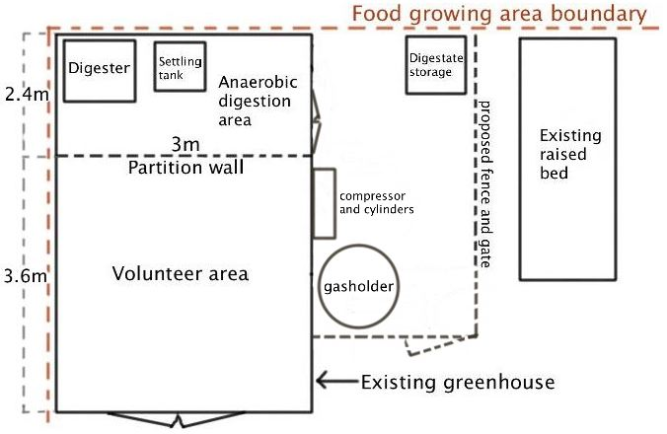
Figure 1. Showing existing greenhouse with proposed partition and outdoor fenced area

Development area 2
Approximately 5m away from Development area 1, a small existing polytunnel will be replaced by a larger one in the same location.
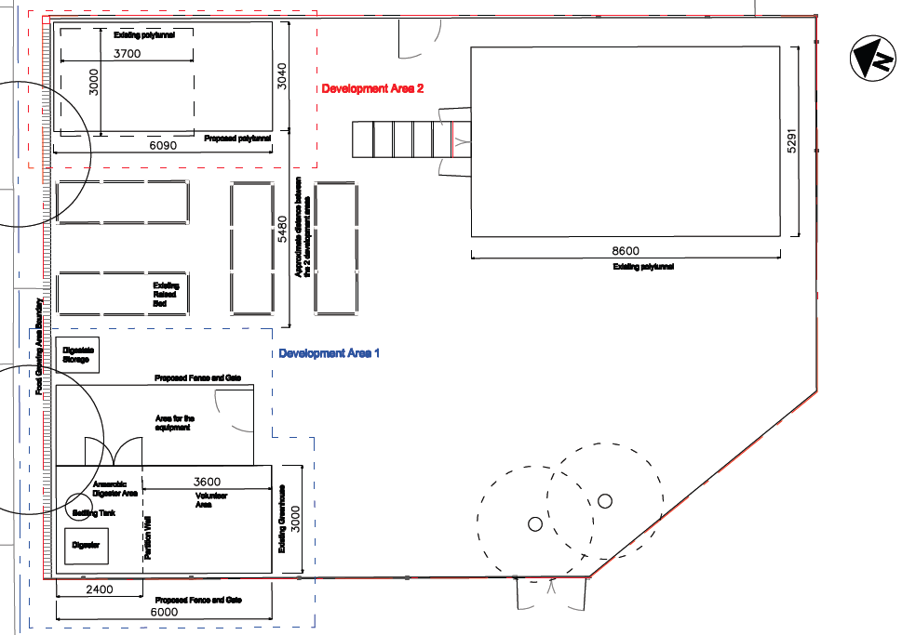
Fig 2. Overhead showing proposed works on both development areas
Scale
Development area 1
The existing greenhouse is 6m x 3m x 3.8m (length/width/height).
- A stud partition ply wall will section off a 2.4m x 3m area as shown above in Fig 1. The wall will feature a large polycarbonate window measuring 1.2m x 2.4m (height/width) for viewing/educational purposes.
- A double door will be installed measuring 1.2m x 2m (width/height) to provide access to the partitioned area.
- A 2.4m x 3m section of the roof (curved Macrolon polycarbonate sheet) will have an angled timber framework erected above it.
- On the framework, 4 x 250 watt solar PV panels will be erected at a 30º angle. The panels measure 1640mm x 992mm x 40mm.
- The proposed fence encloses an area measuring 5.5m x 2.25m (length/width) with a 1m wide gate. Both the gate and fence will be 1.2m high.

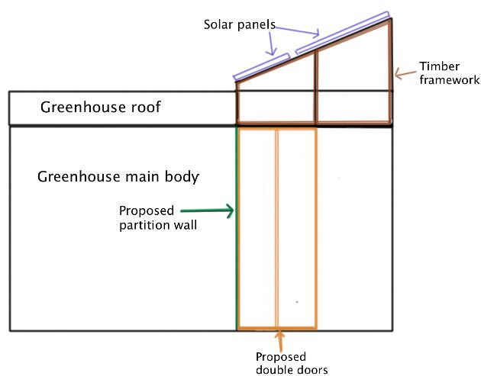

Fig 2. Section of greenhouse with roof frame and solar panels.

Development area 2
Dimensions for the proposed polytunnel are shown below with the existing polytunnel shown in blue.

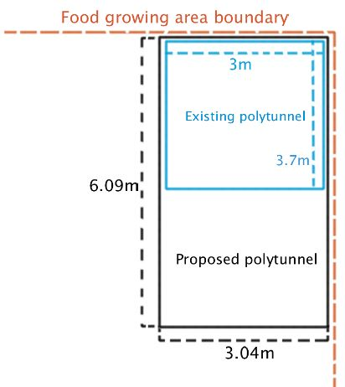
Fig 3. Proposed polytunnel shown over existing one.

Boundary fence
The food growing area and Calthorpe Project boundary will remain unchanged.

Appearance
Development area 1
The exterior of the existing greenhouse will remain the same. The partition wall inside will be a simple 2x4” timber stud wall with ply lining and a polycarbonate window. The ply will be painted white and will feature signage depicting the anaerobic digestion process and the closed-loop waste-energy-food cycle it demonstrates for educational school visits.

Timber double doors fitted with a 5 lever mortice lock and stained to match the existing greenhouse will be used for access to the digester area.

The fence and gate will be constructed from timber and stained to match the existing greenhouse.

Development area 2
The proposed polytunnel will be a larger version of the one to be replaced with a galvanized steel frame and clear polythene walls.

Access
Access will be from an existing pedestrian path, which leads from road access into the Site.

Equipment will be viewed from outside the greenhouse as well as from the volunteer area within the greenhouse. Access to the anaerobic digester section in the greenhouse and the fenced area will be restricted to staff only.

Landscaping
Landscaping will not be a feature of this site as we are aiming for a low-impact development.

Purpose
The installation will be a demonstration site for LEAP – an LBC (Innovation and Development Fund) and WRAP (DIAD II Fund) project aiming to address a range of social, economic and environmental issues during 2012-14.

The London Borough of Camden contact for LEAP is:
Eloise Shepherd
Communities and Third Sector Team
020 7974 5193
Eloise.Shepherd@camden.gov.uk

The project will pioneer a community scale low carbon, odour-free local approach to urban food waste management and renewable energy generation by demonstrating cost-effective micro anaerobic digestion systems. In an urban context, the technology has the potential to:
- create green employment opportunities,
- divert food waste from landfill,
- reduce waste transport emissions and
- support urban agriculture.

Equipment and Processes
The micro AD system will comprise:
- 1m3 anaerobic digester
- 0.75m3 settling tank for digestate
- 1m3 IBC (intermediate bulk container) for liquid digestate storage
- 1.5m3 bladder for gas storage
- Gas compressor
- Gas cylinder storage
- 1Kw solar PV installation

All equipment will be housed in the greenhouse section allocated for anaerobic digestion, and in the fenced area adjacent to the greenhouse. For ventilation, the greenhouse will have 2 opening top vents and one extractor fan and carbon filter in a side wall.

The digester will be fed with 25kgs of food waste daily, collected locally using a bicycle and trailer. Around 2m3 biogas will be produced daily and stored in a gas bladder situated outdoors. It will then be cleaned and compressed by the gas scrubber/compressor before being used to heat nearby polytunnels.

Feedstock (food and green waste) will remain in the digester for a minimum of 40 days after which, it will be separated into liquid and solid fractions before being stored in a container outside the building. The liquid will be used on-site as a liquid fertiliser while the solids will be transferred to nearby outdoor compost areas for maturing and used for horticultural activities.

The solar panels installed on the modified roof of the existing greenhouse will be connected to a controller, inverter and 3 batteries to supply on-site power for the digester and volunteer needs including tea making and lighting.

All equipment used will comprise off the shelf, tested components. Where modifications are made, these will be checked and approved by qualified engineers and technicians.

Gas composition for a maximum 5m3 biogas (6.85kgs) to be stored at any one time on-site, is approximately:
- 60% CH4 (methane)
- 33% CO2
- 6% H2O
- 1% N2 (Nitrogen)
- H2S – 500-4500mg (hydrogen sulphide)

N.B. The trace amounts of hazardous gases are so small they would not register on the planning application form but can be calculated from the figures above.

Gas Use
After scrubbing, the gas will generate heat for the polytunnels on site to aid plant growth in the winter. During warmer months, it will be used for cooking and heating water.

Noise
- The anaerobic digestion system will operate noiselessly with manual mixing and feeding.
- The compressor operates at 40 Db at 1m– approximately the volume of a well-made fridge.

Operation
The AD system will be managed by a small, CIWM (Chartered Intsitute of Waste Management) accredited trained team and will operate under the following:
- ABPR low risk matrix position;
- Exemption T25;
- Exemption U11;
- Our own operating and HACCP based procedures
- H4 odour guidelines

Calthorpe Project - LEAP partnership
The Calthorpe Project have agreed to host the installation as they have an interest in demonstrating a closed loop system and regularly host educational activities that could benefit from such a renewable energy installation.

Contamination
All work will take place above ground making excavation unnecessary, therefore no contamination will occur.

Biodiversity and conservation
While biodiversity will not be impacted by the development, the site will benefit from an increase in food growing space.

Trees and Hedges
The development will not impact any treed on or adjacent to the site and will not impact any features of geological conservation interest.

Flood risk and sewers
The site is not in a flood risk area and is not sited above any sewers.

