LIFETIME HOMES STATEMENT

FOR

New 2-bed two storey apartment
at
Rear of no 31 Percy Street,
London,
U1T 2DD

December 2013

Criterion 1 - Parking

Parking along the street at Percy Street is currently either a “pay and display” or a “permit holders parking”. There is no off street parking anywhere along that road.
It will not be possible to comply with this criterion as the width of the existing parking bays will not be adjustable due to the overall road width and the positioning of the parking bays on both sides of the street.
See attached photos.

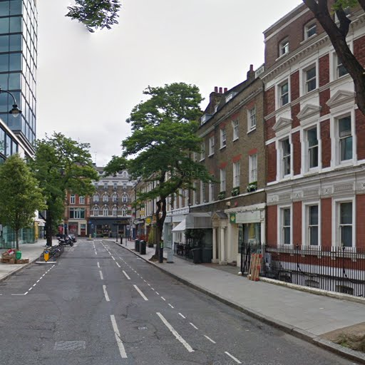

View of parking along 31 Percy Street

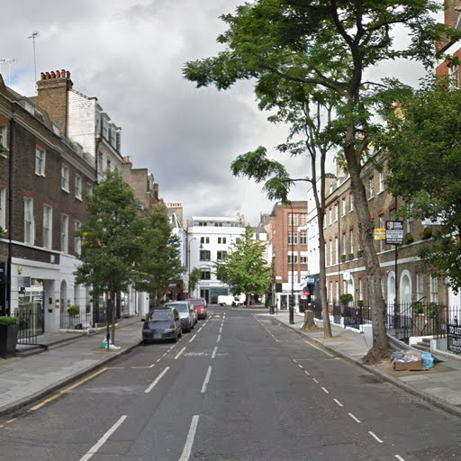

View of parking along 31 Percy Street

Criterion 2 – Approach to dwelling from parking

The approach from the existing parking to the communal entrance of no 31 Percy Street is short. However it does not have level access. It will be necessary for the council to provide a dropped kerb disabled access close to the entrance of the property. There is no alternative entrance to the development.

Criterion 3 – Approach to all entrances

The main communal entrance to the development is straight off the pavement, up 3 no steps. See attached photo.
It will not be possible to provide a ramped approach to the front entrance due to the proximity of the adjoining building entrances and the basement lightwells / stairs / railings.

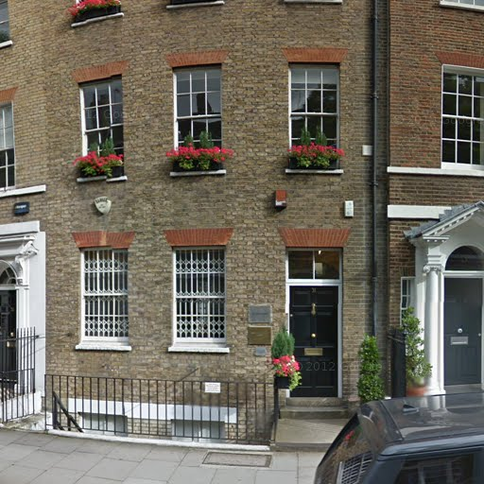

View of front entrance to no 31 Percy Street

Criterion 4 - Entrances

The main entrance is not currently illuminated but lighting could be provided.
The existing entrance does not have level access (3 no steps to access it). See above photo.
The width of the communal door and the main entrance to the proposed flat comply with Criterion 4.
There is currently no porch. The addition of a new porch will affect the overall appearance of the street. The adjoining properties are listed.
Access into the proposed flat is as shown on the drawings.

Criterion 5 – Communal stairs and lift

Not applicable for this development.

Criterion 6 – Internal doorways and hallways

The existing hallway width is 2090 mm in the communal part and it narrows down to 1110 mm by the proposed flat’s main entrance.
Doorway widths are as shown on the drawings.

Criterion 7 – Circulation space

All rooms except the single bedroom comply with criterion 7 circulation requirements.
However, it must be noted that access to the ground floor is down via 3 no steps and access to the first floor is via a staircase. The single bedroom floor level is higher than the landing level.
All the above is due to the difference in levels between the existing building and the new building.
The new toilet provided for the ground floor office of no 31 is at a higher level than the rest of the development which means that the floor level of the single bedroom is affected.
A stair lift could be installed but it will reduce the width of the access to both floors. The site restriction means that the building cannot be made larger to accommodate lifetime homes requirements.

Criterion 8 – Entrance level living space

The living room of the proposed flat is on the new courtyard ground level which is lower than the existing adjoining ground level.
Due to the difference in levels the living room is not easily accessible from the flat’s front door. See plans and sections / elevations and item 3.4 of the Design and Access Statement.
This difference in levels was necessary to allow for the roof of the proposed building to be at the same level as the roofs of the adjoining properties.

Criterion 9 – Potential for entrance level bed-space

An entrance level bed-space could be provided in the living room but as pointed in Criterion 8 above, it is not easily accessible from the front entrance of the flat.

Criterion 10 – Entrance level WC and shower drainage

There is a provision for an entrance level WC but in order to comply with all the criteria (ie shower drainage provision) it will need to be bigger which affect the size of the lounge / dining area. The WC is 1000 mm wide by 1500 mm long.

Criterion 11 – WC and bathroom walls

Both the ground floor WC and the first floor bathroom could comply with Criterion 11. The wall construction will take into account for any future grab rail fixing.

Criterion 12 –Stairs and potential through-floor lift in dwellings

A stair lift can be fitted to the staircase but it will reduce access so this will not be a good solution. It is not possible to have a wider staircase due to the restrictions of the site.
A through-floor lift can be fitted from the lounge to bedroom 1. See revised drawings.
However again it must be noted that it is difficult to access the living room from the front door.

Criterion 13 – Potential for fitting of hoists and bedroom / bathroom relationship

The bathroom is adjacent to bedroom 1 so a hoist could be fitted between the two.
A full height “knock-out panel” can be installed on the wall between the two.

Criterion 14 – Bathrooms

The first floor bathroom complies with Criterion 14. Floor drainage will be added for future use.

Criterion 15 – Glazing and window handle heights

The windows will comply with Criterion 15.

Criterion 16 – Location of service controls

All service controls will comply with Criterion 16.

Summary

The proposed development design is influenced by the existing site constraints and the location of the site.
Some of the Criteria of the Lifetime Homes can be complied or partially complied with but as indicated above it will not be possible to comply with Criteria 1, 2, 3, 4, 10.

