Figure 1: (7mm screw affixed at the back of plaque)

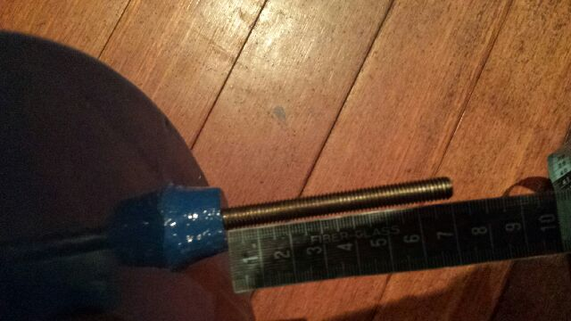

FFigure 2: (Blue Pla que 18 inch in diameter

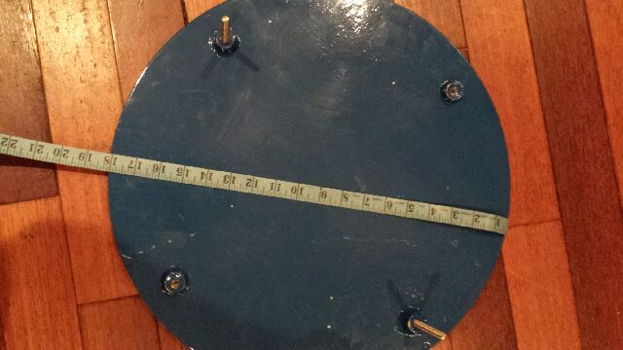

Figure 3: (18in plaque with 7mm screws affixed at the back of plaque)
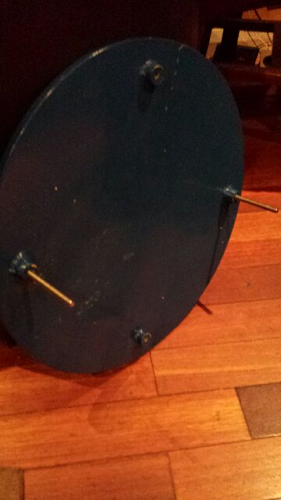



Figure 4 : Example of NJCT blue plaque

