DESIGN & ACCESS STATEMENT with HERITAGE STATEMENT accompanying householder planning/listed building application for
2O CHURCH ROW, LONDON NW3 6UP.

As far as they apply, this statement has been prepared in accordance with the headings and guidelines issued by DC-CABE.

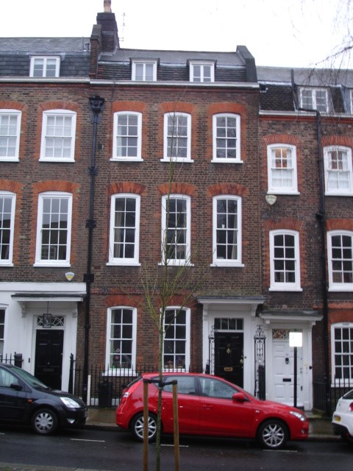

January 2014

- USE

  - The listed house is part of a Georgian terrace and comprises basement, ground, first, second and third floors.

  - The proposal is to convert an empty ground floor rear room into a small bathroom. This will allow the ground floor to accommodate a full-time carer looking after the owner of the house, providing them with their own living room, bedroom and bathroom.

  - No other changes or works are proposed.

- AMOUNT

  - The proposal does not alter the size of the house.

- LAYOUT

  - The proposal does not alter the overall layout of the house.

- SCALE

  - The scale if the property is unaffected by the proposal.

- LANDSCAPE

  - The main garden is at the rear and is unaffected by the proposal.

- APPEARANCE

6.1 The external appearance is unaffected except for the new waste connections into the back of an existing cast iron soil stack and the insertion of a cast iron grille in the wall, to serve an extract fan. There is already a similar grille from a basement fan.

- ACCESS

  - Pat M is unaffected by the proposal.

- HERITAGE STATEMENT

  - The house was constructed in about 1720 and listed in 1950; it is Grade II*.

  - Most internal features remain, such as panelling and cornices, but the rear room has plain plastered walls and no features will be removed or altered as a consequence of the proposal. The rear window in the room is unaffected by the proposal.

  - The proposal has no structural, archaeological or environmental implications. The bathroom could be removed at some future date and the room returned to its existing condition.

rear elevation
