DESIGN AND ACCESS STATEMENT TO ACCOMPANY A PLANNING
APPLICATION FOR ALTERATIONS AND EXTENSIONS TO:

218 TO 228 KENTISH TOWN ROAD
LONDON
NW5 2AD

INCLUDING A SUSTAINABILITY STATEMENT

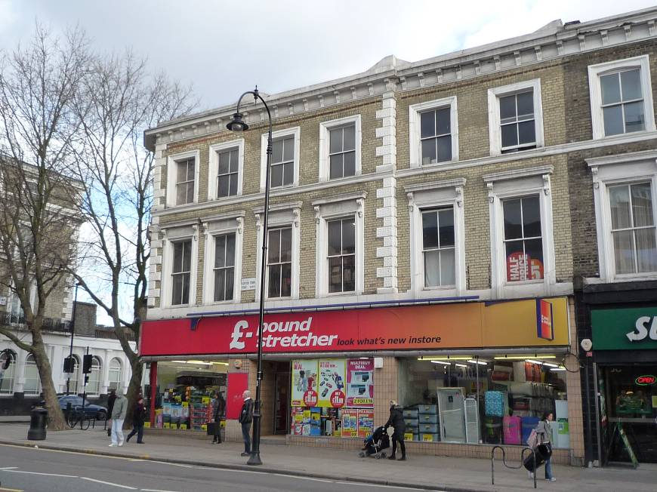


Prime Meridian
26A Ganton Street
London
W1F 7QZ

November 2013

CONTENTS

Page no

Application drawing schedule 2

1. Introduction to the application 3
2. Description of the existing situation 3
2.1 The existing buildings 3
2.2 The surrounding context 6
3. Description of the proposed development 10
3.1 Introduction 10
3.2 Alterations to the existing buildings 11
3.3 The new build elements 12
3.4 Summary 12
4. Camden Planning Policy 13

Appendix A 20

Sustainability Statement 21

APPLICATION DRAWING SCHEDULE

The following drawings are submitted with this planning application, Prime Meridian drawing numbers –

417.11/PLA01 Existing site plan
417.11/PLA02 Existing ground floor plan
417.11/PLA03 Existing first floor plan
417.11/PLA04 Existing second floor plan
417.11/PLA05 Existing elevations
417.11/PLA06 Existing elevations
417.11/PLA07 Existing elevations
417.11/PLA19 OS site location plan
417.11/PLA21 Block Plan
417.11/PLA22 Proposed ground floor plan
417.11/PLA23 Proposed first floor plan
417.11/PLA24 Proposed second floor plan
417.11/PLA25 Proposed roof plan
417.11/PLA26 Proposed elevations
417.11/PLA27 Proposed elevations
417.11/PLA28 Proposed elevations
417.11/PLA29 Proposed elevations

1. INTRODUCTION TO THE APPLICATION

1.1 This Statement has been prepared in support of a planning application to undertake alterations and extensions to the existing buildings at 218 to 228 Kentish Town Road, London, NW5 2AD. Part of the rear of No 222 Kentish Town Road is also included within the proposals.

1.2 The development includes –

- Alterations to the existing 1st and 2nd floors of the building facing onto Kentish Town Road, to change the use from commercial to residential and to reconfigure both floors to form self contained flats.

- Additions over the existing building fronting onto Wolsey Mews.

- Improvements to the energy efficiency and sustainability of the retained existing buildings.

1.3 The planning application documents include drawings showing the existing and proposed layout of the buildings, a Design and Access Statement and a Sustainability Statement.

1.4 The buildings are not Listed, nor are they located within a Conservation Area.

2. DESCRIPTION OF THE EXISTING SITUATION

2.1 The existing buildings

2.1.1 The address of the property is 218 to 228 Kentish Town Road, to be known in this Statement as The Property. Part of the ground floor of No 222 is also included within the proposals.

2.1.2 The Property consists of three former townhouses, each of three storeys, which form the northern end of a terrace of thirteen similar properties, located along the eastern side of Kentish Town Road (see Photograph No1.). No. 228 is on the northern end of the terrace, on the corner of Kentish Town Road and Caversham Road.

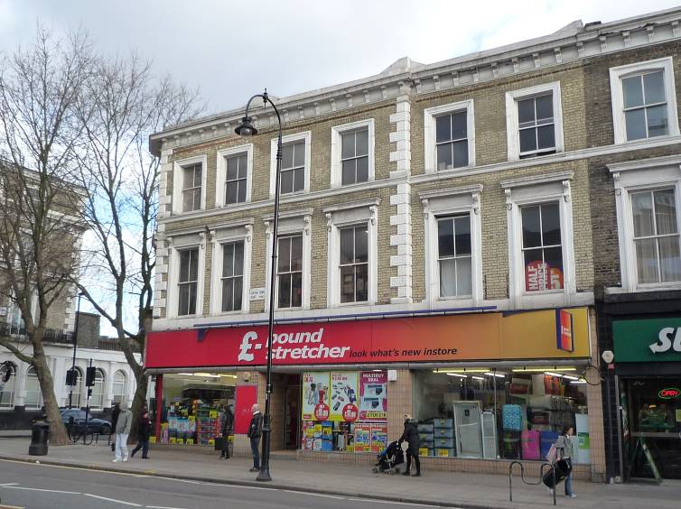

Photograph No1 – The Property viewed from Kentish Town Road

2.1.3 The Property occupies all of the area bounded by Kentish Town Road, Caversham Road and Wolsey Mews, see the block plan in Figure No1.

2.1.4 The buildings facing onto Wolsey Mews are single storey, modern replacements to the original mews buildings.

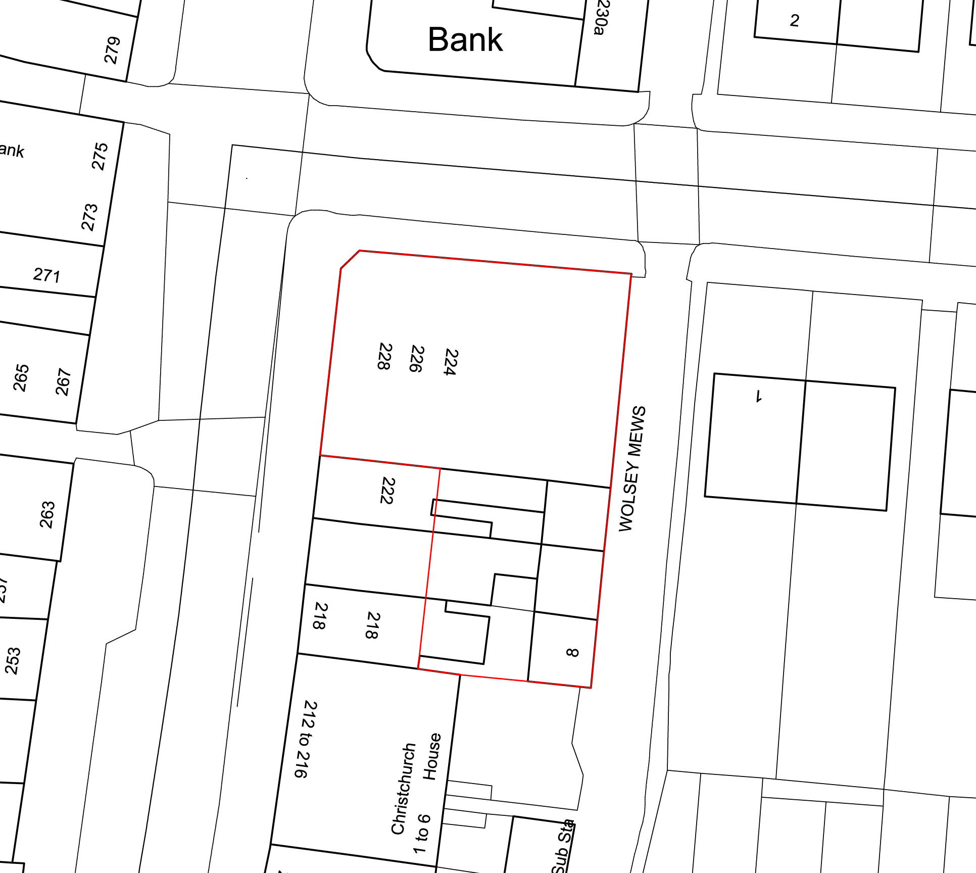

Figure No1 – Block plan of The Property

2.1.5 The ground floor is currently arranged as a single retail unit, with a large sales area, storage and staff facilities, and it extends up to the Wolsey Mews boundary. Extensive sections of the original ground floor party wall between Nos 224 & 226 and 226 & 228 have been removed to form an unobstructed sales area.

2.1.6 The first floor is used as storage for the retail unit, as well as staff accommodation, and the second floor is used for associated commercial use. Currently, the sole access to the first and second floors is through the ground floor retail unit as there is only one staircase remaining from the original three houses at ground floor level. Consequently, the conversion of the upper floors to a new, non-commercial use is only possible if a new access, direct from outside, is provided to these levels.

2.1.7 The Kentish Town Road elevation has a deep fascia panel above the shopfront, and it continues around the corner along the Caversham Road elevation. The Caversham Road elevation is part glazed shopfront and part solid brickwork (see Photograph No.2).

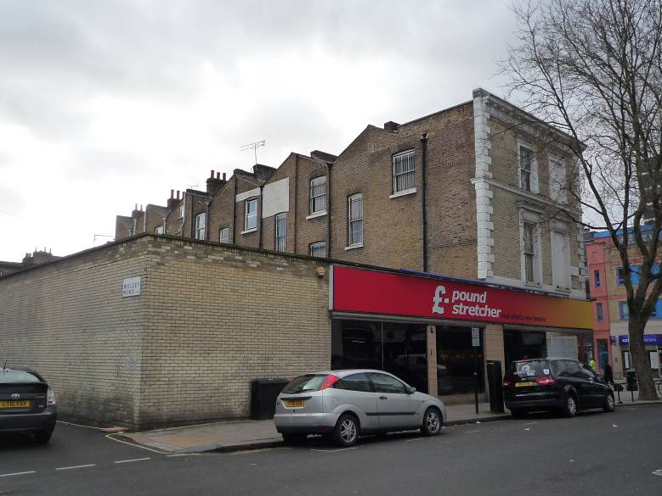

Photograph No 2 – The Caversham Road elevation

2.1.8 The Wolsey Mews elevation is of blank modern brickwork (see Photograph No. 4), and the parapet of the wall is in line with the top of the retail fascia panel.

2.1.9 The Property is constructed of solid masonry external walls, timber internal partitions, timber floors and timber roof structures. The windows above ground floor level are of timber and the large ground floor shopfront is of aluminium.

2.1.10 Above ground floor level, the Kentish Town Road elevation is an ordered composition, with two bays to each of the original three town houses at first and second floor levels. The front wall of Nos. 228 & 226 projects beyond the wall of No. 224 and is conceived as an end pavilion to the original terrace of thirteen houses There is a matching projection at the southern end of the terrace (Nos. 204 & 206). The projection is emphasised by Coade stone quoins to Nos. 228 & 226. Two matching bays, one of which has blind window openings, return along the Caversham Road elevation which also terminates in Coade stone quoins.

2.1.11 The Kentish Town Road windows at first and second floor levels have stone surrounds, and the larger first floor windows have carved brackets supporting flat pediments. A stone string course runs at the level of the second floor window cills and returns down the Caversham Road elevation.

2.1.12 The roof is a low pitched, slated construction behind a projecting and bracketed white parapet to the Kentish Town Road elevation.

2.1.13 The rear elevation is of unadorned London stock brickwork, without an upstand parapet as seen on the front elevation, apart from at the northern end of No. 228. Consequently, the pitched form of the roof is clearly visible. The high points are along the party wall lines, with upstand brick parapets and the low points are in the centre of each house, with the valley gutters clearly visible. The windows are large and the positions of the original staircases are clearly expressed in the fenestration.

2.2 The surrounding context

2.2.1 The Property is part of an original block composition of 13, three storey townhouses, fronting onto Kentish Town Road, with ancillary outbuildings fronting onto Wolsey Mews. A similar composition was constructed contemporaneously to the north of The Property, in the block of buildings on the northern side of Caversham Road.

2.2.2 The original site layout of townhouses with rear mews is shown on the OS map dated 1875, see Figure No 2, and it can be seen that this arrangement was common to the eastern side of Kentish Town Road.

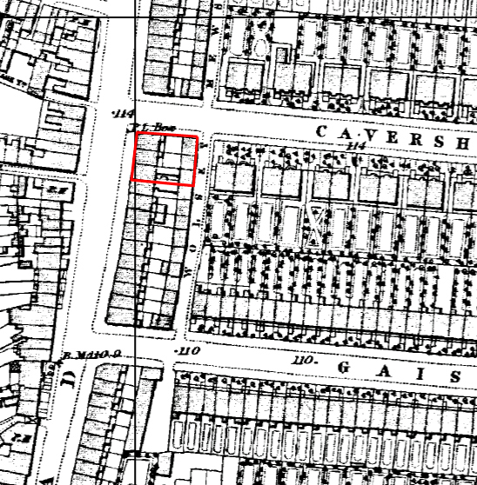

Figure No2 – The area as shown on the 1875 OS map showing, the original 3 storey townhouses fronting Kentish Town Road and two storey mews facing Wolsey Mews

2.2.3 At the southern end of the Mews, the rear of Nos. 204 to 208 Kentish Town Road, remain substantially as originally constructed (see Photograph No. 3). However overtime, alterations have taken place to the Wolsey Mews frontage of The Property which has significantly altered the original design.

2.2.4 In the background of Photograph No. 3, there is a modern building on the corner of Kentish Town Road and Gaisford Road. This replaces the original townhouse and mews on this site. This building returns along Gaisford Road with a three storey element which abuts the houses on the southern side of Gaisford Road.

2.2.5 Further to the south, on the corner of Kentish Town Road and Patshull Road, a modern three storey building was constructed in the 1990’s to turn the corner and run along the southern side of Patshull Road, in a similar configuration to that described in 2.2.3

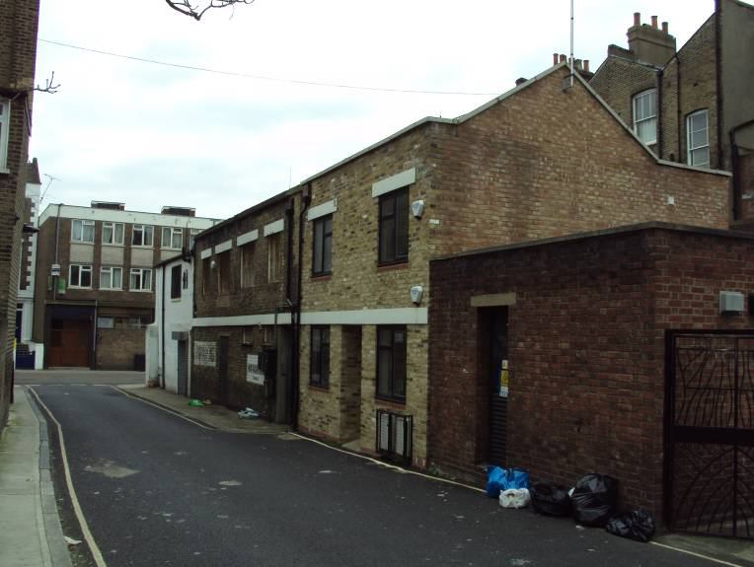

Photograph No 3 - The rear of Nos 204 to 208 Kentish Town Road, with original and rebuilt two storey mews buildngs

2.2.6 The original two storey buildings fronting Wolsey Mews have been demolished and replaced with a tall, blank modern brick wall (see Photograph No. 4), which forms the back wall of the large ground floor retail unit.

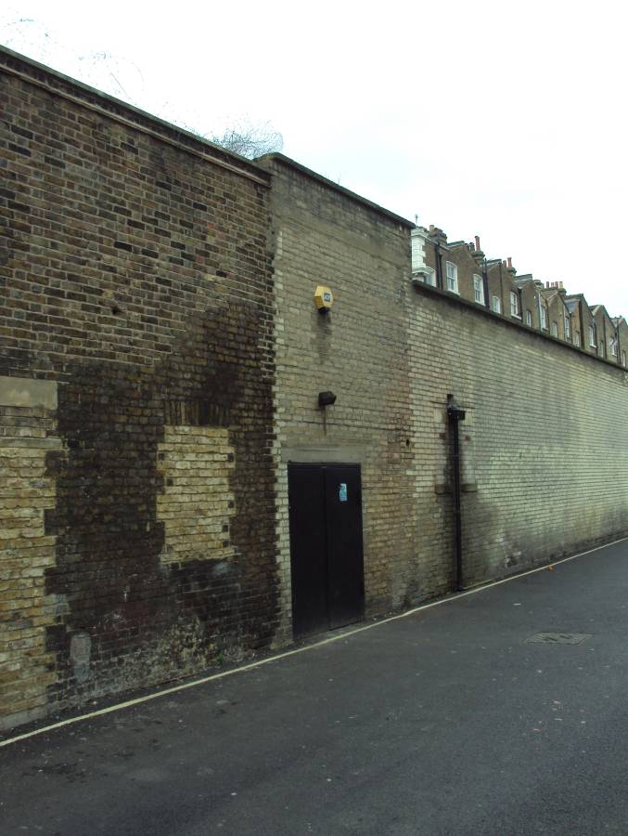

Photograph No 4 – The Wolsey Mews elevation of Nos. 224 to 228 Kentish Town Road, showing modern blank brick walls which replace the original two storey mews buildings

2.2.7 The building on the northern side of Caversham Road, facing the proposed extension, is the two storey original mews building (see Photograph No. 5).

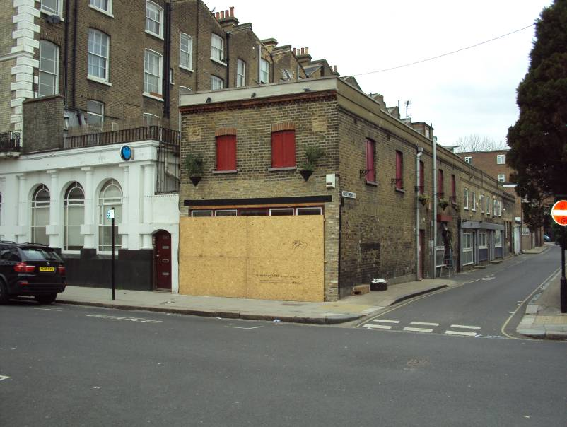

Photograph No 5 –The building on the north side of Caversham Road

2.2.8 Wolsey Mews continues northwards, across Caversham Road, as shown in Photograph No. 5. It can be seen that approximately 50% the original two storey buildings fronting onto the mews survive relatively unaltered.

2.2.9 Photograph No 6 shows that the original buildings at the north end of Wolsey Mews have been replaced with modern, two and four storey buildings. This example, and those referred to in 2.2.4 and 2.2.5, give local instances where three storey buildings have been constructed on the side road leading off of Kentish Town Road. This principle is developed in the proposed extension to No 228.

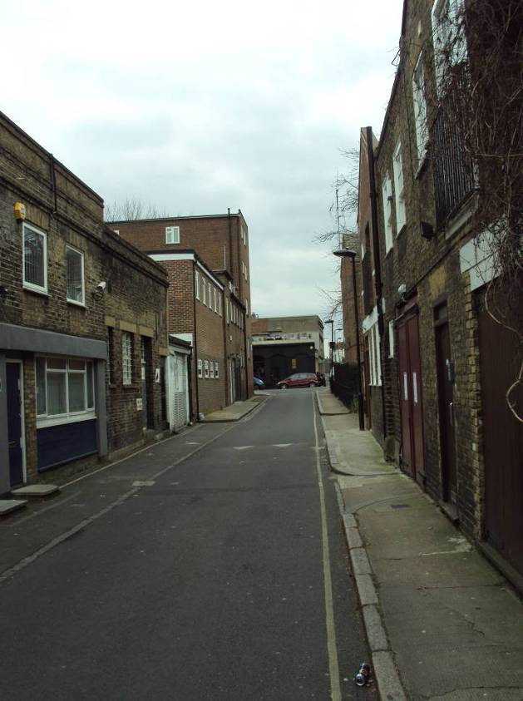

Photograph No 6 – The northern end of Wolsey Mews, showing modern two and four storey buildings fronting the Mews
2.2.10 To the east of Wolsey Mews is a four storey townhouse, No. 1 Caversham Road (see photograph No. 7). This house has staircase and ancillary room windows facing the rear of No. 224 Kentish Town Road.

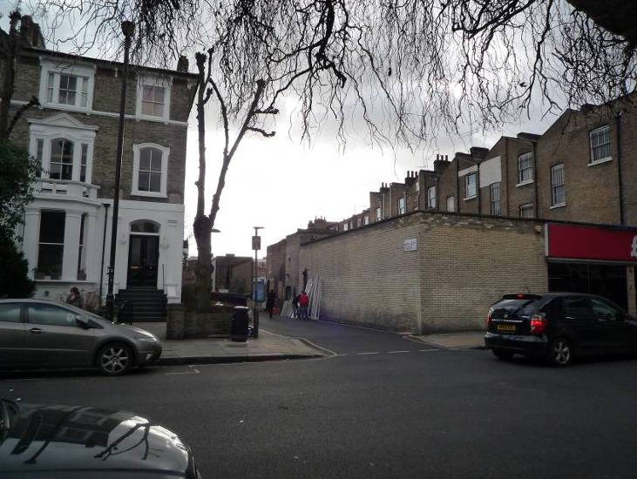

Photograph No 7 – The adjoining 4 storey house at No1 Caversham Road

2.2.11 There are two sites in adjoining streets where new buildings have been undertaken in a modern, rather than a traditional style. The first is in Gaisford Street, where an infill to the existing terrace of houses has been constructed with a plain and unadorned elevation, with large pane windows and inset balconies (see Photograph No 8).

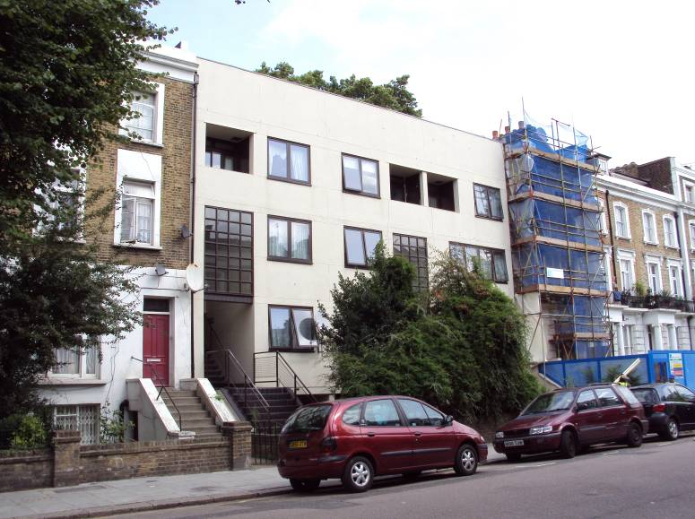

Photograph No 8 – modern infill in Gaisford Street

The other example is an extension to the school in Islip Street (see Photograph No. 9). Here the building is clad in stained vertical and horizontal timber boarding, in contrast to the brickwork of the original buildings. The building also has varying pitched roofscapes, which produce a vibrant effect.

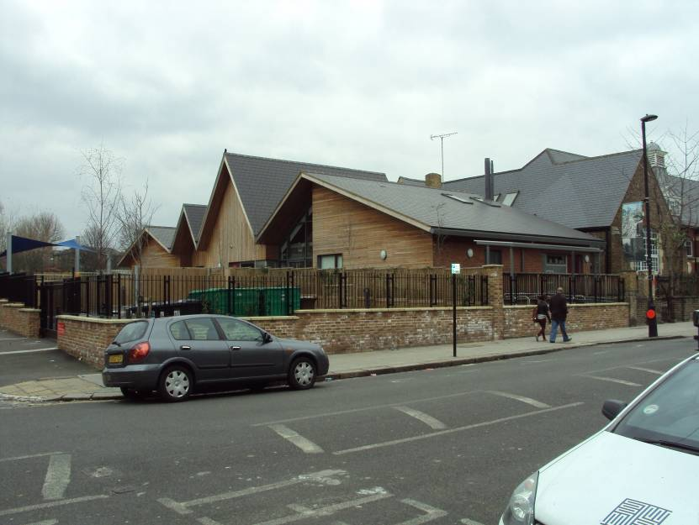

Photograph No 9 – modern school extensions in Islip Street

3. DESCRIPTION OF THE PROPOSED DEVELOPMENT

3.1 Introduction

3.1.1 There are two parts to the proposed development. Firstly, the alterations to the existing buildings fronting Kentish Town Road, and secondly, the construction of new accommodation over the existing single storey elements fronting onto Caversham Road and Wolsey Mews.

3.1.2 The proposals to the Kentish Town Road buildings involve very minor alterations to the external fabric, in adaptation of two existing staircase windows into doors on the rear elevation. Internally, there are alterations to existing walls and openings on the 1st and 2nd floors to reconfigure the existing space into five self contained flats.

3.1.3 The new build elements at the side and rear create four new flats in a two storey extension along Caversham Road and a single storey extension along Wolsey Mews.

3.1.4 The schedule of flats in the proposal is as follows –

Flat no | Number of bedrooms | Gross internal floor area sqm | Location of the flat
1 | 3 | 82 | Existing building
2 | 1 | 42 | Existing building
3 | 1 | 48 | Existing building
4 | 1 | 42 | Existing building
5 | 1 | 48 | Existing building
6 | 1 | 50 | New extension
7 | 1 | 50 | New extension
8 | 2 | 84 | New extension
9 | Studio | 33 | New extension

3.1.5 The ground floor retail area remains unaltered, as does the ground floor shopfront to the Kentish Town Road and Caversham Road elevations.

3.1.6 Due to the previous alterations to the internal layout of the ground floor of Nos. 218 – 228, the only means of access to the upper parts is through the retail unit. This is clearly an impractical arrangement for a proposed change to residential use of the first and second floors. Therefore, a new means of entrance into these areas is required. This will be via the rear flat roof into the original stairwells.

3.2 Alterations to the original buildings

3.2.1 Section 2.1 describes the existing situation of The Property, whereby the original three storey townhouses have been altered and adapted to form a large retail unit across the ground floor, with ancillary commercial space on the first and second floors. This proposal seeks to re-instate the original residential use to the upper floors.

3.2.2 The existing floor areas in The Property are as follows –

 | Retail floor area sqm | Ancillary commercial area sqm | Total sqm
Ground floor | 413
First floor |  | 132
Second floor |  | 132
Total | 413 | 264 | 677

The proposed floor areas in The Property are as follows -

 | Retail floor area sqm | Residential floor area sqm | Total sqm
Ground floor | 413
First floor |  | 132
Second floor |  | 132
Total | 413 | 264 | 677

It can be seen from the above tables that no new floor space will be created within the existing buildings.

3.2.3 The Property has been altered over time to create spaces for the current commercial uses and the main alterations have been –

- The removal of the original ground floor facades on the Kentish Town Road and Caversham Road elevations, and the installation of a large paned, glazed retail shopfront with a deep, coloured and branded fascia above.

- The removal of the ground floor party walls, staircases and internal cross walls to open up the ground floor to form a single retail unit.

- Internal alterations to first and second floor levels, which have removed many of the features of the original three townhouses.

- The demolition of the original mews buildings facing onto Wolsey Mews and Caversham Road and the construction of new blank brick walls to the retail unit.

3.2.4 The conversion of the 1st and 2nd floors to a new residential use involves internal alterations to the staircases and partitions to form the five new flats. New bathrooms and kitchens will be provided as well as new services installations.

3.2.5 The most significant alteration to the existing buildings is the creation of two new entrances from the rear flat roof as the means of access to the five flats. Access onto the roof from ground level is achieved via a staircase up from Wolsey Mews. This approach is necessary as there is not a route from the Kentish Town Road frontage to either of the retained staircases.

3.2.6 The existing building will be retro-fitted to improve the acoustic and thermal insulation which is discussed in the Sustainability Statement.

3.3 The New Build Elements

3.3.1 The new extensions are located over the rear of Nos. 218 – 228 along Wolsey Mews. This alters where change in parapet heights allow, from one storey to two storey, with Unit 9 being significantly lower to allow for a more transient reduction in ridge height closer to that of 210 - 204. These new extensions and the existing buildings fronting Kentish Town Road, remain separate but wholly linked by the communal roof space shared between them. This is the approach route to all of the nine flats, and provides an amenity for the residents.

3.3.2 Section 2 has discussed the form of the original buildings on the site, which included two storey mews buildings fronting onto Wolsey Mews, and noted that a significant number of these buildings still exist along the mews. This proposal seeks to reinstate the two storey mews to the rear of Nos 218 - 228.

3.3.3 The gables facing Caversham Road are clad in a light grey panel system, with aluminium windows integrated into the panel modules. At the junction of the new wall with the corner of the existing building, the new wall is set back to retain the existing Coade stone quoins and to create a clear demarcation between existing and new. A lightweight cladding system has been chosen combined with brick, to keep the weight of the new elements to the minimum, as the new loads will need to be transferred to the existing building structure.

3.3.4 The Wolsey Mews extension is clad in brickwork which is in keeping with the other original and rebuilt mews nearby. The rear wall to No 222 will be adapted to form the entrance to the development and for access to the waste and recycling bin area and the bicycle storage area.

3.3.5 Access to all of the flats is via an entrance onto Wolsey Mews through No 222, which leads to a flight of steps up onto first floor roof level.

3.4 Summary

3.4.1 The Property is formed of three original townhouses which are the northern end of a long terrace of buildings. The Kentish Town Road elevation and the rear elevation remain substantially unaltered from their original design at first and second floor levels, as does the original roof structure. However, the ground floor Kentish Town Road and Caversham Road elevations have been substantially altered by the installation of a large, continuous, glazed panel shopfront, which is consistent with all of the other buildings in the terrace. The original rear two storey mews buildings have been demolished.

3.4.2 There have been significant internal alterations at ground floor level, to form a single retail space across the three original townhouses, with masonry piers remaining to support the upper floors. Openings have also been formed in the party walls at first and second floor levels.

3.4.3 The proposed alterations to the Kentish Town Road buildings will re-instate the original residential use to the first and second floors.

3.4.4 The proposed new extensions will, in part, re-instate the form of the original two storey buildings along Wolsey Mews albeit adapted so reduce the impact on the area with lower and changing eaves heights, with set backs to reduce the overall massing impact.

3.4.5 The proposed alterations will include significant improvements to the energy efficiency of the existing buildings, and the sustainability when assessed across a variety of criteria within the BRE Domestic Refurbishment Assessment. The new extensions will be designed to achieve Level 4 of the Code for Sustainable Homes.

4. Camden Planning Policy

Camden Council publishes a range of Development Policies which describe the framework for development in the Borough. This section discusses the Development Policies relevant to these proposals. In this section the Policy is written in italic text and commentary follows.

4.1 Policy DP5 – Homes of different sizes

4.1.1 Policy:

The Council will contribute to the creation of mixed and inclusive communities by securing a range of self-contained homes of different sizes. We will:

a) seek to ensure that all residential development contributes to meeting the priorities set out in the Dwelling Size Priorities Table, including conversion of existing residential and non-residential floorspace;

 | 1 bedroom | 2 bedrooms | 3 bedrooms | 4 bedrooms or more | Aim
Social rented | lower | medium | high | very high | 50% large
Intermediate affordable | medium | high | high | high | 10% large
Market | lower | very high | medium | medium | 40% 2 bed

Dwelling Size Priorities Table

b) expect a mix of large and small homes in all residential developments.

In considering the mix of dwelling sizes appropriate to a development, the Council will have regard to the different dwelling size priorities for social rented, intermediate affordable and market homes, and will take into account:

c) the character of the development, the site and the area, including the impact of the mix on child density;

d) site size, and any constraints on including homes of different sizes; and

e) the economics and financial viability of the site, including the demand for homes of different sizes.

4.1.2 Discussion:

The proposed flats will be for the private market sector.

There are no residential units in the existing building. The proposals will provide a total of nine flats, with the following mix –

No of bedrooms | No of flats | % of total
Studio | 1 | 11
1 | 6 | 67
2 | 1 | 11
3 | 1 | 11

The Dwelling Size Priorities Table shows that the very high priority for Market accommodation is two bedroom flats, and the aim is 40% of the total in the development. The proposal includes 11% of the total as two bedroom units in response to the previous application which required the whole development to be reduced. However, the arrangement of the existing building does favour the provision of one bedroom units, and 66% of the total are one bedroom flats. All effort has been made to meet the requirements.

The existing site constraints precluded the provision of any external amenity space or play area on the previous application. This has since been addressed with most of the Wolsey Mews units having a private terrace. The proposed mix with a majority of one and two bedroom flats, will appeal to single people and 2 to 4 people sharing rather than to families.

4.2 Policy DP6 – Lifetime Homes and wheelchair housing

4.2.1 Policy:

All housing development should meet Lifetime homes standards. 10% of homes developed should either meet wheelchair standards, or be easily adapted to meet them.

4.2.2 Discussion:

The latest iteration of the Lifetime Homes (LTH) is the revised criteria published on 5th July 2010. There are 16 design criteria, which are listed below -

- Criterion 1 Parking (width or widening capacity)
- Criterion 2 Approach to dwellings from parking (distance, gradients and widths)
- Criterion 3 Approach to all entrances
- Criterion 4 Entrances
- Criterion 5 Communal stairs and lifts
- Criterion 6 Internal doorways and hallways
- Criterion 7 Circulation space
- Criterion 8 Entrance level living space
- Criterion 9 Potential for entrance level bed-space
- Criterion 10 Entrance level WC and shower drainage
- Criterion 11 WC and bathroom walls
- Criterion 12 Stairs and potential through floor lift in dwellings
- Criterion 13 Potential for future fitting of hoists and bedroom/bathroom railings
- Criterion 14 Bathrooms
- Criterion 15 Glazing and window handle heights
- Criterion 16 Location of service controls

This application is for alterations and extensions to existing buildings. The existing structure and layout of the existing buildings do impose constraints on the scope and range of LTH standards that are achievable in the proposed development.

Paragraph 6.5 of Camden Development Policies acknowledges that -

“the design or nature of some existing properties means that it will not be possible to meet every element of the lifetime homes standard, for example in listed buildings, but considers that each scheme should achieve as many features as possible. All housing proposals should be accompanied by a submission showing how each of the lifetime homes standards will be met, with a full justification why any individual element will not be met”

The nature of the proposals makes it difficult for all of the flats to comply with all of the 16 LTH criteria. Table No1 shows which LTH criteria have been met for each of the 8 proposed flats.

SUMMARY OF COMPLIANCE WITH LIFETIME HOMES STANDARDS
FLAT NO | 1. Parking width | 2. Approach from parking | 3. Approach to all entrances | 4. Entrance | 5. Stairs and lifts | 6. Internal doorways | 7. Circulation space | 8. Entrance level living space
1 | No parking | No parking | Not level | Yes | Communal stairs – yes | Yes | Yes | Yes
2 | No parking | No parking | Not level | Yes | Communal stairs – yes | Yes | Yes | Yes
3 | No parking | No parking | Not level | Yes | Communal stairs – yes | Yes | Yes | Yes
4 | No parking | No parking | Not level | Yes | Communal stairs – yes | Yes | Yes | Yes
5 | No parking | No parking | Not level | Yes | Communal stairs – yes | Yes | Yes | Yes
6 | No parking | No parking | Not level | Yes | Communal stairs – yes | Yes | Yes | Yes
7 | No parking | No parking | Not level | Yes | Communal stairs – yes | Yes | Yes | Yes
8 | No parking | No parking | Not level | Yes | Communal stairs – yes | Yes | Yes | Yes
9 | No parking | No parking | Not level | Yes | Communal stairs - yes | Yes | Yes | Yes
FLAT NO | 9. Potential bed space | 10.Entrance level wc | 11.Bathroom walls grab rails | 12. Stairs and floor lift | 13. Future hoists | 14. Bathrooms | 15. Glazing | 16. Service controls
1 | Yes | Yes | Yes | Single storey | Yes | Yes | Yes | Yes
2 | Yes | Yes | Yes | Single storey | Yes | Yes | Yes | Yes
3 | Yes | Yes | Yes | Single storey | Yes | Yes | Yes | Yes
4 | Yes | Yes | Yes | Single storey | Yes | Yes | Yes | Yes
5 | Yes | Yes | Yes | Single storey | Yes | Yes | Yes | Yes
6 | Yes | Yes | Yes | Single storey | Yes | Yes | Yes | Yes
7 | Yes | Yes | Yes | Single storey | Yes | Yes | Yes | Yes
8 | Yes | Yes | Yes | Yes | Yes | Yes | Yes | Yes
9 | Yes | Yes | Yes | Single storey | Yes | Yes | Yes | Yes

Table No 1 – compliance with Lifetime homes standards for each flat

The following factors directly affect the ability of meeting the various Criteria with Lifetime homes -

- The location of The Property and the arrangement of the existing buildings means that on site car parking is not possible, and so Criteria 1 and 2 cannot be complied with.

- All flats are accessed from a first floor deck level. However, a new semi-ambulant staircase will be provided from ground level to the roof deck.

4.3 Policy DP22 – Promoting sustainable design and construction

4.3.1 Policy:

The Council will require development to incorporate sustainable design and construction measures. Schemes must:

a) demonstrate how sustainable development principles, including the relevant measures set out in paragraph 22.5 below, have been incorporated into the design and proposed implementation; and

b) incorporate green or brown roofs and green walls wherever suitable.

The Council will promote and measure sustainable design and construction by:

c) expecting new build housing to meet Code for Sustainable Homes Level 3 by 2010 and Code Level 4 by 2013 and encouraging Code Level 6 (zero carbon) by 2016;

d) expecting developments (except new build) of 500 sq m of residential floorspace or above or 5 or more dwellings to achieve “very good” in EcoHomes assessments prior to 2013 and encouraging “excellent” from 2013;

e) expecting non-domestic developments of 500sqm of floorspace or above to achieve “very good” in BREEAM assessments and “excellent” from 2016 and encouraging zero carbon from 2019.

The Council will require development to be resilient to climate change by ensuring schemes include appropriate climate change adaptation measures, such as:

f) summer shading and planting;

g) limiting run-off;

h) reducing water consumption;

i) reducing air pollution; and

j) not locating vulnerable uses in basements in flood-prone areas.

4.3.2 Discussion:

Item c) requires that non new build developments of over 5 units achieve “excellent” in Eco Homes assessments from 2013. Recent BRE Global advice “BREEAM and CSH operational Guidance published on 5th September 2012 (1) states that -

“due to the introduction of the CSH and BREEAM Domestic Refurbishment schemes, the application of the EcoHomes scheme is only applicable for new build developments in Scotland….BREEAM Domestic Refurbishment replaced EcoHomes for all domestic refurbishment projects in England, Wales, Northern Ireland and Scotland”

In the light of this change, the non new build flats in this proposal will be assessed using the BREEAM Domestic Refurbishment assessment.

There is further discussion on these points in the Sustainability Statement included in this Statement.

4.4 Policy DP23 – Water

4.4.1 Policy:

The Council will require developments to reduce their water consumption, the pressure on the combined sewer network and the risk of flooding by:

a) incorporating water efficient features and equipment and capturing, retaining and re-using surface water and grey water on-site;

b) limiting the amount and rate of run-off and waste water entering the combined storm water and sewer network through the methods outlined in part a) and other sustainable urban drainage methods to reduce the risk of flooding.

c) reducing the pressure placed on the combined storm water and sewer network from foul water and surface water run-off and ensuring developments in the areas identified in the North London Strategic Flood Risk Assessment and shown on Map2 as being at risk of surface water flooding are designed to cope with the potential flooding;

d) ensuring that developments are assessed for upstream and downstream groundwater flood risks in areas where historic underground streams are known to have been present; and

e) encouraging the provision of attractive and efficient water features.

4.4.2 Discussion:

Currently, the site is entirely covered with buildings and all the rainwater that falls on the roof surfaces is drained to public sewers in adjoining roads. There are no existing measures to capture, retain and re-use surface water.

The proposed development provides the opportunity to improve surface water capture, retention and re-use. A green roof and green planting areas will attenuate the speed of rain water run off after rainfall, and stagger the flow to the mains sewers.

The Property is not located within an area noted as being at risk of surface water flooding as shown on Map2.

There is not an opportunity to provide a water feature within the proposed development.

4.5 Policy DP24 – Securing high quality design

4.5.1 Policy:

The Council will require all developments, including alterations and extensions to existing buildings, to be of the highest standard of design and will expect developments to consider:

a) character, setting, context and the form and scale of neighbouring buildings;

b) the character and proportions of the existing building, where alterations and extensions are proposed;

c) the quality of materials to be used;

d) the provision of visually interesting frontages at street level;

e) the appropriate location for building services equipment;

f) existing natural features, such as topography and trees;

g) the provision of appropriate hard and soft landscaping including boundary treatments;

h) the provision of appropriate amenity space; and

i) accessibility.

4.5.2 Discussion:

The proposed extension to The Property along Wolsey Mews reinstates a two storey element to this location, which section 2.2.2 has shown was part of the original building composition, and which can still be seen at 204 – 208 Kentish Town Road.

The building typologies in the area are of three and four storey terraced houses along Kentish Town Road, with two storey buildings to the rear, and four storey terraced and semi detached houses along Islip, Caversham and Gaisford Roads. The Kentish Town properties occupy their entire plots, without any external spaces, and the houses on adjoining roads are set back from the road with private gardens to front and rear. The two different typologies reflect the uses of the buildings. Kentish Town Road has commercial occupancies on the ground floor and sometimes the first, whereas the side roads are primarily residential.

The new extensions are built over the existing buildings and so are within a historically established building line. They are lower in height than the adjoining buildings.

The proposed extensions are subservient to the existing buildings along the Kentish Town Road frontage. This is expressed in the reduced height and the setting back of the new walls from the face of the existing building. This approach clearly differentiates the new from the original, and also retains the feature quoins on the corner of the existing building.

There are no existing natural features or trees within the site.

The proposals do not include any large items of plant or service installations, as each flat will have heating and ventilation equipment located within the flat, rather than communal systems located in common areas.

The proposals do not involve any alterations to the street level frontages, apart from improving and widening of the access on the Wolsey Mews elevation. It is not possible to change the brick facades to Nos 224 – 228 as they enclose the storage areas to the retail space in The Property.

The existing ground floor boundary conditions remain unaltered, as all of the proposed alterations are at 1st floor level, apart from the new entrance from Wolsey Mews at the rear of No 222.

A new semi-ambulant accessible staircase will be provided at the site entrance. This will connect ground floor level with the roof access deck and allow access directly into flat Nos. 6, 7, 8 & 9. The other flats are then accessed via staircases that can be adapted for stairlfts.

References

(1) BRE Global, Scheme Document, BREEAM and CSH: Operational Guidance, document SD5070 revision 4.0, 5th September 2012, BRE Global Ltd 2012

APPENDIX A – Green roof details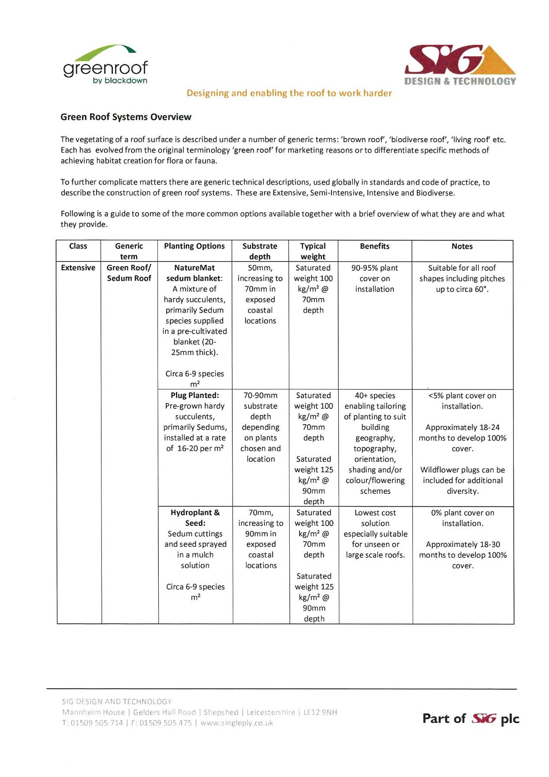
SUSTAINABILITY STATEMENT TO ACCOMPANY A PLANNING APPLICATION
FOR ALTERATIONS AT

218 TO 228 KENTISH TOWN ROAD
LONDON
NW5 2AD

1. INTRODUCTION

1.1 This Statement has been prepared to accompany a planning application for alterations to 218 – 228 Kentish Town Road, London, NW5 2AD.

1.2 This Statement addresses the issues discussed in Camden’s Development Policies Document, Section 3, in particular Policy DP22 and paragraphs 22.6 to 22.19.

1.3 Paragraph 22.7 sets out a number of points to be considered during the design process, under the two categories, “Design” and “Fabric/Services”, and each point will be discussed in this document.

1.4 The proposals involve two separate and distinct elements. Firstly, the conversion of the existing buildings fronting onto Kentish Town Road, and secondly, the construction of extensions over the existing buildings along Wolsey Mews.Therefore, the project requires consideration of both sustainable new construction and sustainable retro-fitting methods.

1.5 Paragraph 22.7 recognises that the construction process is a major consumer of resources, and that it can produce large quantities of waste and carbon emissions. It goes on to say that -

“The possibility of sensitively altering or retro-fitting buildings should always be strongly considered before demolition is proposed”.

This approach is central to the alterations to the existing Kentish Town Road buildings.

2. DESIGN

This section discusses the approach to the 15 Design points described in Paragraph 22.7, which are written in italic text, the discussion on each point then follows.

2.1 The layout of the uses:

The existing commercial use is retained on the ground floor, as there is no practical alternative use for this space. The proposals seek to re-instate the original residential use to the 1st and 2nd floors.

The new flats have been planned so that 2nd floor bedrooms are above 1st floor bedrooms and 2nd floor living spaces are above 1st floor living spaces, apart from the bedroom of flat No 4.

The ground floor use is a convenience store, with opening hours that do not extend into the late evening.

Where possible, apart from flat No. 1, the bedrooms within the Kentish Town Road building are located away from the front elevation to minimise the noise nuisance from this road.

2.2 Floor plates size/depth:

The floor plate depth of the existing building is 8m and is domestic in scale, being originally built as a house. The new build elements have a depth of 5.5m. These dimensions are determined by the form of the existing buildings, but are suitable for residential use.

2.3 Floor to ceiling heights:

The floor to ceiling height in the existing buildings is 3.35 on the 1st floor and 3.1m on the second floor, which reflects the status of the original houses. A new suspended ceiling will be provided throughout the first floor, which will incorporate sound insulating material to form acoustic separation from the second floor.

The maximum floor to ceiling height in the new build element will be 2.35m, this reflects the lower status of the original mews buildings on the site, and is a function of keeping the extension as low as practical.

2.4 Location, size and depth of windows:

The windows in the existing buildings are large, as they were originally part of the townhouse design, which typically had very large first floor windows. The windows in the new building will be smaller, to reflect the subservience of these to the original building. All habitable rooms in both elements will have window areas equal to at least 10% of the floor area of the relevant room.

New windows will be high performance double-glazed type, and the existing retained single glazed windows will be fitted with internal secondary glazing.

2.5 Limiting excessive solar gain:

Solar gain is heat build up within a building that can predominantly be attributed to direct solar radiation passing through windows and other glazed elements of the fabric. The Zero Carbon Hub has noted that west facing properties are the most likely to experience overheating due to solar gain (1). Solar gain through the opaque elements is relatively small, and will not be considered in this Statement.

The existing building has large windows that face east and west, and two on the Caversham Road elevation that face northwards. The new building has windows which predominantly face east onto Wolsey Mews, and east facing rooflights.

The large west facing windows and the external noise environment of Kentish Town Road, require that each of the conversion flats will have a mechanical system of ventilation, to bring in adequate fresh air for background and purge ventilation, without opening a window, and to exhaust excessive heat build up. These systems will have a heat recovery function so that energy can be reused for heating purposes when required.

2.6 Reducing the need for artificial lighting:

The large windows and domestic scaled floor plates of the existing building will provide very good natural light into the rooms, and so minimise the need for artificial lighting during daylight hours.

The new elements will have windows that at least comply with Building Regulations requirements of a minimum area of 10% of the room floor area.

2.7 Shading methods:

The existing windows will remain unshaded. The windows in the new extensions predominantly face east.

2.8 Optimising natural ventilation:

All of the flats have openable windows to allow natural ventilation. Also, all flats are double aspect, that is, there are windows in opposing walls which allow natural cross ventilation from one side to another. The principle of natural ventilation strategy is supported in Paragraph 22.17.

However, the urban location, especially of the Kentish Town Road frontage, does present a noisy external environmental which may have issues relating to poor air quality. To address this problem, the flats in the Kentish Town Road building (Nos. 1 to 5) will incorporate small individual mechanical ventilation systems such as those by Villavent. The systems will be designed to comply with Approved Document F of the Building Regulations, table 5.2d.

2.9 Inclusion of renewable energy technology:

The existing buildings have roof slopes that face due south, at a pitch of approximately 30 degrees, with a usable area of approximately 40 sqm. These surfaces are ideally suitable for renewable solar technologies, and solar thermal panels will be installed. The hot water generated will be used for domestic hot water use within Flat Nos. 2, 4 & 5.

2.10 Impact on existing renewable and low energy technologies in the area:

The applicant does not envisage any impact of these technologies.

2.11 Sustainable urban drainage, including green or brown roof:

The proposals will not add any additional roof area to be drained on the site, as buildings already cover 100% of the site.

The flat roof over the Unit 9 extension will be designed as a green roof. The type proposed will be as SIG Extensive green roof specification, see Appendix A of the main Statement.

2.12 Adequate storage space for recyclable material, composting where possible:

A designated storage area will be provided in the rear of No. 222. There will be access direct from Wolsey Mews for collection purposes as well as from within the site for use by the residents.

2.13 Bicycle storage:
A secure communal bicycle rack will be provided in the Wolsey Mews entrance area, with space for 9 cycles.
2.14 Measures to adapt to climate change:

The measures employed, which are discussed elsewhere in this Statement are –

- Green roof area to attenuate rain water run off and increase biodiversity.

- Fabric First approach to the retro fit of the existing buildings and the construction of the new extensions.

- Installation of solar thermal panels.

- Designated waste and recycling storage and secure bicycle storage.

- Located close to public transport infrastructure – tube, bus and overground.

- Retention of an existing building.

2.15 Impact on microclimate:

The proposed extensions will produce minimal shading to part of Caversham Road adjacent to the site.

3. FABRIC/SERVICES

This section discusses the approach to the 13 Fabric/services points described in Paragraph 22.7.

3.1 Level of insulation

The fabric of the existing building will be upgraded with new insulation to the external walls and roof, to improve the thermal efficiency. The existing solid masonry external walls will be lined with thermally broken studwork, insulation and boarding using the Knauf system or similar. This will provide a U-value in the region of 0.25W/m²/^{O}C. The roof will be insulated at 2nd floor ceiling level to provide a U-value in the region of 0.16W/m²/^{O}C, existing windows will be fitted with secondary glazing to achieve a U-value in the region of 1.6W/m²/^{O}C.

The new buildings will be constructed to achieve the following standards –

- Walls 0.25W/m²/^{O}C
- Roof 0.18W/m²/^{O}C
- Windows 2.0W/m²/^{O}C

3.2 Choice of materials

The main materials to be used are brick, concrete block, timber and cladding panels.

3.3 Air tightness

The current iteration of the Building Regulations requires a maximum air tightness of 10m³/h/m²@50Pa. The proposed flats will achieve a figure of not more than 5m³/h/m²@50Pa.

3.4 Efficient heating systems

Each flat will have a high efficiency gas condensing boiler for space and water heating requirements. Typically space and water heating account for approximately 65% of residential energy use. The Fabric First approach, which requires high levels of fabric insulation and low air permeability, will suppress the energy demand for space heating, and regulated taps will reduce the hot water requirement in the flats.

Thus the demand for space and hot water is controlled through the specification of building materials. The heating systems will be highly efficient, with thermostatic controls to each radiator, highly insulated pipe work and tanks.

3.5 Effective Building Management System (BMS)

The proposal is for 9 self-contained flats, and so the potential for BMS is very limited. The only areas where some degree of control is possible are the common parts and the circulation spaces, both on the roof deck and the stairways. Here movement sensors will be attached to the lighting systems so that the lights are operable only when people are using the spaces, to minimise energy consumption.

3.6 The source of energy used

Mains gas will be used for space and water heating. Mains gas is available in the existing building and the adjoining roads.

Mains gas is a more efficient fuel for this than mains electricity due to the losses incurred in the power stations and in transmission to the point of use.

Solar technologies on the roof of the existing building will contribute hot water to flat Nos. 2, 4 & 5.

3.7 Metering

Gas, water and electricity supplies to all flats and the common parts will be separately metered.

3.8 Counteracting the heat expelled from plant equipment

There will be no plant equipment that will require this action.

3.9 Enhancement of/provision for biodiversity

Currently there are no provisions for biodiversity on the site.

The proposals do include a green roof, which will extend to 15m².

3.10 Efficient water use

All flats will have a maximum daily water use of 105 litres/person/day, this is the requirement to comply with Level 4 of the Code for Sustainable Homes (see policy DP22).

3.11 Re-use of water

There will be rain water harvesting facilities to capture the run off and store and use for toilet flushing.

3.12 Educational elements

The proposal is for private flats, with no public access. However, meters will be located in accessible and visible locations within each flat.

3.13 On-going management and review
References

(1) Zero Carbon Hub, Overheating in Homes, February 2013

