Proposed creation of additional floor space
providing 10 additional bedrooms,
St John’s Wood Centre, 48 Boundary Road,
St John’s Wood, London NW8 0HJ

HERITAGE STATEMENT

- INTRODUCTION
  - This document needs to be read in conjunction with the accompanying Design and Access Statement which describes the proposed alterations and extension to the above described Care Home.
The purpose of this document is to describe the importance of the St. John’s Wood Centre as a heritage asset falling within the Alexandra Road Conservation Area. The document will then go on to describe how the proposal to create an additional 10 bedrooms responds to the heritage considerations which have been described.

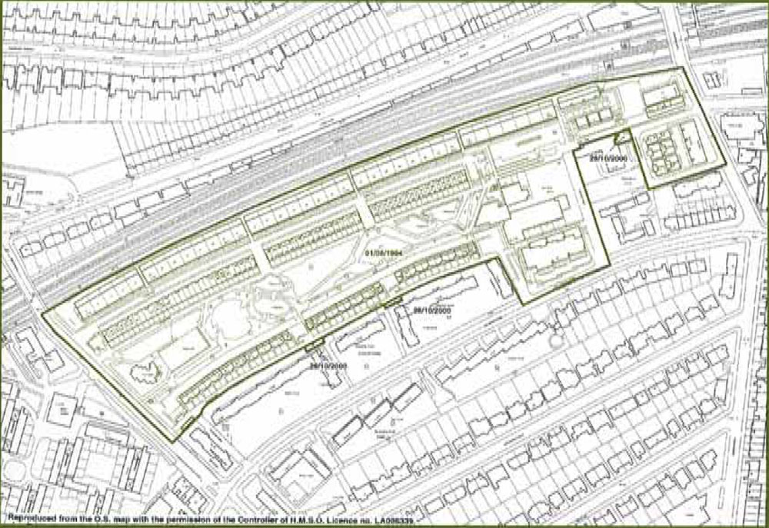
- CHARACTER AND HISTORY OF THE AREA

Defined boundary of Alexandra Road Conservation Area
  - The St. John’s Wood Centre is the most southerly building falling within the Alexandra Road Conservation Area which was designated in 1996. Although not at the heart of the conservation area which has as its focus the substantial blocks of terraced housing that comprise the Alexandra Road Housing Estate, the centre was nevertheless built during the same period. In effect it was thus part of a comprehensive residential redevelopment of 13 ½ acres of land between the late 1960’s and early 1970’s. The Council’s own “Conservation Area Statement” makes it clear that this area previously occupied by speculative housing “had become run down and was awaiting demolition” by the close of the Second World War. Co-funded by the Ministry of Housing and Local Government, the area was thus prepared for comprehensive re-development for the purposes of public housing by the London Borough of Camden. The re-development comprised 520 dwellings, a tenants hall, underground parking, shops, workshops, a school, a children’s reception centre and residential accommodation for young physically handicapped peopled (in fact the St. John’s Wood Centre). Demolition commenced in 1970 and occupancy of the new housing was completed by 1979. The housing estate was listed in 1993 whilst the under conservation area was designated in 1996.
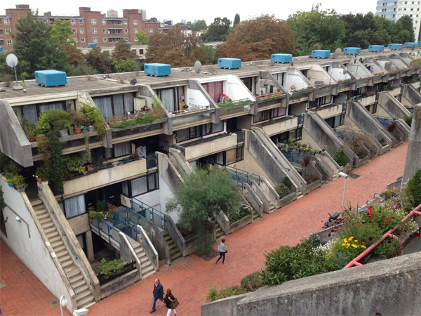
Alexandra Road Housing Estate
Photographer: Andrea Klettner
Source: http://lovelondoncouncilhousing.blogspot.co.uk/

  - So far as the residential estate is concerned this was designed by Neave Brown as high density housing for Camden’s Architects Department. It comprised low-rise but high density housing stacked ziggaret style in large concrete structures, as an alternative to then contemporary high rise solutions. The estate has a strong geometric quality with use made of blocks in stepped and overhanging sections. Much of the estate is constructed of fair-faced white concrete blocks. In addition to these large groupings of housing, significant areas of landscaping between the blocks form an integral part of the scheme. Like the housing elements the landscaping forms East/West axes interspersed between the terraces. The blocks vary in height from 4 to 7 storeys.
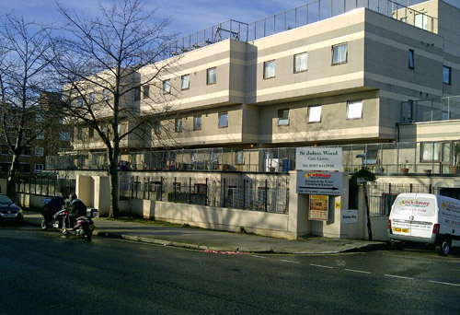
St John’s Wood Centre viewed from Boundary Road

  - The St. John’s Wood Centre itself was designed by Evans and Shalev and built as a centre for physically handicapped young people. By virtue of the 1998 consent referred to in the Design and Access Statement an additional storey was built onto the structure. The Council’s Conservation Area Statement states that the St. John’s Wood Centre along with its neighbour, the Jack Taylor School and 9, Langley Walk “Have, their own distinctive character associated with the use of blockwork. Formally though they share the stepped sections of the housing estate, with their more modest scale and masonry they represent a departure from the mega-structure approach of the housing estate.”

  - As explained in the Design and Access statement planning permission was granted for works of alteration including the erection of a third floor and change of use to a Care Home in 1998 (reference PW9802564RI). In recommending these works at the time the Officer commented at paragraph 6.5 “The overall detailed design treatment which has been employed reflects the design idiom of the existing building. Offices are satisfied that this is the correct approach to use because of the importance which must be attached to the setting of the building within the Alexandra Road Conservation Area which include Grade II* listed buildings of similar design characteristics to the building which currently exists at 48 Boundary Road”.

The Offices also commented within the report on the poor condition of the grey concrete which had weathered badly but concluded (with regard to the proposals) that “with respect to both the bulk of proposed design of the building it would enhance the character and appearance of the Conservation Area”.

- POLICY BACKGROUND
  - The Design and Access statement provide a comprehensive assessment of policies relevant to this proposal at paragraph 3 of that document. Specifically with regard to the historic environment, we consider that the following Camden policies are most relevant.
CS14 Promoting High Quality Places and Conserving our Heritage
DP25 Conserving Camden’s Heritage
  - The National Planning Policy Framework (NPPF) published in March 2012 is also relevant. It requires that sufficient information is provided to support the submission of Planning Application to ensure the potential import of any proposals on the significance of the heritage asset can be fully assessed. In particular paragraph 128 states:-
In determining applications, local planning authorities should require an application to describe the significance of any heritage assets affected, including any contribution made by their setting. The level of detail should be proportionate to the assets’ importance and no more than is sufficient to understand the potential impact of the proposal on their significance. As a minimum the relevant historic environment record should have been consulted and the heritage assets assessed using appropriate expertise where necessary.
The document continues at paragraph 131 by stating that Councils should take account of “the desirability of sustaining and enhancing the significance of heritage assets and putting them to viable uses consistent with their conservation”.
It further comments about “the desirability of new development making a positive contribution to local character and distinctiveness”.
- THE PROPOSAL
  - Quite property the starting point in the consideration of this proposal was the likely relationship of the works both with the host building and the wider context, that is the conservation area. It has clearly been established, both through this document and the Design and Access Statement that the St. John’s Wood Centre is characterised by an uncompromising design reflective of the emerging building technologies of the 1960’s. This explains the use of larger concrete blocks, the use of cantilevers between floors, flat roofs and uniform square shaped glazing. There is an uniformity within this design which thus shapes the whole structure from the ground level to the roof.
  - In the light of this homogenous design it was felt that the only design approach would be to carefully copy the original building in providing the additional 10 beds. Thus the design utilises the same concrete blocks as the host building carrying them through into the further storey. Likewise the proposed glazing carefully follows the proportions of the existing glazing. As we have stated in the Design and Access Statement the additional accommodation would not result in a building structure any higher than the roofline of the existing lift tower and stairwells. In fact the 10 beds would sit neatly between these two stairwells which sit at either end of the existing Care Home.
Thus we consider that the scale of the finished building would be little changed from the existing and in any case would continue to be somewhat dominated by the neighbouring apartments.
  - As the submitted elevations show, however, one alteration we propose is the replacant of the existing steel mesh balconies with glazed replacements. In our view the existing balconies, which have the appearance of commercial fencing, do little for the appearance of the Care Home. Interestingly we believe that the Council, through their Conservation Area assessment, are similarly unimpressed with this element. We believe that glazed panels at about 1.8 metres in height would be preferable, visually, and could be likely to weather more successfully. In our view the existing steel mesh structures detract from the significance of the asset. In contrast we believe their replacement with glazed panels will enhance the asset.

- Conclusion
  - In our view these proposals will enhance the significance of this asset and will preserve the character of the conservation area.
The proposal remains relatively modest in scale and will conform, in architectural terms, to the character of this late twentieth century building. Our conclusion therefore is that the proposal conforms both to relevant development plan policies as well as the provision of the NPPF. We would urge therefore that planning permission is granted.
Sources of information:-
- National Planning Policy Framework
- Camden Core Strategy 2010
- Alexandra Road Conservation Area Statement 2000
- Committee report – PW9802564R1 – November 1998

