Top 5 user queries – TRIM
- TRIM is not enabled in Word/Outlook
Usually this just refers to Microsoft add-ins not being enabled in TRIM and can be resolved by doing the following:
- Open TRIM – select ‘tools’ and ‘desktop add ins’, then tick all of the Microsoft office applications (Word, Excel, PowerPoint, Project, Outlook)
- Click ‘ok’, and restart TRIM and any Office applications for the add-ins to register:
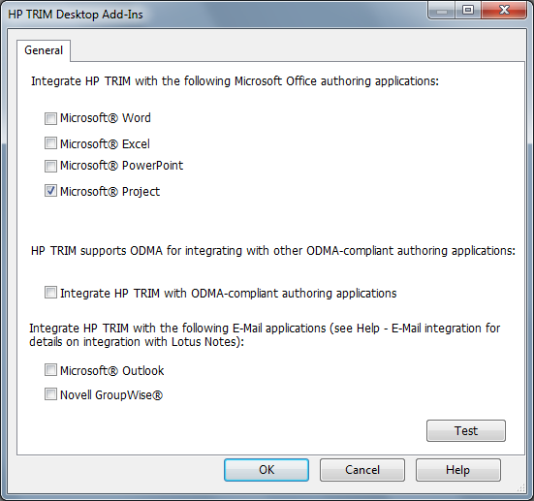

- TRIM doesn’t appear in my Citrix applications

- The user has to request this by raising a call with Service Desk (4321 or e-form) and requesting it specifically.
- Currently the Office integration is not available on Citrix. This is being worked on and will be available in the future.

- TRIM is not installed on my PC

- The user has to request this by raising a call with Service Desk (4321 or e-form) and requesting it specifically.

- Search fields have disappeared

- Defined search fields (set-up by the user) can ‘disappear’ if there are search results windows already open when user is defining fields.
- Ensure all search result windows are closed, then ask user to define their search fields again by doing the following:
- Click on yellow folder next to ‘Search by’ box, select desired search field from list (following page), and click ‘ok’

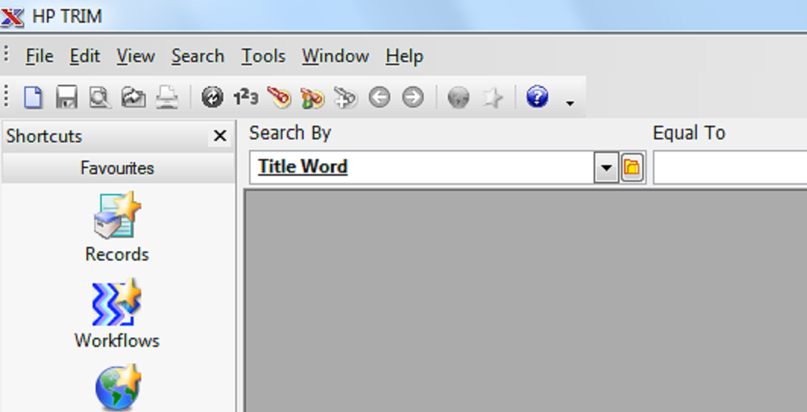
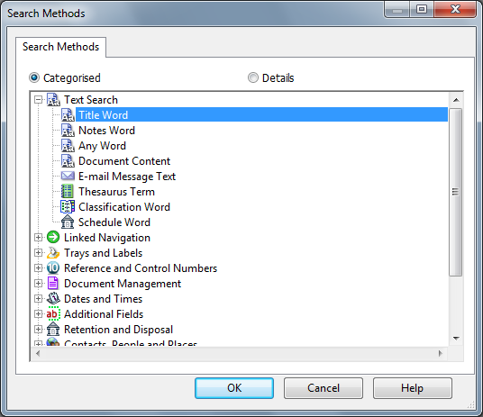
- Repeat the above steps for each field the user wishes to search by. Assuming all the previous search boxes are closed, the user’s desired fields should now be ‘fixed’

- Menus underneath the HP TRIM tab are ‘greyed out’

- Restarting the application usually resolves this, alternatively the user can raise a call with Service Desk (4321 or e-form)

