 | 01344 481047  07763 058779  services@abracad.co.uk  www.abracad.co.uk | 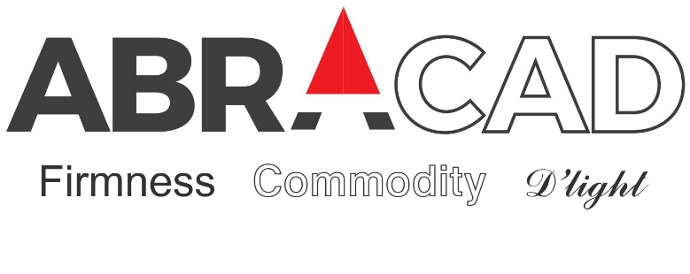 |  | The Atrium  Broad Lane  Bracknell  Berkshire  RG12 9BX

Planning application heritage statement for proposed alterations to 45 Courthope Road, London, NW3 2LE for P. Arena & S. Barbara

May 2025

About the site:

This Victorian mid-terraced house lies in the appealing and diverse Hampstead Conservation Area (one of the first such areas created following the Town & Country Planning Act in 1968).
The property is in need of refurbishment to return it to being one nice house.
It is not a Listed building.

Design proposal:

The interior is due to be re-organised and modernised, like others have done locally.
It is proposed to brick up the high level side windows to the current kitchen/dining space and change the lean-to glazing to a slate roof with openable rooflights to improve ventilation and reduce slight overlooking, and open up to the rear court with new patio doors (no extension of the property).
Matching new obscure glazed laundry south-east side window to second floor.
Materials would match with the existing building and not overly impact adversely on neighbours.
May remove render from front elevation to return to original brick if practical.
New matching white painted timber framed sealed unit double glazed windows.

Alistair Lloyd BA Hons Dip Arch Dip U.D. (Architect & Urban Designer)

