REDINGTON FROGNAL
NEIGHBOURHOOD FORUM

25 April 2025
Dear Adam,

2025/1350/P: 35 Hollycroft Avenue – object

The garden building that has been constructed is almost double the size of the modest shed which it replaced.

Large garden buildings are eroding the local ecological network formed by Redington Frognal gardens. Such garden development habitat results in losses of habitat and the carbon sink from soft natural surface.

The garden building is not compliant with the Neighbourhood Plan’s policies for Sustainable Development, which should have been noted by Savills in the retrospective design and access statement. Relevant policies are:

SD 1:
- Development must have no adverse impact on biodiversity and wildlife habitat, including through loss of garden space.
- If there is likely to be an adverse impact, this must be offset by gains elsewhere within the site, such as tree and hedge planting.
- The achievement of a net gain in biodiversity is strongly encouraged
- The creation of garden development and building extensions must be in accordance Policies SD 2 to SD 5, and maximise the area of soft, natural landscaping, to act as a carbon sink and help mitigate against climate change and the urban heat island effect

SD 4:
- The area of soft natural garden space within the site should be maintained or increased.
- Landscaping should be an integral part of the design and layout of development and should include trees and other planting with a high value to biodiversity, as set out in section 6.2 Planting Guidance to Enhance Biodiversity and Conservation Area Character.
xii Development that incorporates eaves and spaces for internal bat roosts, and the use of bird bricks and other features to support wildlife, will be particularly welcomed.

SD 5:
iii Extension into garden space, including outbuildings, must involve no significant reduction in the overall area of natural soft surface and have no significant adverse impact on the amenity, biodiversity and ecological value within the site.

The policies relating to Biodiversity and Green Infrastructure are also relevant:

BGI 1:
Open/unbuilt areas within development sites must be designed to enhance their ecological, wildlife and residential amenity values. This includes:
- retaining, providing and reinstating trees, hedgerows and other planting using native species, especially those of high value to biodiversity, as set out in the 6.2 Planting Guidance to Enhance Biodiversity and Conservation Area Character. A very high urban greening score is encouraged;
- achieving an urban greening score in excess of the London Plan target
- maximising the area of soft landscaping and using planting with high value to pollinators and insects, as set out in the 6.2 Planting Guidance to Enhance Biodiversity and Conservation Area Character;
- minimising hard surface areas to those necessary for the site……..
- retaining hedges and walls and taking opportunities to use hedges as boundary treatments…….
vii The inclusion of new water features, such as natural wildlife ponds.

If Camden is minded to grant consent, the Neighbourhood Forum requests mitigation for loss of soft natural surface.

The site is in an area with much underground water where, previously, there had been many ponds nearby. Appropriate mitigation might therefore include the excavation of a natural wildlife pond to support the bats which commute and forage in the area.

Lost rivers and ponds from Arup Google Earth map
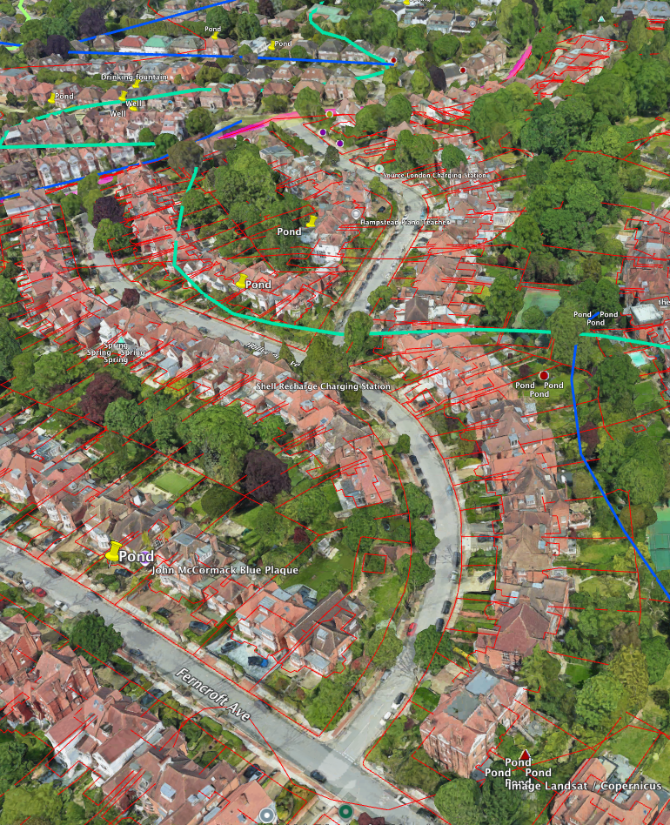
The photo above is from the Google Earth map produced by Arup. This can be viewed on the Forum website at:
https://www.redfrogforum.org/underground-rivers/

The attached .kmz file links straight to the Google Earth site.

Yours sincerely,

Nancy Mayo

Secretary
Redington Frognal Neighbourhood Forum
https://www.redfrogforum.org
https://twitter.com/RedfrogNF

REDINGTON FROGNAL
NEIGHBOURHOOD FORUM

