

H S P Architects Llp, 5 Goodge Place, London, W1T 4SD

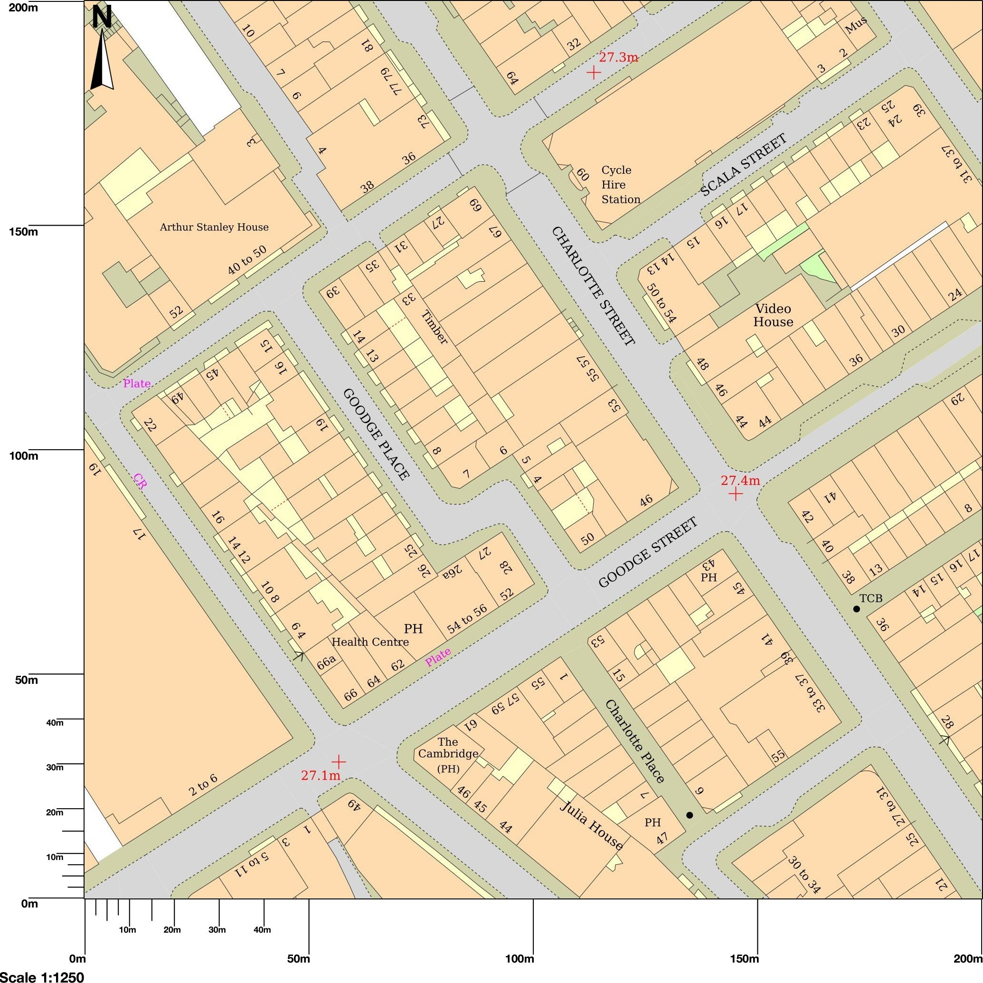

© Crown copyright and database rights 2025 OS 100054135. Map area bounded by: 529301,181609

529501,181809

. Produced on 25 April 2025 from the OS National Geographic Database. Supplied by

UKPlanningMaps.com. Unique plan reference: p4f/uk/1246350/1672983

