Design & Access Statement

19 Crediton Hill, London, NW6 1HS

Erection of single storey garden room to rear garden.

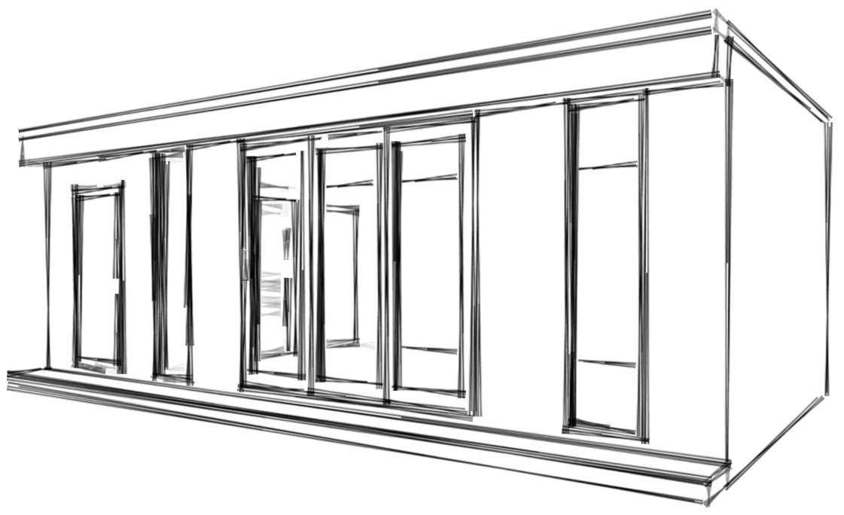

Contents:

- Site and surroundings
- Planning History
- 3.Proposal
- Relevant planning Policy
  - Local Plan
  - Home Improvement planning guidance
  - West End Green Conservations Area
  - Fortune Green and West Hampstead Neighbourhood Forum
- Analysis and Key Considerations
- Conclusion

- Site and Surroundings

  - The application site is a two storey ‘arts and crafts’ style semi-detached property to the west side of Crediton Hill. The application relates to an outbuilding within the rear garden to the property.
  - The property sits within the middle section of the road. To the south side are larger properties built closer to the 1860’s with the north of the road consisting of further ‘arts and crafts’ style property.
  - The surrounding area is a leafy residential area consisting of a mix of large detatched and semi-detatched properties which benefit from large rear gardens. There are other examples of outbuildings to nearby properties at No.s 23 Crediton Hill and 302 West End Lane.

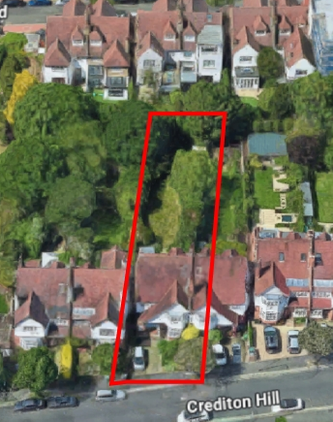

- Planning History

  - A search of the Council records reveals the following planning history relating to the property

2.1.1 (2024/1525/P) – 17/9/24 Granted – Erection of a single storey rear extension with rooflights
    - (2024/1757/P) – 23/9/24 Refused – Erection of a front dormer
    - (2024/4771/T) – 28/11/24 No objection to work to trees
2.1.4 (2024/5033/P) – 6/1/25 Granted – proposed extension to existing rear patio
2.1.5 (2024/5727/P) – 3/3/25 Granted – Proposed installation of a round heritage window to front facade
2.1.6 (2025/0703/T) – 21/3/25 No objection to work to trees –

  - Planning history relating to neighbouring property

    - (2023/2056/P) – 21/07/23 – Granted – Erection of Outbuilding, 7m x 7m x 2.95m tall. Approximately 45sqm

- Proposal

  - The application proposes the erection of an outbuilding to the rear of the garden, using timber frame construction, acting as ancillary space to the main house.
  - The garden room would be 4m deep and 8m wide and have a maximum height of 3.0m, constructed with a flat ‘living ‘ roof. The structure would be located to the rear of the garden 4.3m away from the rear boundary, approximately 600mm from the left boundary and 150mm from the right boundary.
  - The proposed garden room would be constructed in Western Red cedar cladding to 3 sides, under clad in cement particle board to sides to meet fire regulation standards. The cladding will soften over a period of time and blend into the area nicely. The rear would be clad in CPB and painted in a dark shade. There would be double glazed doors and windows to the front only, facing back onto the main house.
  - The garden room will be raised slightly from the ground using Steel ground screws as a foundation system
  - As stated above, the garden room would be used for ancillary space for the enjoyment of the home owner only.

- Planning Policy

4.1i - Policy A1 – Protecting Amenity – The construction time would be short and during respectable working hours. The build itself is based in a garden that is west facing and as such there would be limited light restriction to neighbours, left and right. The proposal is designed to be 4 plus metres from the rear boundary so not to affect the rear neighbour in this way either. The cladding materials used are of a high end nature and will soften over a short period. The buildings are insulted so will reduce noise pollution to the neighbours from garden usage.

4.1ii - Policy A3 – Biodiversity – The outbuilding will be raised from the ground using ground screws, as such this land is still available to nature, albeit a change of nature to a grass ground cover. The roof will be covered with a living room, the roof area is 2.4sqm larger than the foot print due to the overhang, therefore increasing the biodiversity footprint. Due to the land under the building also being open to nature, albeit of a different kind, we can assume that the increase in biodiversity of 100% or more. As this is a Householder application this development is exempt. https://www.gov.uk/guidance/biodiversity-net-gain-exempt-developments#developments-below-the-threshold

4.1iii – Policy D1 - Design - This is a small scale construction in the form of carpentry, using small scale tools onsite. The ground screws are also installed using hand held tools. The screw pile foundations limit excavation and impact on the land, limiting impact on tree roots, unlike concrete foundation alternatives. The use of a rubber roof system and green roof above results in all water making it’s way back to nature with any overflow being diverted into the ground with a soakaway behind the building. It’s an aesthetically pleasing design using western red cedar to the façade that will soften into nature over time. The installation of a ‘living roof’ will also hide the building into nature.

4.1iv – Policy D2 – Heritage – There is a mix of heritage within the immediate area. Ranging from the 1830s Victorian property through to the end of the arts and crafts movement of 1920’s. There is clear divide between the property styles. The proposed garden room would not be clearly visible to the area and as such not take anything away from the enjoyment of the local amenity. The design is clean, balanced and well build and will only improve the aesthetic of the immediate neighbours.

4.1v – Policy CC1& CC2 – Climate Change Mitigation and adapting to climate change – The use of sustainable timber for construction and the inclusion of a sedum roof in the design is key here. From an environmental standpoint, sedum roofs play a vital role in mitigating the urban heat island effect, reducing energy consumption, and lowering greenhouse gas emissions. They provide enhanced thermal insulation, reducing heating and cooling needs for buildings, which can translate into significant energy savings over time.

4.2 Home Improvement Planning Guidance 2021 – 5.5 Outbuildings
The garden room will be sited to the rear of the garden and is 10% of the total garden area for the property, the materials used will ensure that over a short period the building will soften into it’s surroundings. Due to the nature of the construction materials, insulation and the living roof it should provide little to no detraction to neighbours amenity. There will be space surrounding the building, due to the desire for nature to reach sunlight and the amount of rain we have there should be no reason for nature to not grow into these spaces. Due to the west facing nature of the gardens there should be no or very little reduction to sunlight on neighbours gardens. The location of the proposed building will ensure that there is a quiet nature zone to the rear of the garden improving the habitat for nature. The ground screws used will ensure little impact on the roots of retained trees. All water that hits the proposed roof will be managed by the living roof and also a small soak away for any overflow.
Bearing in mind the above design feature we consider the proposed outbuilding to fall within Home improvement Planning Guidelines.

4.3 West End Green Conservation Area.
Discusses scale, mass and rhythm in relation to historic pattern of development. The proposed outbuilding is designed within it’s time period and as such extends the rhythm of historic pattern and is sympathetic with the environment as constructed using Western Red cedar and a green roof.

4.4 Fortune Green and West Hampstead Neighbourhood Forum - Neighbourhood development Plan
Raises very little with regards to garden room development or garden management, simply suggesting that ‘extensions’ should be in proportion with it’s context and setting. As the garden room is less than 10 % of the garden we feel that it falls well within proportion and considering the materials used, that it being built within context of the setting.
The development plan also identifies that certain conservation areas share the same area and that their policies are relevant. We have already covered the policies of the West End Green conservation area above.

In light of the above, we trust that the Householder Application can be granted accordingtly.

