DECISION

Planning (Listed Building and Conservation Areas) Act 1990

Approval of Details (Listed Building) Granted

Address:
89 Great Russell Street
London
WC1B 3PS

Proposal:
Approval of details pursuant to condition 4 (parapet brickwork) of planning permission ref 2024/0260/L, granted on 30/07/2024, for works to the roof including structural reinforcement, relaying and part replacement of slate covering, and part removal and rebuilding of front, side and rear parapets.
Drawing Nos: CBP Brick Parapet Report 13/03/2025; Cover Letter 13/03/2025.

The Council has considered your application and decided to grant Approval of Details (Listed Building) subject to the following condition(s):

Conditions And Reasons:

Informative(s):

Reasons for granting approval of details (listed building):

The application site is a grade II listed end-terrace Georgian townhouse in use as a single family dwelling, located on the north side of Great Russell Street immediately west of the British Museum within the Bloomsbury Conservation Area.

Approval of details is sought to clear condition 4 (parapet brickwork) of listed building consent ref 2024/0260/L, granted on 30 July 2024, for works to the mansard roof and associated parapets.

Condition 4 stipulates that the rebuilding of the roof parapets shall be undertaken using reused bricks. Details of the brick bond, pointing mix and profile shall be submitted to and approved in writing by the local planning authority before the relevant part of the work is begun.

The submitted report outlines that all salvaged bricks in sound condition will be reused and any damaged bricks will be substituted with reclaimed London stock bricks to match the existing. Due to the exposed location of the main roof, the reconstructed parapets will consist of a brick-on-edge detail with a creasing tile as already found on the rear section of roof and to match the parapet party wall to No 90 Great Russell Street. The pointing will have a slightly recessed flush joint, employing a dry-ready natural hydraulic lime and 5mm down tan flint sharp sand strengthened by natural pozzolan binder for a weather resistant mortar with an approximate 2:5 ratio mix. A wall sample of the party parapet wall has been built on site demonstrating these properties.

The information provided for this approval of details application satisfies the requirements of condition 4 and demonstrates that a durable long-term solution has been found which will cause no harm to the special interest of the listed building, to the setting of the adjacent listed buildings, or to the character and appearance of the conservation area.

Public consultation was undertaken by means of site notice and a press notice, but no responses were received. Bloomsbury CAAC was consulted, but chose not to respond. The site's planning history was taken into account when arriving at this decision.

Special regard has been attached to the desirability of preserving the listed building and its features of special architectural or historic interest, the setting of adjacent listed buildings and the character and appearance of the conservation area, under s.16, s.66 and s.72 of the Planning (Listed Buildings and Conservation Areas) Act 1990 as amended by the Enterprise and Regulatory Reform Act (ERR) 2013.

As such, the proposal is in general accordance with policies D1 and D2 of the Camden Local Plan 2017. The proposed development also accords with the London Plan 2021 and the National Planning Policy Framework 2024.

You are advised that all conditions relating to listed building consent ref 2024/0260/L, granted on 30/03/2024, which need details to be submitted, have been approved.

In dealing with the application, the Council has sought to work with the applicant in a positive and proactive way in accordance with the National Planning Policy Framework. The council publishes its adopted policies online, along with detailed Camden Planning Guidance. It also provides advice on the website for submitting applications and offers a pre-application advice service.

You can find advice about your rights of appeal at:

http://www.planningportal.gov.uk/planning/appeals/guidance/guidancecontent

Yours faithfully

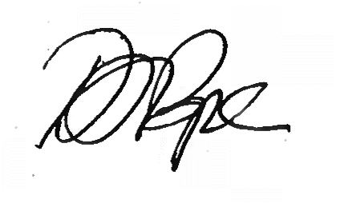
Daniel Pope
Chief Planning Officer

