VMZINC standing seam wall cladding on vented Galvanised Sheet

H74 Zinc strip / sheet coverings / flashings

To be read with preliminaries / general conditions
TYPES OF ZINC WORK
130 Main Cladding
- Cladding system: VMZINC Single lock standing seam cladding (horizontal or vertical) for vertical walls and soffits.
- Substrate: 0.7mm Galvanised Steel Deck fixed to a metal framing system. The Galvanised Steel deck must have dimensions, allowing clips to be attached at the required spacings. A corrugated steel deck can only be used on vertical surfaces. For all surfaces such as sills, parapets, etc the substrate must be continuous. The metal framing system , should create a minimum 38mm vented airspace, between the steel deck and the insulation ( which should be protected by the VMZINC membrane).
- Underlay: A VMZINC membrane to be installed over the metal deck
- Vapour control layer as per requirements.
- Metal Framing System as per requirements
- Insulation as per requirements protected with VMZINC membrane.
- Zinc: As clause 520.
- Finish: VMZINC PLUS in QUARTZ-ZINC, ANTHRA-ZINC or PIGMENTO Grey, Red, Green, Blue or Brown.
- Thickness: 0.8mm.
- Longitudinal joints: 25mm high single lock standing seam.
- Spacing: not more than 430mm accordance with design and wind loadings.
- Cross joints: Single welts, in accordance with manufacturer’s recommendations.
- Spacing, panels to be no longer than 4m.
- Vented apron detail: As clause 340.
Vented parapet detail: As clause 470

340 Vented base detail
• Eaves zinc: As clause 520.
- Finish: VMZINC PLUS in QUARTZ-ZINC, ANTHRA-ZINC or Pigmento Red, Green, Blue or Brown or Azengar.
- Thickness: 0.8mm.
• Joints: Spacing: 2m.
• Continuous drip 10mm linear vent opening
470 Vented Parapet
• Ridge: As clause 520.
- Finish: VMZINC PLUS in QUARTZ-ZINC, ANTHRA-ZINC or Pigmento Red, Green, Blue or Brown or Azengar.
- Thickness: 0.8mm.
• Joints: Spacing: 2m.
• Overlap between tray and parapet at least 60mm with 10mm linear vent opening.

GENERAL REQUIREMENTS/PREPARATORY WORK
510 WORKMANSHIP GENERALLY
• Standard: Generally to CP 143-5.
• Fabrication and fixing: To provide a secure, free draining and completely weather tight installation.
- • Operatives: Trained in the application of zinc coverings/flashings by participation in a Pro-Zinc training course. Submit records of experience on request. VMZINC at Work installers offer evidence of successfully completed projects, records of VMZINC training and extended material warranties.
• Measuring, marking, cutting and forming: Prior to assembly wherever possible.
• Metal temperature: Do not form zinc when the metal temperature is below 7˚C. (10˚C for Pigmento).
• Marking out: With pencil, chalk or crayon. Do not use scribers or other sharp instruments without approval.
• Folding: With mechanical or manual presses to give straight, regular and tight bends, leaving panels free from ripples, kinks, buckling and cracks. Use hand tools only for folding details that cannot be pressed. The minimum bending radius is thickness x 2 (x 3 for Pigmento).
• Sharp metal edges: Fold under or remove as work proceeds.
• Sealants: Do not use in joints to attain waterproofing.
• Solder: Use only where specified.
• Finished zinc work: Fully supported, adequately fixed to resist wind uplift and able to accommodate thermal movement without distortion or stress.
• Protection: Prevent staining, discolouration and damage by subsequent works. All instructions and recommendations contained in the guidelines for design and specification and VMZ General Technical Recommendation of VMZINC standing seam facades to be applied. Plastic film must be removed within 2 months of installation and in such a way so as not to trap water between the partially removed film and the zinc.
520 ZINC STRIP/SHEET
• Zinc-titanium-copper alloy:
- To BS EN 501 and BS EN 988.
• Zinc manufactured following ISO 14001 (environmental management), ISO 9001 (quality management) and ISO 18001 safety management.
- Stamped or labelled with type, finish and thickness.
- Zinc to be coated on underside with a protective 60 micron lacquer.
• Manufacturer:
- VMZINC Collier House Mead Lane Hertford Herts SG13 7AX
Tel: 01992 822 288 Fax: 01992 584 460 Email: vmzinc.uk@vmzinc.com Web: www.vmzinc.co.uk
- Product reference:
VMZINC in VMZINC PLUS in QUARTZ-ZINC, ANTHRA-ZINC or Pigmento Red, Green, Blue or Brown Azengar.
535 INTEGRITY OF ZINC
• Requirement: Design coverings/flashings and methods of attachment to prevent loss of weather tightness and permanent deformation due to wind pressure or suction.
• Wind loads: Calculate to BS 6399-2.
555 LAYOUT
• Setting out of longitudinal and cross joints: Submit proposals.
610 SUITABILITY OF SUBSTRATES
• Condition: Dry and free of dust, debris, grease and other deleterious matter.
620 PREPARATION OF EXISTING TIMBER SUBSTRATES
• Remedial work: Adjust boards to level and securely fix. Punch in any protruding fasteners and plane or sand to achieve an even surface.
• Defective boards: Give notice.
• Moisture content: Not more than 22% at time of covering.

FIXING ZINC
720 STANDING SEAM FIXED CLIPS
• Fixing: Secure each clip (minimum of 5) to substrate with two fixings (205709000).
Each clip to withstand a pulling force of 50 daN
725 STANDING SEAM SLIDING CLIPS
• Stainless steel.
- Two piece clips with 70mm sliding movement (205710000)
• Fixing: Secure each clip to substrate with three fixings.
Each clip to withstand a pulling force of 50 daN
Typical clip spacing:
Middle zone every 330mm
Edge zone 200mm
Corner zone 150mm
750 CLIPS FOR FLASHINGS/ CROSS JOINTS
• Material: Zinc of same thickness as that being secured.
• Dimensions:
- Width: Not less than 50 mm.
- Length: To suit detail.
• Fixing: Secure each clip to substrate with two fixings not more than 50 mm from edge of strip/ sheet being fixed.
760 CONTINUOUS CLIPS
• Material: Zinc of same thickness as that being secured.
• Dimensions:
- Width: To suit detail.
- Length: Not more than 1.8m.
• Fixing: To substrate at 200 mm centres. Welt edge of strip/ sheet being fixed to continuous clip and dress down.
810 FORMING DETAILS
• Folds and welts: Form without thinning, or splitting the strip/sheet.
• Thermal movement: Form details with appropriate allowance for movement, without impairment of security at full expansion or contraction.
825 SOLDERING
• All zinc must be cleaned back to its natural state.
• The protective coat on the underside of the upper panel must be removed over a width of 20mm either chemically, using DECALAQ, or mechanically, using a 3 MTM RolocTM Bristle Disc brush mounted on a small disc sander.
• The pre-weathering must be removed from the parts to be soldered. ZINN7 (flux) to be applied to allow spot soldering with solder (40% tin 60% lead) ZINN7 applied over whole length of joint and then soldered. Wipe clean. Please see VMZINC soldering document.

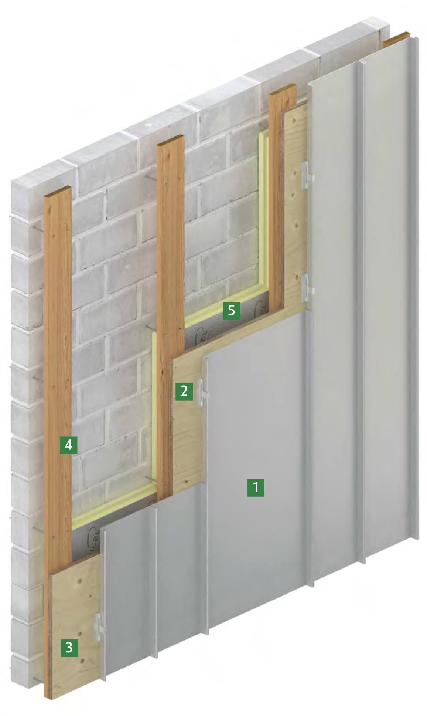

Standing Seam Cladding on Plywood

- VMZ standing seam panels in VMZINC PLUS
- Fixing clip
- 18mm plywood
- Battens creating a vented 38mm airspace
- Insulation protected by VMZ Membrane

IMPORTANT
All instructions and recommendations contained in the guidelines for specification and installation, published by UMICORE have to be applied.

