**26 Hillfield Court, Belsize Avenue, NW3 4BJ**

**Design and Access Statement**

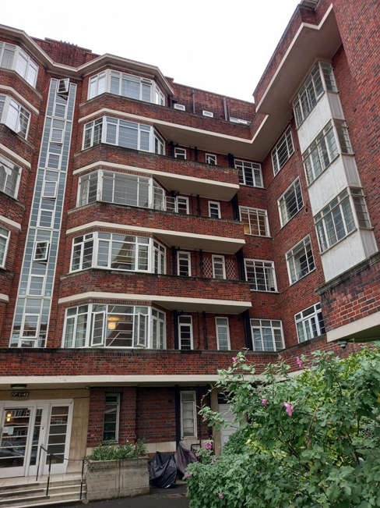

**Description of the proposed works**

Replace Crittall windows and French doors with Aluminium windows and French doors to similar design.

**Site Location**

Hillfield Court is located within the Belsize Conservation Area. It is not a listed building. The site comprises a six storey 1930’s mansion block set on a large site with private residents parking. Flat 26 is located on the third floor and the elevations are not visible from Belsize Avenue.

**Overall Fenestration**

Over time, there have been a number of alterations to the original Crittall windows at Hillfield Court. It is estimated that half the flats have had their original Crittall windows replaced with UPVC or aluminium window profiles. In addition, the full height windows to common areas have also been replaced with UPVC windows.

The following are three recent examples of approved applications to replace windows.:

• 2012/1098/Flat 104 - replace Crittall with UPVC (granted on appeal)

• 2017/4698/P Flat 46 - replace Crittall with UPVC

• 2021/1395/P Flat 24 - Replace Crittall with Aluminium Glass Balustrade

These will not be visible from Belsize Avenue and barely visible from ground level at Hillfield Court.

**EXISTING WINDOWS AND FRENCH DOORS**

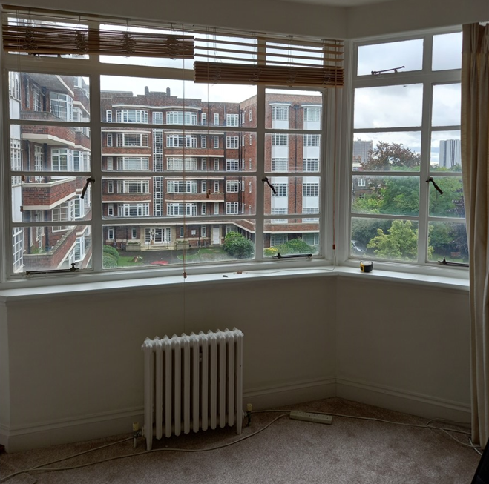

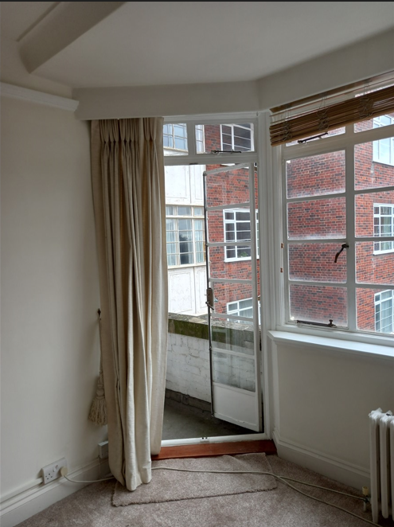

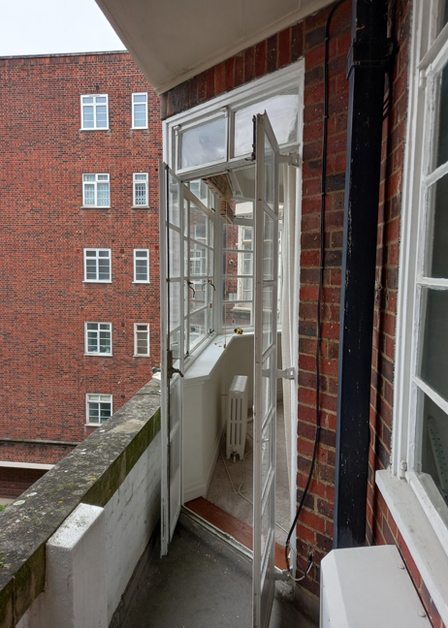

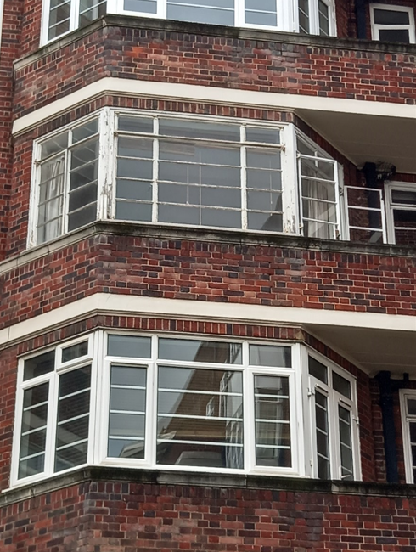

**CONTEXT AND STATEMENT OF HISTORIC SIGNIFICANCE**

Anglian Home Improvements have been contracted to replace 5 x windows at the property with white Aluminium Frames & double glazing plus 1 x set of French doors.

This will give our customers the much-needed additional warmth and security to the property.

**SURROUNDING AREA:** Many of the surrounding flats have already changed their windows and French doors to UPVc or Aluminium.

**AMOUNT:** The replacement windows and French doors will be replaced in accordance the plans and drawings.

**LAYOUT**: The new windows and French door will replace the ones in situ and there will be no change in the aperture sizes.

**SCALE**: The windows and French door will be in proportion to the house as they will be in the original openings. The windows will match in style and design as closely as possible.

**LANDSCAPING**: Our proposal will not require any landscaping as these are replacement windows and French doors only.

**ACCESS:** Access will be gained by entering the property via the main entrance. If any special measures needed are with highways or any other property owners to install the windows and French door or bring materials to site these will be discussed and arranged, as necessary.

**APPEARANCE:** We appreciate the importance of retaining the properties history and the importance of maintaining its unique features however we would ask that a fair balance is struck between the visual aesthetics of the property and the wellbeing and standard of living for the occupants.

The benefits to the homeowner are that the proposed windows and French doors will require minimal maintenance and as such the aesthetics of the property will be maintained without the reliance of too much future upkeep.

A fair balance needs to be struck between the ideals of historical preservation versus the human rights of individual homeowners.

Our proposed windows and French doors are to be white Aluminium with double glazed sealed units. This way the property is benefiting from having quality double glazed windows & French doors which will enhance the property and the surrounding buildings while giving our customer the much-needed upgrade in performance. In addition, draught proofing, sound insulation and security measures will all be improved upon to the benefit of the quality of the life of the homeowners.

**The following aspects of the proposal respect or enhance the heritage significance of the item or conservation area for the following reasons.**

The new windows and French doors will have the same opening designs and will be in the existing brick openings. Being in white Aluminium they will replicate the current windows & French doors and will be made using traditional materials. The windows and French doors will be in white Aluminium with similar designs to respect the property.

**The following aspects of the proposal could detrimentally impact on heritage significance. The reasons explained as well as the measures to be taken to minimise impacts.**

The new windows and French doors will be double glazed, and this may show a little from the outside however this should not detract too much from the originals as they will be in the same style and will look visually improved from the current windows.

**Trickle vents have been included as part of the recent legislation on ventilation and are shown on the plans but can be removed or conditioned to not be used if their inclusion is detrimental.**

**The following sympathetic solutions have been considered and discounted for the following reasons.**

Secondary double glazing behind the current windows would not help as the current windows would still be in the same state of disrepair and be in need of regular upkeep. They would also continue to deteriorate year upon year.

Our customer does not want to replace the windows with single glazing as they would not provide any additional benefit to the overall energy efficiency and look. This property has several windows to maintain and these replacements in Aluminium will improve the look of all the elevations.

Furthermore, Anglian are a Green Deal provider and are environmentally responsible. We work with local authorities across the country and understand the importance of conservation areas. We regularly gain approval for our specialist windows in conservation areas and listed buildings and our products are now being recognised for their improvements in design.

We have tried to produce a range of windows and French doors that specifically address the design concerns commonly raised in connection with conservation areas or listed buildings.

**DEVELOPMENTS WITHIN OR AFFECTING CONSERVATION AREA, LISTED BUILDING, OR ITS SETTING.** We have carefully considered the proposed changes to the property and feel that the new windows and French doors should not have a detrimental effect on the property as a whole and its surrounding area or setting as the products are to be sympathetic in design as per the current frames.

Therefore, no additional harm will be caused by these new windows and French doors, and the public benefit is the property owners can reduce their heating costs then reducing their carbon footprint which will not only help the property owners but the wider community long term. We have used sympathetic materials in the design.

