**Lower Ground Floor**

Area for planned works

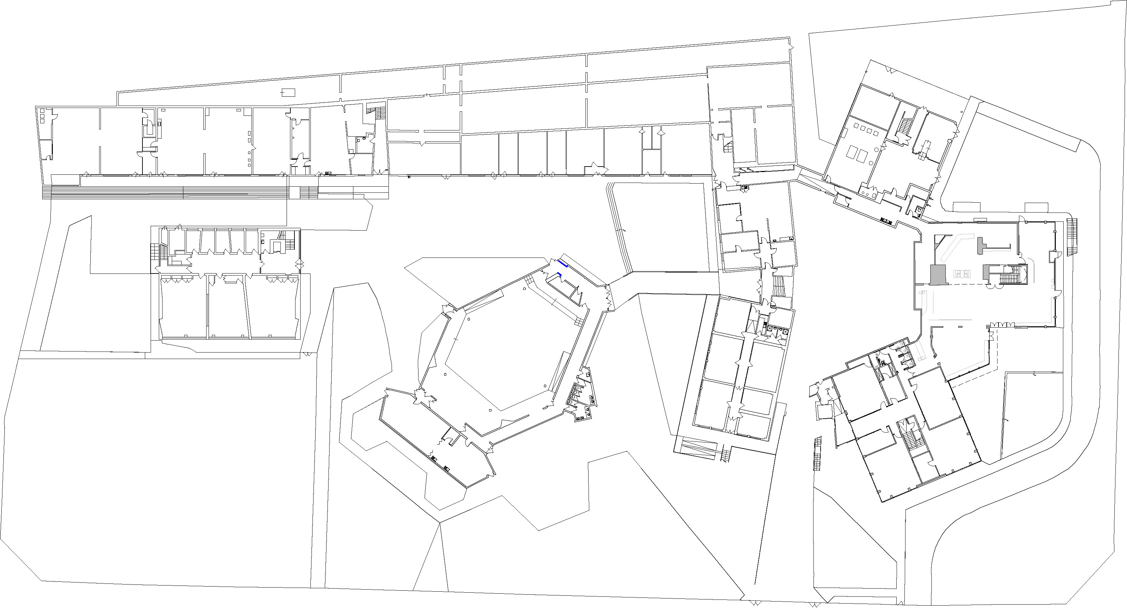**Ground Floor** 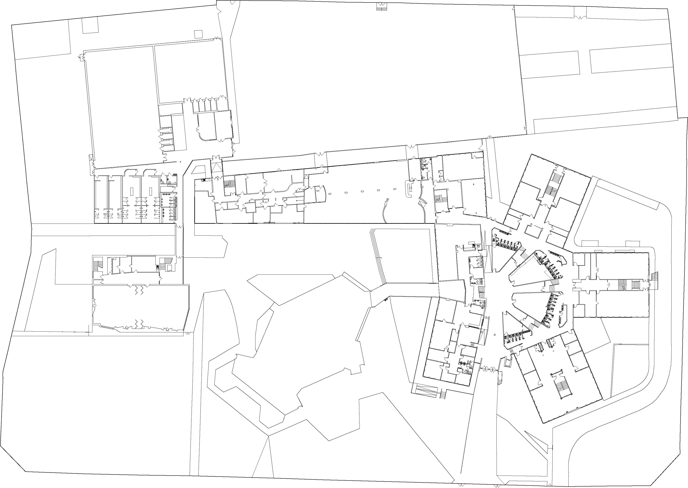

Areas where the original tiles will remian

Kitchen

Office

TE4

MU8

MU4

MU5

MU6

MU7

Shared Office Space

Canteen

Sensory Roon

CS5

Staff Work Base

OAE

OAE

Live

lesson

AEN2

AEN6

Nurse

Tech Off

Data Manager

AEN5

5

AEN3

TLA Work-space

AEN Teachers

AEN1

OAE

AEN4

Exams Officer

HoF AEN

HoF

Visitor Car Park

AstroTurf

RG1

DOL

RG4

RG3

RG2

Services/Boiler Room

Assembly Hall

MU3

TE1

TE2

Tech  
Prep

TE3

MU1

MU2

Staff Car Park

YTL 8

YTL 7 SPL 7

YTL 9

**PERFORMING ARTS BLOCK**

LP

MR1

DoO

PA Office

Green room

DoL

Deputy

DSL

IT Tech

Curriculm tech manager

PE Office

CEIAG CoOrd

DoL Curr

SPPL & 6th Fm Office

Finance & HR

DoLKS5 & YTL 12&13

MR5

ML2

Site Team

YTL10 SPL 10

Attendance Office

Main Office

Sixth Form Study Area

Main Foyer

PE1

CFR

**YELLOW BLOCK**

**GREEN BLOCK**

**RED BLOCK**

Top Pitch

PA

Server Room

Humanities Base

YG4

YG1

YG3

YG2

GGB

GGA

Art Base

Reception

DHT

HT

Staff Room

ML1

Library

The Base

PA1

PA2

Changing Rooms

Gym

Sports Hall

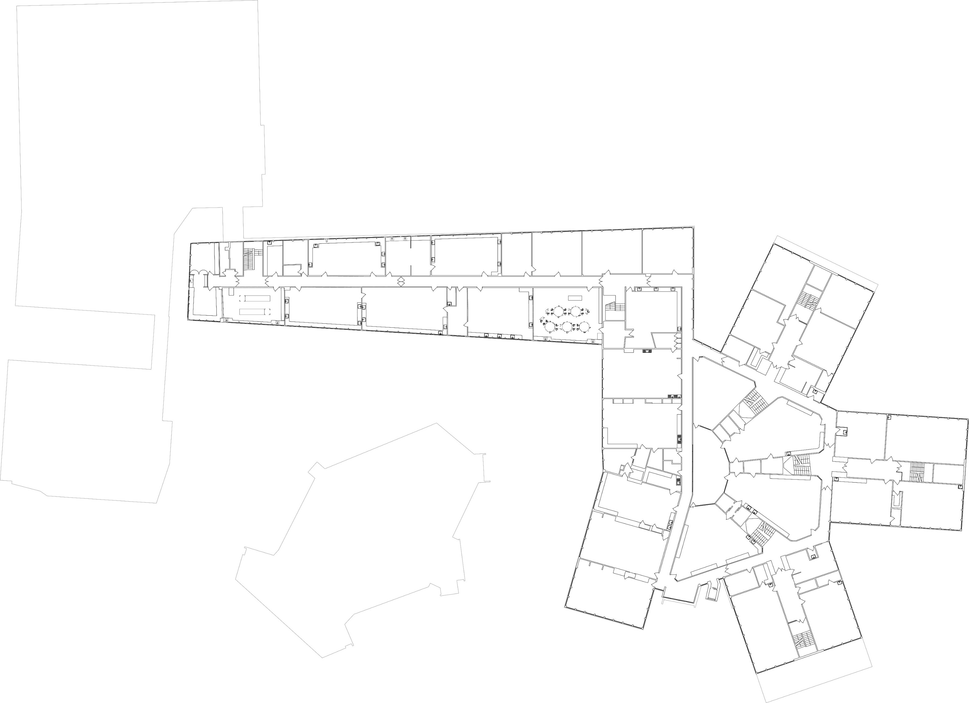 **First Floor**

IER

Tech office

MFL Office

Maths Office

R1B

R1A

G1A

G1B

G1C

MR3

YTL

Y1D

Y1A

Y1C

Y1B

AR3

AR1

AR5

AR4

CS2

CS1

S1

S4

S3

S7

S8

S9

S10

S11

**Acland Burghley School**

Science Office

AR2

CS3 A/B AA/B

DHT

FL ART

store

store

store

DHT

S2

DoL

CS4

S5

S6

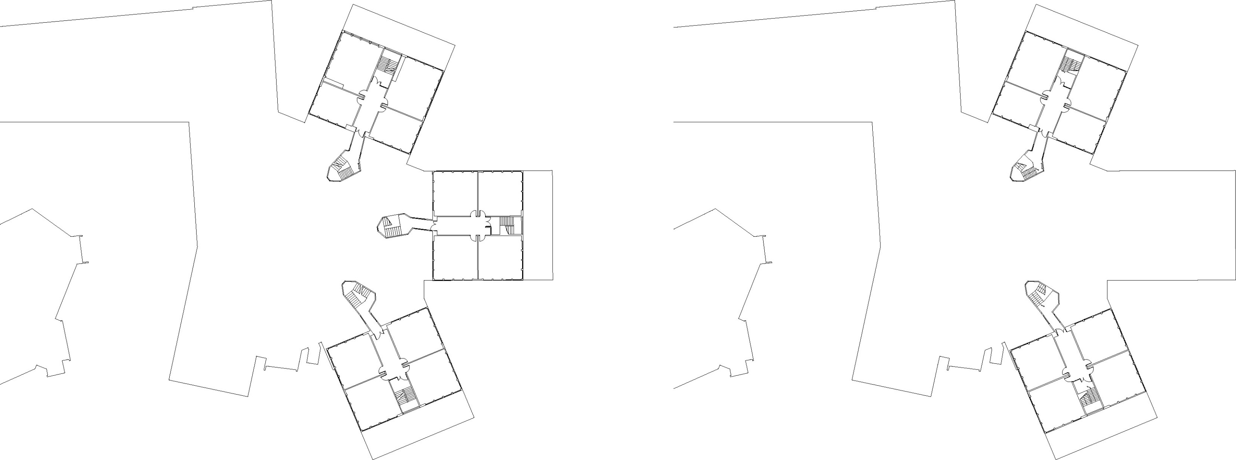**Second Floor Third Floor**

English Office

R3A

R3D

R3B

R3C

Y3D

Y3A

Y3B

Y3C

G2C

R2B

R2C

R2A

R2D

G2D

G2A

G2B

Y2A

Y2B

Y2C